Camouflage Response Sheet
© The Andy Warhol Museum, one of the four Carnegie Museums of Pittsburgh. All rights reserved.
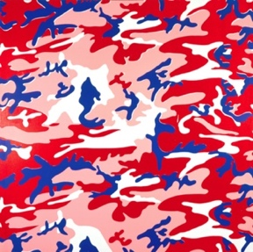
You may view and download the materials posted in this site for personal, informational, educational and non-commercial use only. The contents of this site may not be reproduced in any form beyond its original intent without the permission of The Andy Warhol Museum. except where noted, ownership of all material is The Andy Warhol Museum, Pittsburgh; Founding Collection, Contribution The Andy Warhol Foundation for the Visual Arts, Inc.

Artwork: _______________________________

Initial Response to Artwork:_________________
______________________________________________
__________________________________________________________________________________________________________________________________________

Musical Selection #1 Response:
__________________________________________________________________________________________________________________________________________________________________________________________________________________________________________________________________________________________________________________________________

Musical Selection #2 Response:
__________________________________________________________________________________________________________________________________________________________________________________________________________________________________________________________________________________________________________________________________

Musical Selection #3 Response:
__________________________________________________________________________________________________________________________________________________________________________________________________________________________________________________________________________________________________________________________________

Analysis of Response:
__________________________________________________________________________________________________________________________________________________________________________________________________________________________________________________________________________________________________________________________________
____________________________________________________________________________________________

Additional Notes:
__________________________________________________________________________________________________________________________________________________________________________________________________________________________________________________________________________________________________________________________________

____________________________________________________________________________________________

