Appropriation and Manipulation of News Images Handout
© The Andy Warhol Museum, one of the four Carnegie Museums of Pittsburgh. All rights reserved.
You may view and download the materials posted in this site for personal, informational, educational and non-commercial use only. The contents of this site may not be reproduced in any form beyond its original intent without the permission of The Andy Warhol Museum. except where noted, ownership of all material is The Andy Warhol Museum, Pittsburgh; Founding Collection, Contribution The Andy Warhol Foundation for the Visual Arts, Inc.

Explain:
- Why you chose this photo
- The changes you made to it or would make to it given time and technology (ie, dimensions to enlarge, repetition, color, etc.)
- What you think the image might mean with your alterations
________________________
________________________________________________________________________________________________________________________

Appropriation and Manipulation of News Images Handout
© The Andy Warhol Museum, one of the four Carnegie Museums of Pittsburgh. All rights reserved.
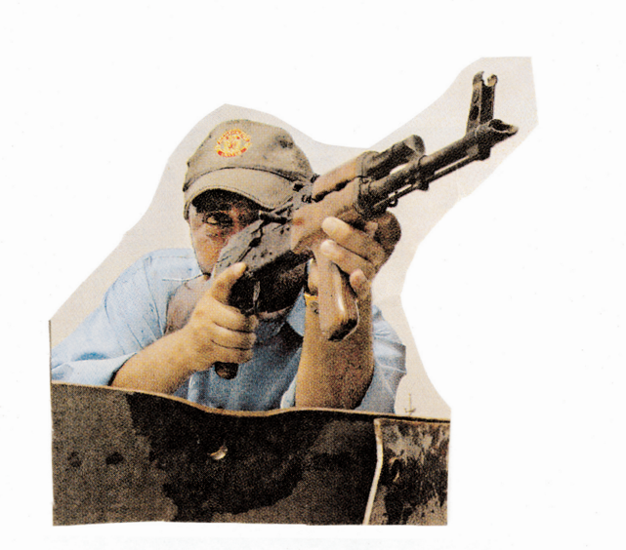
You may view and download the materials posted in this site for personal, informational, educational and non-commercial use only. The contents of this site may not be reproduced in any form beyond its original intent without the permission of The Andy Warhol Museum. except where noted, ownership of all material is The Andy Warhol Museum, Pittsburgh; Founding Collection, Contribution The Andy Warhol Foundation for the Visual Arts, Inc.
Explain:
- Why you chose this photo
- The changes you made to it or would make to it given time and technology (ie, dimensions to enlarge, repetition, color, etc.)
- What you think the image might mean with your alterations

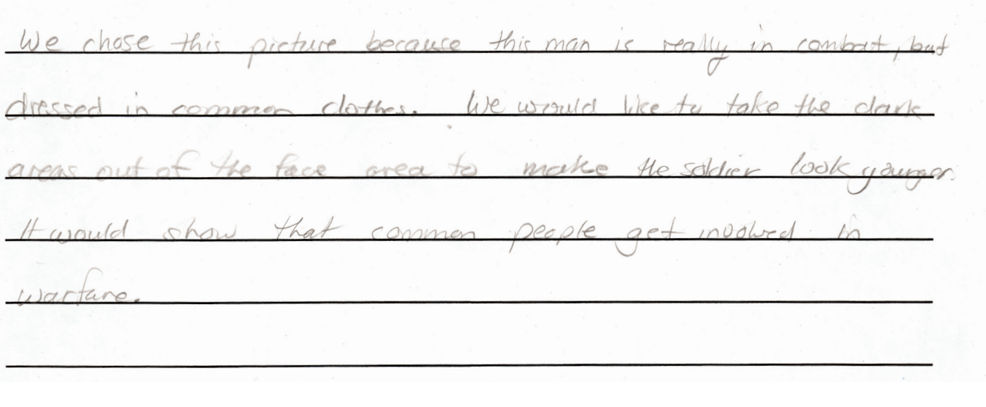

Appropriation and Manipulation of News Images Handout
© The Andy Warhol Museum, one of the four Carnegie Museums of Pittsburgh. All rights reserved.
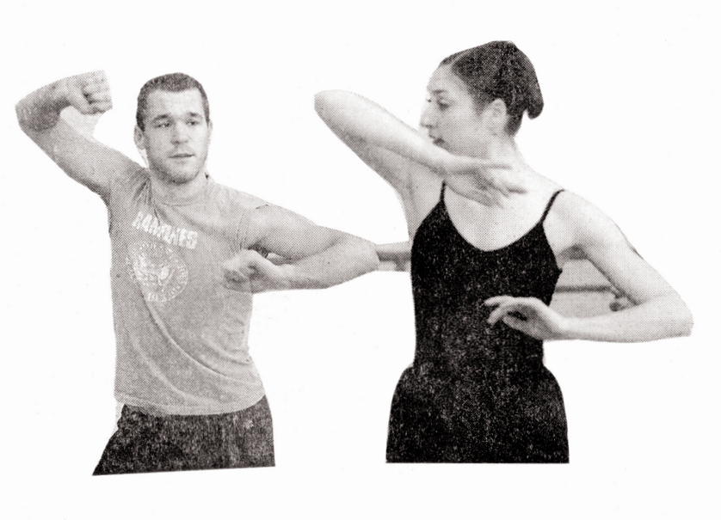
You may view and download the materials posted in this site for personal, informational, educational and non-commercial use only. The contents of this site may not be reproduced in any form beyond its original intent without the permission of The Andy Warhol Museum. except where noted, ownership of all material is The Andy Warhol Museum, Pittsburgh; Founding Collection, Contribution The Andy Warhol Foundation for the Visual Arts, Inc.
Explain:
- Why you chose this photo
- The changes you made to it or would make to it given time and technology (ie, dimensions to enlarge, repetition, color, etc.)
- What you think the image might mean with your alterations

