Transformation Handout: Kaino
© The Andy Warhol Museum, one of the four Carnegie Museums of Pittsburgh. All rights reserved.
You may view and download the materials posted in this site for personal, informational, educational and non-commercial use only. The contents of this site may not be reproduced in any form beyond its original intent without the permission of The Andy Warhol Museum. except where noted, ownership of all material is The Andy Warhol Museum, Pittsburgh; Founding Collection, Contribution The Andy Warhol Foundation for the Visual Arts, Inc.

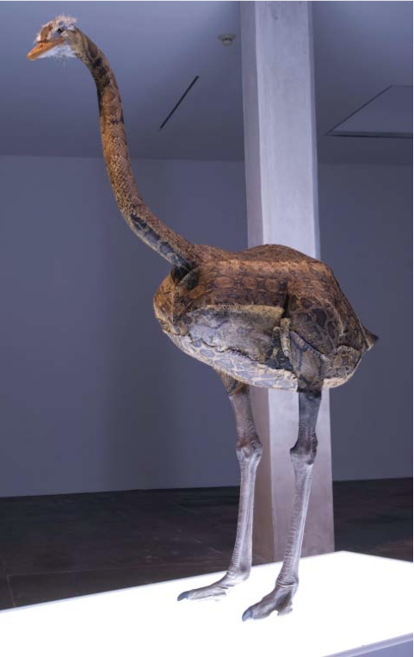
Glenn Kaino, Graft (Ostrich), 2006, Python skin, ostrich feathers, plastic, thread, and paint, Courtesy of the artist and The Project, New York, Installation view at The Andy Warhol Museum, Pittsburgh, Photos by: Maria Bernazzoli.

Glenn Kaino, a Japanese American artist born, raised, and currently working in Los Angeles, has versatile skills as an art maker and director of large media projects. Weaving in and out of fi ne and commercial art realms Kaino has worked as a co-founder of Deep River Gallery in LA and as chief creative offi cer of Napster. He has also taught at UCLA and University of Southern California. Kaino’s work has been shown at the Whitney Biennial at the Whitney Museum of American Art in New York, The Studio Museum in New York, the Museum of Contemporary Art San Diego, The Walker Art Center in Minneapolis, and The Andy Warhol Museum, Pittsburgh.

Transforming commonplace objects and iconic cultural symbols, Kaino (like Andy Warhol) references the subtleties and ironies of popular culture. He often explores issues of cultural identity through both still and kinetic sculptures. In Graft, a proud and ominous ostrich stands atop a light box. The Ostrich is a plastic, life-sized reproduction, but the artist has sewn the bird’s exterior—by hand—using real python snake skin. Kaino gives careful consideration to his materials and process in order to evoke meaning. Possible associations a person might make after viewing Graft range from plastic surgery and second skins, to fashion accessories and trends. In grafting new skin onto this nomadic, head-in-the-sand herbivore Kaino creates a new bird—a likely predator capable of dealing death by its grip. The inner nature of the tightly bound bird is hidden in plain sight. Like taxidermied animals found in hunting lodges and natural history museums around the world, this once-fast hybrid ostrich is now permanently stilled.

Discussion Questions
1. What are the characteristics of an ostrich, a python?
Compare and contrast these descriptions.
2. What choices did the artist make in combining these two animals? What are the results of this combination?
3. What do you think the title Graft implies?
4. What do you think this work means? Does it have cultural implications about appearances, race, or identity? Why
or why not?

Additional Links
Artist’s website http://gkaino.uber.com/
About the exhibition at the Warhol http://www.carnegiemuseums.org/cmag/article.php?id=94
Interview with the artist http://www.discovernikkei.org/forum/en/node/2351

