Interpreting Symbols Handout

© The Andy Warhol Museum, one of the four Carnegie Museums of Pittsburgh. All rights reserved.
You may view and download the materials posted in this site for personal, informational, educational and non-commercial use only. The contents of this site may not be reproduced in any form beyond its original intent without the permission of The Andy Warhol Museum. except where noted, ownership of all material is The Andy Warhol Museum, Pittsburgh; Founding Collection, Contribution The Andy Warhol Foundation for the Visual Arts, Inc.

Research the historical and cultural context of each artwork. Use the following information to guide your search. Hypothesize about the intended audience for each artwork. What do you think the artist might be trying to communicate to the audience?

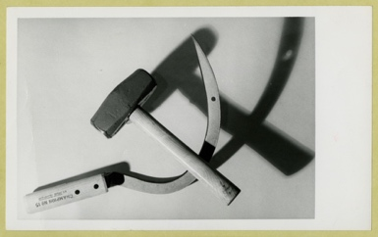  Pop Art, Cold War  Andy Warhol, Hammer and Sickle, 1971 | 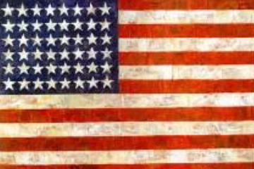  Early Pop Art, Age of Baby Boomers, Youth Revolution  Jasper Johns, Flag, 1954-55
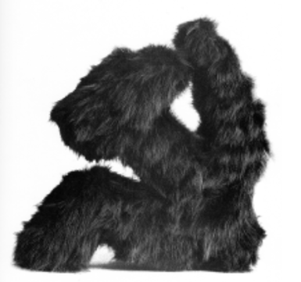  Sotz Art, Soviet Union Withdraws Troops from Afghanistan  Leonid Sokov, Sickle and Hammer, 1988 | 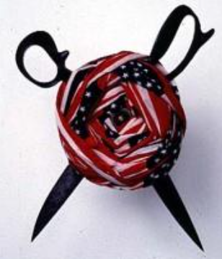  Post-Reagan Years, Cuts in Welfare and Healthcare in the US  Donald Lipski, "No. 10, from Who's Afraid of Red, White, and Blue," 1990
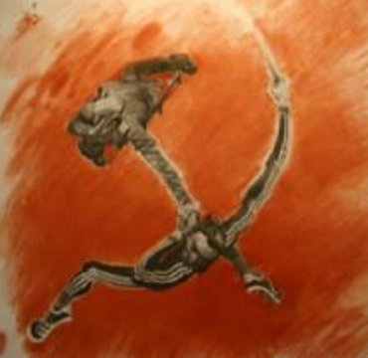  Post-Soviet Russia, Chechen Conflict | 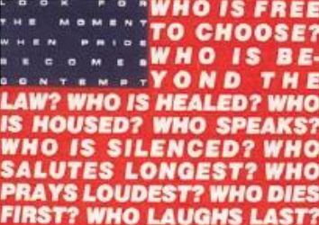  Post 9-11 Climate in the US, Global Protests of War in Iraq  Barbara Kruger, Untitled (Questions) 1991

Work of Art | 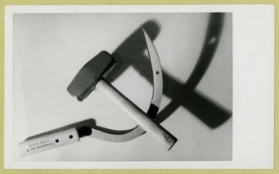  Andy Warhol, Hammer and Sickle, 1971 | 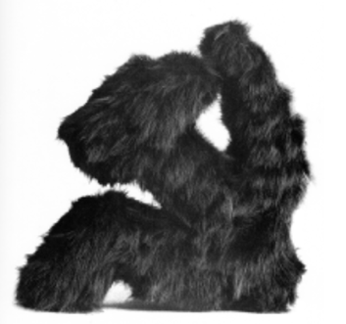  Leonid Sokov, Sickle and Hammer, 1988 | 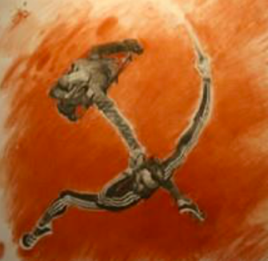
Adjectives:
List characteristics that describe this work.
Associations:
Using the word “like” or “as,” list connections you can make to this artwork.
Ideas:
List the ideas, feelings, and meanings that this artwork conveys.

Work of Art | Jasper Johns, Flag, 1954-55 | 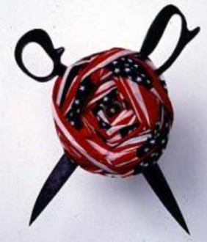  Donald Lipski, "No. 10, from Who's Afraid of Red, White, and Blue," 1990 | Barbara Kruger, Untitled (Questions) 1991
Adjectives:
List characteristics that describe this work.
Associations:
Using the word “like” or “as,” list connections you can make to this artwork.
Ideas:
List the ideas, feelings, and meanings that this artwork conveys.

