Flashbulb Memory Activity
© The Andy Warhol Museum, one of the four Carnegie Museums of Pittsburgh. All rights reserved.
You may view and download the materials posted in this site for personal, informational, educational and non-commercial use only. The contents of this site may not be reproduced in any form beyond its original intent without the permission of The Andy Warhol Museum. except where noted, ownership of all material is The Andy Warhol Museum, Pittsburgh; Founding Collection, Contribution The Andy Warhol Foundation for the Visual Arts, Inc.

1. Look at these images or insert your own.
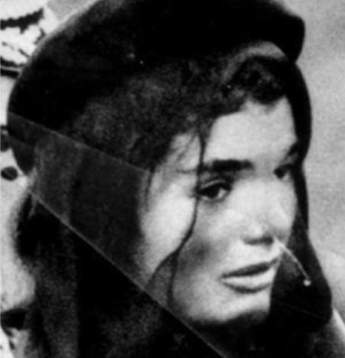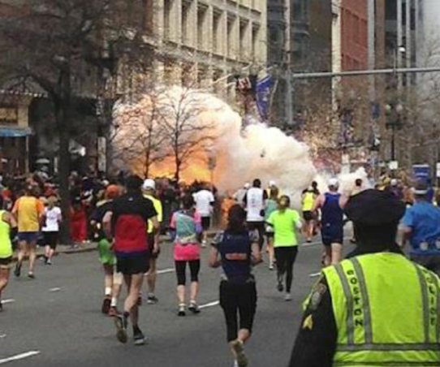
Select a photograph of an event that had a particularly strong impact on you or about which every detail of the memory seems sharp.

2. What do you remember about the event? Write down your memory including as many details as you can about how you experienced it.
________________________________________________________________________

3. How were you impacted then? Does the event still impact your life today? Explain. ________________________________________________

4. What do you think younger generations who did not live through this event should remember or know about it? What is the legacy of this event? ________________________________________________

