Andy Warhol’s Blotted Line

© The Andy Warhol Museum, one of the four Carnegie Museums of Pittsburgh. All rights reserved.
You may view and download the materials posted in this site for personal, informational, educational and non-commercial use only. The contents of this site may not be reproduced in any form beyond its original intent without the permission of The Andy Warhol Museum. except where noted, ownership of all material is The Andy Warhol Museum, Pittsburgh; Founding Collection, Contribution The Andy Warhol Foundation for the Visual Arts, Inc.

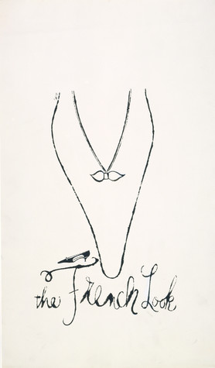

Overview
This lesson features Warhol’s early drawing technique that incorporates a basic printing process. Students use critical thinking skills to judge commercial advertisements and to make decisions on what they will include, embellish, and edit out of their own drawings.

Grade Levels
- Elementary school
- Middle school
- High school

Subjects
- Arts
- English and language arts

Pennsylvania Standards for the Arts and Humanities
- 9.1.3.A - Know and use the elements and principles of each art form to create works in the arts and humanities.
- 9.1.5.A - Know and use the elements and principles of each art form to create works in the arts and humanities.
- 9.1.8.A - Know and use the elements and principles of each art form to create works in the arts and humanities.
- 9.1.12.A - Know and use the elements and principles of each art form to create works in the arts and humanities.

Objectives
- Students examine visual and written data.
- Students identify, describe, and analyze Warhol's use of design elements.
- Students use materials to learn the drawing/printing process and how to apply watercolor and gold leaf.
- Students make aesthetic decisions (color, line, etc.) in their work to create a particular visual impact.
- Students predict marketability to an intended audience.
- Students establish criteria for successful advertising.

Andy Warhol, "The French Look", 1958
The Andy Warhol Museum, Pittsburgh; Founding Collection, Contribution The Andy Warhol Foundation for the Visual Arts, Inc. © The Andy Warhol Foundation for the Visual Arts, Inc.
1998.1.1266

About the Art
Warhol’s drawing The French Look is one of many shoe illustrations he created using a type of line drawing known as the blotted line technique. Warhol first experimented with blotted line while still a college student at Carnegie Institute of Technology (now Carnegie Mellon University). He continued to craft this technique in his commercial work in New York City throughout the 1950s. Blotted line enabled Warhol to create a variety of illustrations along a similar theme. This type of production allowed him to bring multiple ideas to clients to increase the odds that one of his drawings would be chosen for the final advertisement.

Blotted line combines drawing with basic printmaking. Warhol began by copying a line drawing in pencil on a piece of non-absorbent paper, such as tracing paper. Next, he hinged this piece of paper to a second sheet of more absorbent paper by taping their edges together on one side. With a fountain pen, Warhol inked over a small section of the drawn lines. He then transferred the ink onto the second sheet by folding along the hinge and lightly pressing or “blotting” the two papers together. The process resulted in the dotted, broken, and delicate lines that are characteristic of Warhol’s illustrations. Warhol often colored his blotted line drawings with watercolor dyes or applied gold leaf.

Points of View
“I was getting paid for it, and I did anything they told me to do. If they told me to draw a shoe, I’d do it, and if they told me to correct it, I would—I’d do anything they told me to do, correct it and do it right.”
Andy Warhol, quoted in article by G.R. Swenson, “What Is Pop Art?: Answers from 8 Painters, Part I,” Artnews 62 (November, 1963) p. 26

“Another reason why he liked it [the blotted line technique] so much [was that] by having your master drawing with which you made your blot, you could keep blotting it and redrawing it and blotting it each time and make duplicate images.”
Nathan Gluck, Warhol’s commercial art assistant, Interview with Patrick S. Smith, Andy Warhol’s Art and Films, UMI Research Press, (Ann Arbor: Michigan, 1986), p. 311.

“It was absolutely true that he could draw anything and very, very quickly. And so we used him a lot.”
Tina S. Fredericks, art director, interview with Patrick S. Smith, Warhol: Conversations about the Artist, UMI Research Press, (Ann Arbor: Michigan, 1988), p. 100.

“Andy and I began a campaign, which was unprecedented at the time. We ran full pages, half pages, every Sunday in the “New York Times.” And it was a spectacular showcase for I. Miller and for Andy as well. It expanded his audience in a way that no magazine editorial ever could have. In a sea of tiny little images that were the pages of the Times, these bold blockbuster fantasies were extraordinarily effective. What the ads did was to revitalize and revive the I. Miller brand, and from a dowdy, musty, fusty, dusty, dowager establishment, it became a stylish emporium for debutantes.”
Geraldine Stutz, art director, from an exhibition audio guide produced by Antenna audio in collaboration with The Andy Warhol Museum and the Art Gallery of Ontario, Canada

Discussion Questions
1. Use adjectives to describe the lines and colors Warhol used in his drawings.
2. Did Warhol draw in all the details? What is left out? Why?
3. What type of person do you think Warhol was trying to attract with these ads? Explain your answer.
4. When you look at advertisements how do artists and designers manipulate images to make products seem more appealing? (Look through magazines to find examples.)

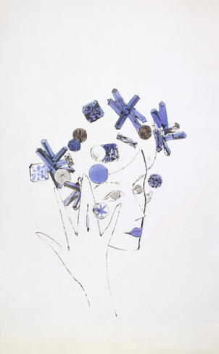

Andy Warhol, Female Head, 1950s
The Andy Warhol Museum, Pittsburgh; Founding Collection, Contribution The Andy Warhol Foundation for the Visual Arts, Inc.
© The Andy Warhol Foundation for the Visual Arts, Inc.
1998.1.853

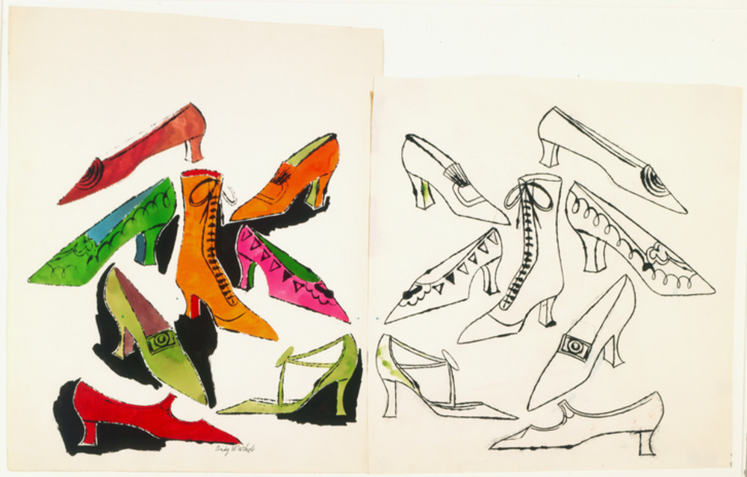

Andy Warhol, Eight Shoes, 1950s
The Andy Warhol Museum, Pittsburgh; Founding Collection, Contribution The Andy Warhol Foundation for the Visual Arts, Inc.
1998.1.1045
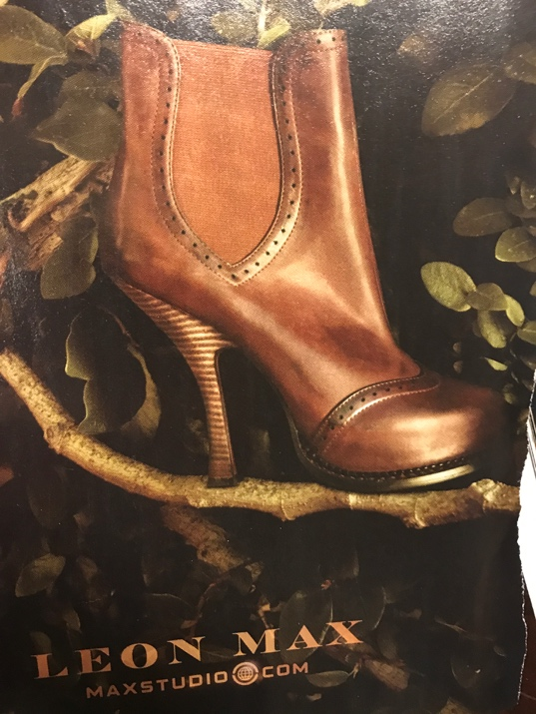

Source image of boot from a magazine.

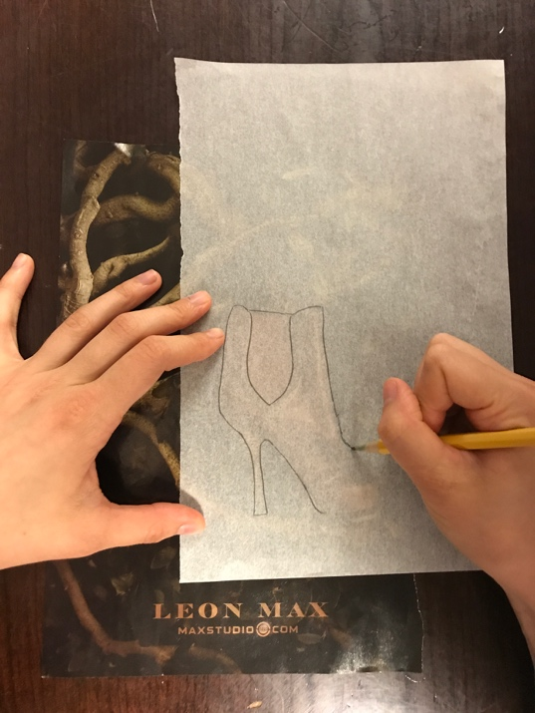

Student traces a boot outline with a pencil.

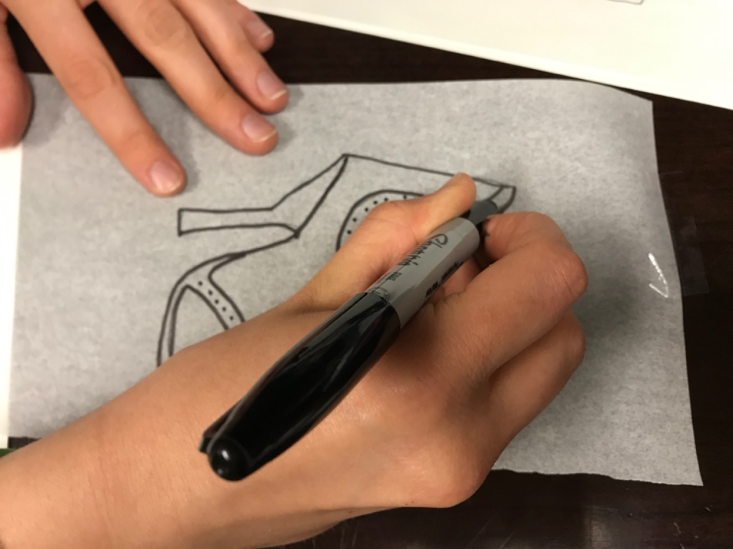

Student traces over a pencil line with black marker.

Student hinges tracing paper to watercolor paper.

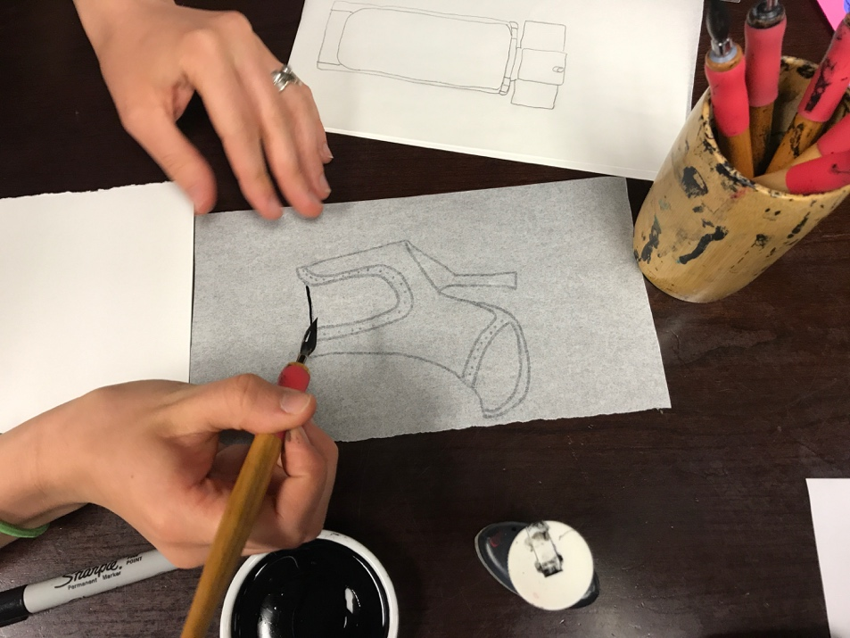

Student begins to apply ink over the shoe outline.

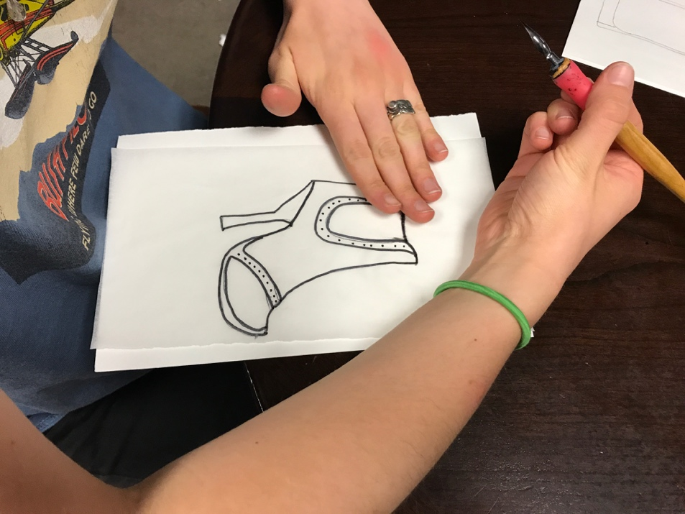

Student blots ink onto watercolor paper.

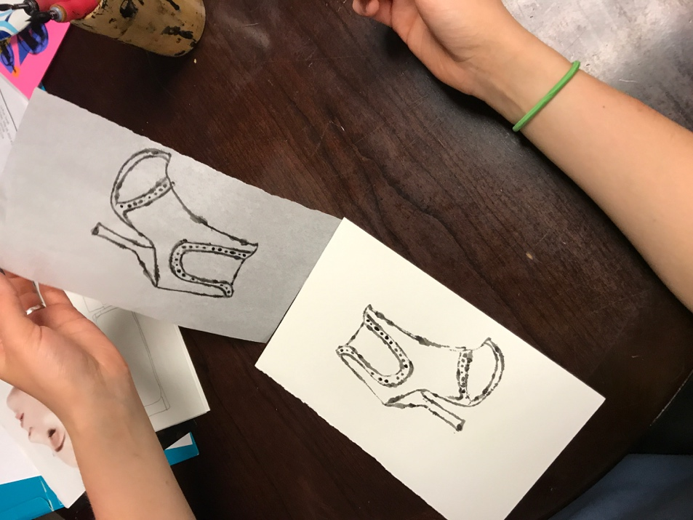

Student continues to ink and blot the tracing until entire image has been transferred onto the watercolor paper.

Materials
- Pencils and dark markers
- Ink pens and nibs
- India ink
- Dr. Martin’s watercolor dyes
- Source images
- Paper towels
- Tracing paper
- Arches 88 or Coventry Rag paper
- Clear tape
- Gold leaf
- Aquasize and Aquasize brushes
- Watercolor brushes
- Paint trays and containers

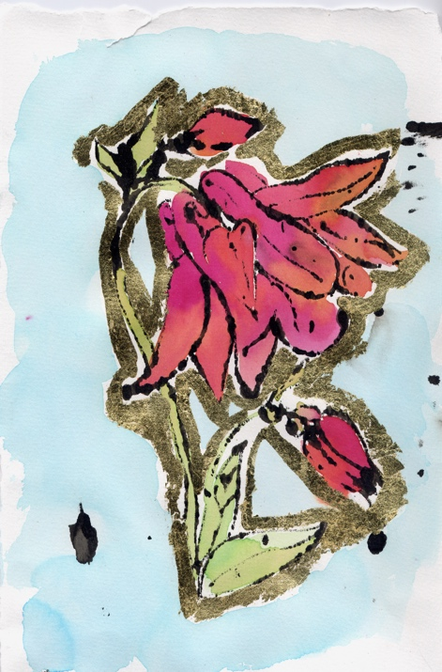

An example of student work produced using Andy Warhol’s blotted line technique.

Procedure
- View The Warhol's blotted line technique video on YouTube. https://www.youtube.com/watch?v=85Hb0c2IAyk&feature=youtu.be

- Cut full sheets of Arches 88 or Coventry Rag paper into smaller sheets. Cut tracing paper to corresponding sizes.

- Collect a range of magazine source images (e.g.models, shoes, perfume, jewelry, etc.).

- Select a source image, then tape a piece of tracing paper on top of the image. Trace the lines of the source image onto the tracing paper with a pencil. Trace over the penciled line with black marker. Next, hinge the tracing paper with tape to the Arches 88 or Coventry Rag paper.

- Opening the papers like a book, ink a small part of the traced drawing, then lightly blot the ink onto the watercolor paper with fingers or the opposite end of the ink pen. Continue to ink and blot small segments at a time until the drawing is finished. Dr. Martin’s dyes or gold leaf can be used after the ink is dry to fill in the drawings.

- When using gold leaf, apply a thin layer of Aquasize on selected areas and wait for it to become tacky before placing pieces of gold leaf on top.
Extension: If there is time, make a series of drawings from the same source image with alterations to color, decoration, and impact.

Wrap-up
Have students hang their drawings next to their original source material. On a separate piece of paper, ask students to identify what they chose to include and embellish and what they chose to exclude for the original source in their final illustrations. Using a rating scale from 1–5 (five being the highest rating), have students assess the appeal of their product illustrations. Students should write a sentence or two explaining their rating. As a class, discuss which drawings are successful, which are not, and why.

Assessment
The following assessments can be used for this lesson using the downloadable assessment rubric.
- Aesthetics 1
- Communication 3
- Communication 4
- Creative Process 3
- Creative Process 4
- Creative Process 5
- Creative Process 6

