Brillo: Is It Art?

© The Andy Warhol Museum, one of the four Carnegie Museums of Pittsburgh. All rights reserved.
You may view and download the materials posted in this site for personal, informational, educational and non-commercial use only. The contents of this site may not be reproduced in any form beyond its original intent without the permission of The Andy Warhol Museum. except where noted, ownership of all material is The Andy Warhol Museum, Pittsburgh; Founding Collection, Contribution The Andy Warhol Foundation for the Visual Arts, Inc.

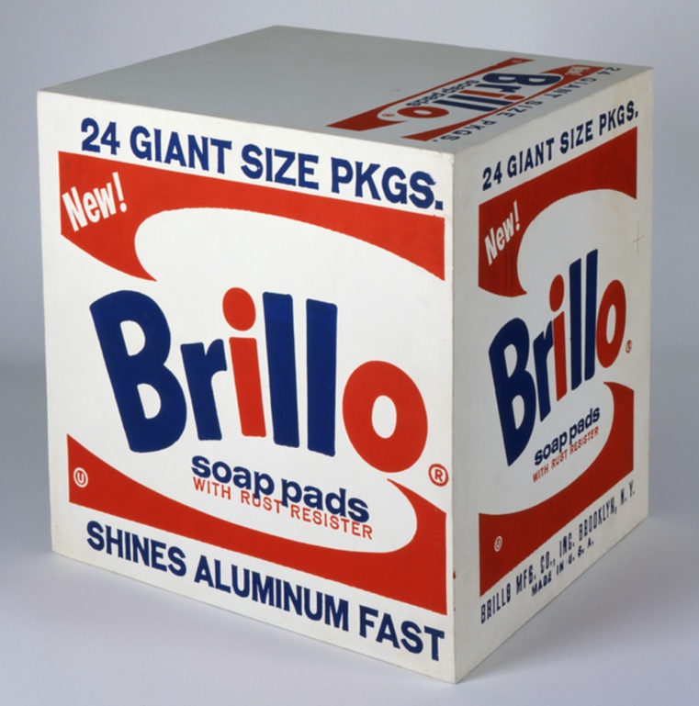

Overview
This lesson serves as an icebreaker and introduction to critical response. Students think about an often-controversial work of art, Andy Warhol’s Brillo Box, in order to judge for themselves what constitutes good art. Students use higher-level thinking skills to differentiate between tastes and biases and to listen to diverse perspectives, even if the perspectives differ from their own.

Grade levels
- Middle school
- High school

Subjects
- Arts
- Art history
- English and language arts

Pennsylvania Standards for the Arts and Humanities
- 9.3.8.D - Evaluate works in the arts and humanities using a complex vocabulary of critical response.
- 9.3.12.C - Apply systems of classification for interpreting works in the arts and forming a critical response.

Objectives
- Students create brainstorming webs.
- Students list personal tastes and biases.
- Students compare and contrast personal tastes and biases.
- Students classify data.
- Students examine cause and effect.
- Students form aesthetic responses to artworks.

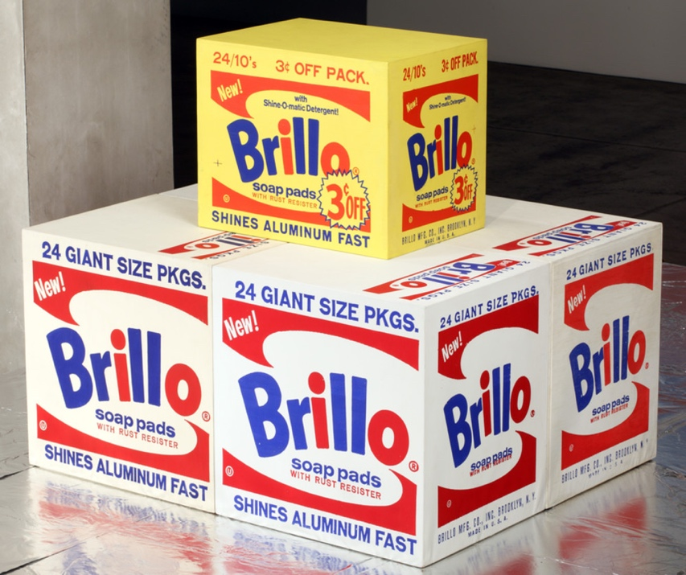

Andy Warhol, Brillo Box (3¢ Off),
The Andy Warhol Museum, Pittsburgh; Founding Collection, Contribution The Andy Warhol Foundation for the Visual Arts, Inc.
© The Andy Warhol Foundation for the Visual Arts, Inc.
1998.1.711

About the Art
In the mid-1960s, Warhol carried his consumer-product imagery into the realm of sculpture. Calling to mind a factory assembly line, Warhol employed carpenters to construct numerous plywood boxes identical in size and shape to supermarket cartons. With assistance from Gerard Malanga and Billy Linich, he painted and silkscreened the boxes with different consumer product logos: Kellogg’s corn ﬂakes, Brillo soap pads, Mott’s apple juice, Del Monte peaches, and Heinz ketchup. The ﬁnished sculptures were virtually indistinguishable from their cardboard supermarket counterparts. Warhol ﬁrst exhibited these at the Stable Gallery in 1964, cramming the space with stacked boxes that recalled a cramped grocery warehouse. He invited collectors to buy them by the stack, and, though they did not sell well, the boxes caused controversy. In reference to his boxes, Warhol later said that he “wanted something ordinary,” and it was this mundane, commercial subject matter that infuriated the critics. The perfectly blank “machine-made” look of Warhol’s boxes contrasted sharply with the gestural brushstrokes of abstract expressionist paintings.

Points of View
“[The boxes] were very difﬁcult to sell. He thought that everyone was going to buy them on sight, he really and truly did. We all had visions of people walking down Madison Avenue with these boxes under their arms, but we never saw them.”
Stable Gallery art dealer Eleanor Ward in David Bourdon, Warhol, 1995

“A few days after the move to our [Gerard Malanga and Andy Warhol] workspace, January 28th, a truckload of wood boxes arrived, individually wrapped and taped in clear plastic sheeting. And so would begin the arduous task of taping the ﬂoor with rolls of brown paper and setting out each box in a grid-like pattern of eight rows lengthwise... Billy Name and I would take turns painting with Liquitex all six sides of each box—which numbered nearly 80—the Campbell’s tomato juice for starters, by turning each box around on its side. We waited until the paint dried. Andy and I repeated this process silkscreening all ﬁve sides again down the line. The sixth side —the bottom side—remained blank... Completing the work took nearly six weeks, from early February well into mid-April.”
Warhol’s studio assistant Gerard Malanga, Archiving Warhol: Writings and Photographs, 2002

Discussion Questions
- Would you buy this artwork? Why or why not?
- What does the artwork remind you of?
- Is the association pleasant or important, or is it unpleasant or banal?

Materials
- Pencils
- Taste and Bias handout
- Taste and Bias example
- Reproductions of Brillo Box

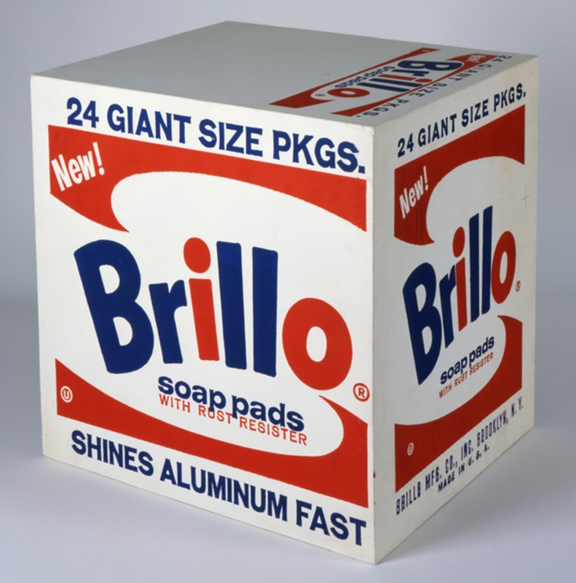

Andy Warhol, Brillo Soap Pads Box, 1964
The Andy Warhol Museum, Pittsburgh; Founding Collection, Contribution The Andy Warhol Foundation for the Visual Arts, Inc.
© The Andy Warhol Foundation for the Visual Arts, Inc.
1998.1.709

Vocabulary
- Critic: A person who forms opinions and expresses judgments of the merits, faults, or value of something (for example, music, art, literature, movies, or food).
- Opinion: A belief, judgment, point of view, or conclusion formed about something without necessarily being based on fact.
- Bias: A strong inclination for, or a preconceived notion about, something that often inhibits impartial judgment.
- Taste: A personal preference or liking of something.

Procedure
- Before class, prepare reproductions of Warhol’s Brillo Box to hand out to students, or enlarge one to hang in the front of the class.
- Review with students the following vocabulary terms: bias, critic, opinion, and taste.
- Discuss the following questions:
- What do critics do in popular culture?
- What is the difference between an informed and an uninformed opinion?
- How are taste and bias different?
- How do we judge something to be good or bad?
- Pass out handouts and pencils. Have students create a word web, writing out all of the things they know or think about the Brillo Box, their likes/dislikes, and their assumptions.
- Help students explain their answers more fully when they are unclear. (See the bubbles on attached example for questions that teachers might ask students.)
- After the discussion, instruct students to identify which phrases on their webs are tastes and which are biases. Separate these into a taste list and a bias list.

Extension
This exercise can be repeated with a piece of music. Students create webs and then musical taste and bias lists.

Wrap-up
As a class, discuss when we are critics in our everyday lives and how we make critical judgments about things, such as music, fashion, and movies. In their journals, students should discuss the following:
- The similarities between personal tastes and biases.
- How tastes and biases, as well as informed and uninformed opinions, might affect a critic’s response.
- How they distinguish between good and bad art.

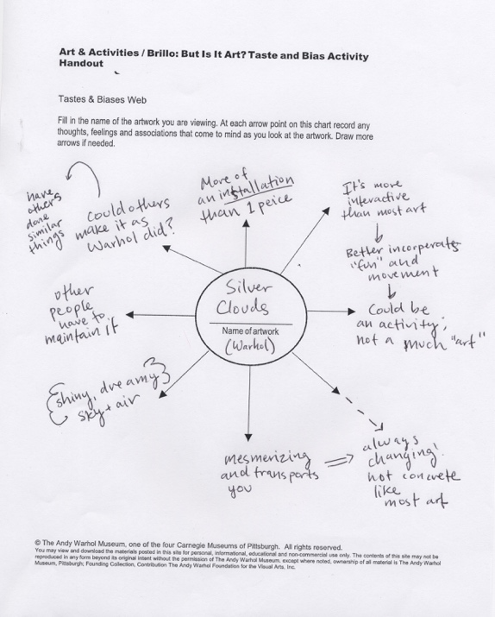

A completed version of the Taste and Bias handout using Warhol’s Silver Clouds as the basis for exploration.

Assessment
The following assessments can be used for this lesson using the downloadable assessment rubric.
- Aesthetics 1
- Aesthetics 3
- Communication 3
- Critical thinking 1
- Critical thinking 2
- Critical thinking 4
- Historical context 4

Taste and Bias Activity Handout
© The Andy Warhol Museum, one of the four Carnegie Museums of Pittsburgh. All rights reserved.
You may view and download the materials posted in this site for personal, informational, educational and non-commercial use only. The contents of this site may not be reproduced in any form beyond its original intent without the permission of The Andy Warhol Museum. except where noted, ownership of all material is The Andy Warhol Museum, Pittsburgh; Founding Collection, Contribution The Andy Warhol Foundation for the Visual Arts, Inc.

Tastes and Biases Web
Fill in the name of the artwork you are viewing. At each arrow point on this chart record any thoughts, feelings, and associations that come to mind as you look at the artwork. Draw more arrows if needed.

Name of Artwork

