Camouflage Sound Activity

© The Andy Warhol Museum, one of the four Carnegie Museums of Pittsburgh. All rights reserved.
You may view and download the materials posted in this site for personal, informational, educational and non-commercial use only. The contents of this site may not be reproduced in any form beyond its original intent without the permission of The Andy Warhol Museum. except where noted, ownership of all material is The Andy Warhol Museum, Pittsburgh; Founding Collection, Contribution The Andy Warhol Foundation for the Visual Arts, Inc.

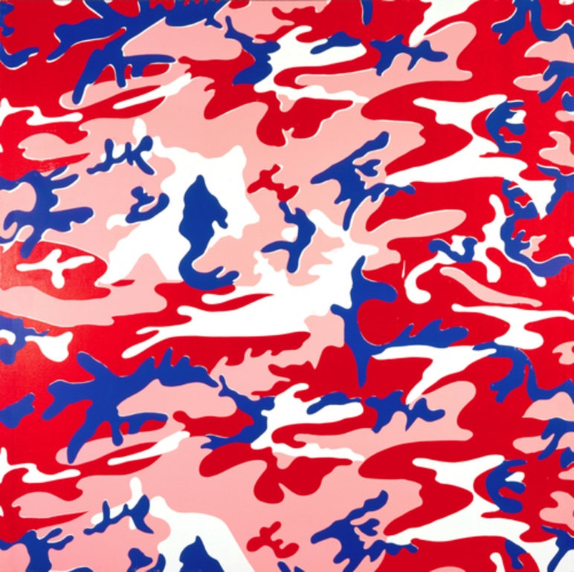

Overview
Students use viewing, speaking, listening, and writing skills to explore their own intuitive responses to and interpretations of an artwork. Sound clips are played while students look at a work of art and write their feelings, thoughts, and associations. Comprehension and discussion questions allow for rich follow-up journaling and reflection.

Grade Levels
- Elementary school
- Middle school
- High School

Subjects
- Arts
- English and language arts

Pennsylvania Standards for the Arts and Humanities
- 9.4.3.C - Recognize that the environment of the observer influences individual aesthetic responses to works in the arts (e.g., the effect of live music as opposed to listening to the same piece on a car radio).
- 9.4.5.C - Identify the attributes of various audiences’ environments as they influence individual aesthetic response (e.g., Beatles’ music played by the Boston Pops versus video taped concerts from the 1970s).
- 9.4.8.C - Describe how the attributes of the audience’s environment influence aesthetic responses (e.g., the ambiance of the theatre in a performance of Andrew Lloyd Weber’s Cats).
- 9.4.12.C - Compare and contrast the attributes of various audiences’ environments as they influence individual aesthetic response (e.g., viewing traditional Irish dance at county fair versus the performance of River Dance in a concert hall).

Objectives
- Students describe Andy Warhol's use of design elements.
- Students associate personal ideas and experiences with an abstract work of art.
- Students describe new thoughts and feelings about an artwork as music is added to the environment.
- Students theorize how music or sounds influence interpretations.
- Students speculate how different environments affect our experiences of art.

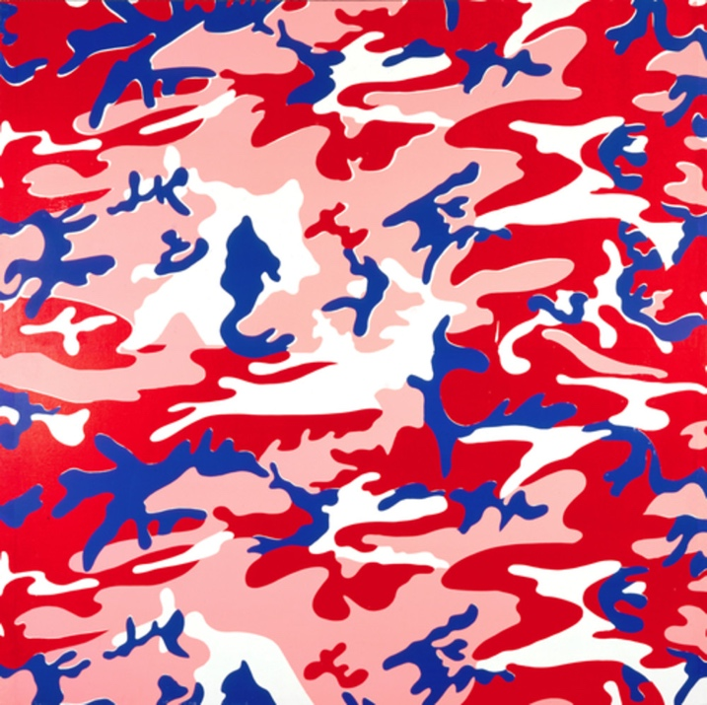

Andy Warhol, Camouflage, 1986
The Andy Warhol Museum, Pittsburgh; Founding Collection, Contribution The Andy Warhol Foundation for the Visual Arts, Inc.
© The Andy Warhol Foundation for the Visual Arts, Inc.
1998.1.350

About the Art
Warhol is reported to have asked his studio assistants, “What can I do that would be abstract but not really abstract?” Camouﬂage gave him the opportunity to work with both an abstract pattern and an immediately recognizable image. Unlike military motifs, Warhol’s camouﬂage paintings reﬂect bright synthetic and inorganic colors, which would not provide a veil or disguise in any landscape. At the military’s request, artist’s created camouﬂage beginning in the early twentieth century. It was ﬁrst used for concealment of equipment, and then for uniforms. As Warhol invented more camouﬂage works, he incorporated the pattern into his self-portraits. In these works, the juxtaposition of identity and disguise mirrors the artist’s lifelong struggle to gain notoriety while keeping his own private life hidden.

Warhol also collaborated with the fashion designer Stephen Sprouse to create a line of camouﬂage clothing. This apparel associated war with high fashion, and women dressed in camouﬂage gowns in urban settings attracted attention rather than blended in. Over the past few decades, the military has struggled to create an effective urban camouﬂage uniform because the environment is constantly changing. Unfettered by such concerns, contemporary urban clothing designers are interested in making a bold statement.

Points of View
“To call these paintings decorative would be short-sighted, for in manipulating the size, shape, and colors of the traditional military fabric—a fabric designed not to be seen—he demonstrated an almost effortless ability to summon up an entire range of art historical references, from Chinese landscapes to Monet’s Water Lilies…. Of course pretending he didn’t know anything about art history was one of the many ways in which Warhol camouﬂaged himself. He told countless interviewers that Walt Disney was his favorite artist, while quietly amassing a collection that included paintings by Corot, Fragonard, Picasso, Fontana, and Yves Klein, among others.”
Writer and former Warhol associate Bob Colacello in Brenda Richardson, Andy Warhol: Camouflage, 1988

Discussion Questions
- What do you feel, think, and associate with this painting?
- What do you think the painting might mean?
- Where do we most often view artworks? Describe that environment.
- Where would you least want to put an important work of art and why?
- Is the environment important to the artwork?
- Is the viewer’s experience important to the artwork?

Materials
- Music clips on SoundCloud
  - Spring, Vivaldi
https://soundcloud.com/thewarholmuseum/spring-vivaldi-excerpt
  - War, Edwin Starr
https://soundcloud.com/thewarholmuseum/war-edwin-starr-excerpt
  - I Feel Love, Donna Summer
https://soundcloud.com/thewarholmuseum/i-feel-love-donna-summer
- Pencils
- Paper
- Handout: Camouflage Response Sheet

Procedure
- Look at Warhol’s Camouflage, 1986, without discussing any information about the work (historical/cultural context, interpretations, criticisms, etc.).
- Write down your feelings, thoughts, associations, and observations while looking at the work in silence.
- Listen to the ﬁrst music clip: Spring, Vivaldi.
- Do not try to identify the music. Instead, write down any new feelings, thoughts, associations, and observations while looking and listening.
- Listen to the second music clip: War, Edwin Starr.
- Repeat step four.
- Listen to the third music clip: I Feel Love, Donna Summer.
- Repeat step four.
- Compare and contrast your personal responses to the different pieces of music to the responses of your peers.
- Reﬂect on the responses, and then write a brief analysis.

Wrap-up
Ask students to reﬂect on the following questions in their journals:
- How did your experience viewing the art change as the music changed?
- Did the music enhance your experience of the artwork, or was it distracting?
- How did the meaning and context of the artwork change as your experience changed?
- Hypothesize other environmental factors that could affect the way a person views a work of art (lighting, temperature, etc.).

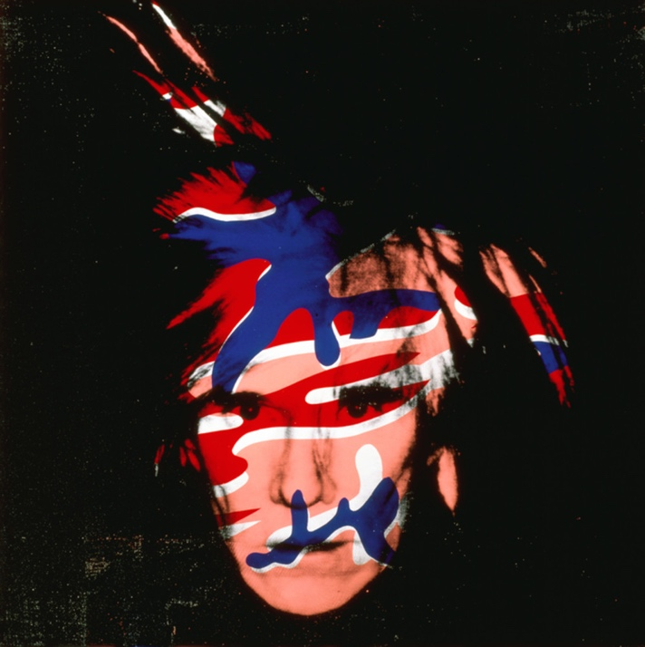

Andy Warhol, Self-Portrait, 1986
The Andy Warhol Museum, Pittsburgh; Founding Collection, Contribution The Andy Warhol Foundation for the Visual Arts, Inc.
© The Andy Warhol Foundation for the Visual Arts, Inc.
1998.1.805

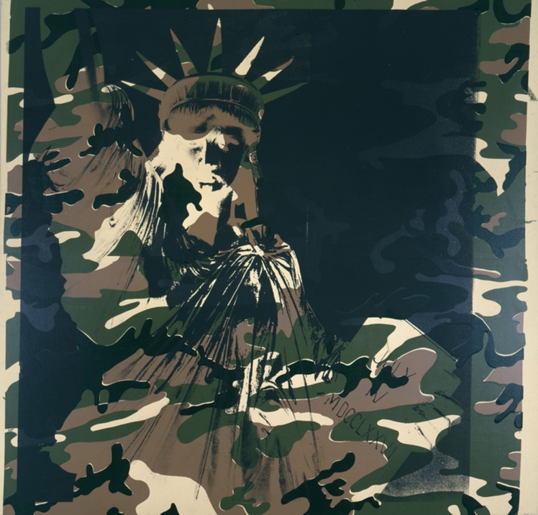

Andy Warhol, Statue of Liberty, 1986
The Andy Warhol Museum, Pittsburgh; Founding Collection, Contribution The Andy Warhol Foundation for the Visual Arts, Inc.
© The Andy Warhol Foundation for the Visual Arts, Inc.
1998.1.347

Assessment
The following assessments can be used for this lesson using the downloadable assessment rubric.
- Aesthetics 1
- Communication 3
- Creative process 2
- Critical thinking 2
- Historical context 4

Camouflage Response Sheet
© The Andy Warhol Museum, one of the four Carnegie Museums of Pittsburgh. All rights reserved.
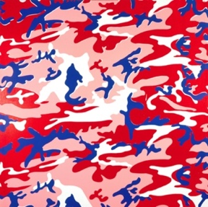
You may view and download the materials posted in this site for personal, informational, educational and non-commercial use only. The contents of this site may not be reproduced in any form beyond its original intent without the permission of The Andy Warhol Museum. except where noted, ownership of all material is The Andy Warhol Museum, Pittsburgh; Founding Collection, Contribution The Andy Warhol Foundation for the Visual Arts, Inc.

Artwork: _______________________________

Initial Response to Artwork:_________________
______________________________________________
__________________________________________________________________________________________________________________________________________

Musical Selection #1 Response:
__________________________________________________________________________________________________________________________________________________________________________________________________________________________________________________________________________________________________________________________________

Musical Selection #2 Response:
__________________________________________________________________________________________________________________________________________________________________________________________________________________________________________________________________________________________________________________________________

Musical Selection #3 Response:
__________________________________________________________________________________________________________________________________________________________________________________________________________________________________________________________________________________________________________________________________

Analysis of Response:
__________________________________________________________________________________________________________________________________________________________________________________________________________________________________________________________________________________________________________________________________
____________________________________________________________________________________________

Additional Notes:
__________________________________________________________________________________________________________________________________________________________________________________________________________________________________________________________________________________________________________________________________

____________________________________________________________________________________________

