Campbell’s Soup: Ode to Food

© The Andy Warhol Museum, one of the four Carnegie Museums of Pittsburgh. All rights reserved.
You may view and download the materials posted in this site for personal, informational, educational and non-commercial use only. The contents of this site may not be reproduced in any form beyond its original intent without the permission of The Andy Warhol Museum. except where noted, ownership of all material is The Andy Warhol Museum, Pittsburgh; Founding Collection, Contribution The Andy Warhol Foundation for the Visual Arts, Inc.

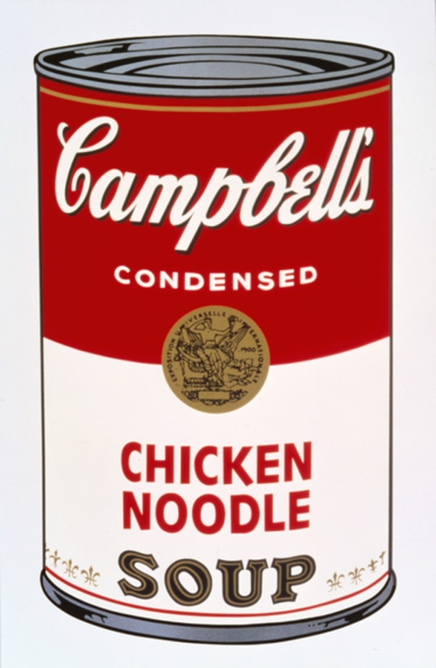

Overview
Students produce narrative illustrations and writings in the poetic form of an ode after discussing an Andy Warhol quote and viewing his Campbell’s Soup Can artworks. Students explore the concept of liking something so much that one is compelled to create art about that thing.

Grade levels
- Elementary school
- Middle school

Subjects
- Arts
- English and language arts

Pennsylvania Standards for the Arts and Humanities
- 9.1.5.E - Know and demonstrate how arts can communicate experiences, stories or emotions through the production of works in the arts.
- 9.1.8.E - Communicate a unifying theme or point of view through the production of works in the arts.
- 9.1.12.E - Delineate a unifying theme through the production of a work of art that reflects skills in media processes and techniques.
- 9.2.5.D - Analyze a work of art from its historical and cultural perspective.
- 9.2.8.D - Analyze a work of art from its historical and cultural perspective.
- 9.2.12.D - Analyze a work of art from its historical and cultural perspective.

Objectives
- Students explain and discuss an ode.
- Students define and discuss repetition.
- Students articulate and illustrate food preferences.
- Students compare and contrast student work.
- Students assess the effects of repetition in daily life (art, music, food, etc.).

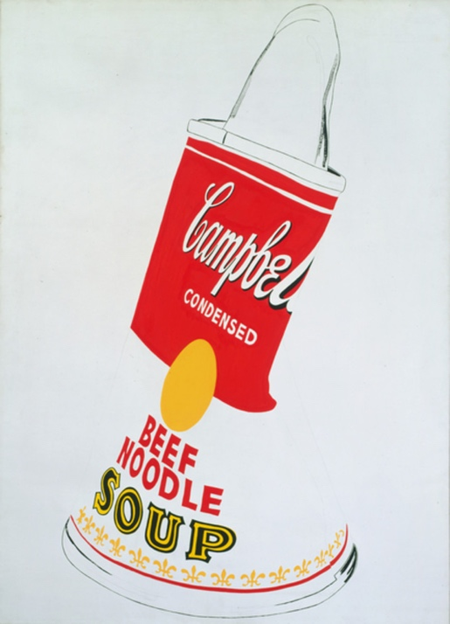

Andy Warhol, Crushed Campbell's Soup Can (Beef Noodle), 1962
The Andy Warhol Museum, Pittsburgh; Founding Collection, Contribution The Andy Warhol Foundation for the Visual Arts, Inc.
© The Andy Warhol Foundation for the Visual Arts, Inc.
1998.1.30

About the Art
Warhol's Campbell's Soup Can paintings are key works of the 1960s pop art movement, a moment when many artists made work derived from popular culture. Warhol's Campbell's Soup Cans elevate the popular or everyday to the status of art. The Campbell's brand and its red-and-white label date from the late nineteenth century and became increasingly familiar in the twentieth century, particularly with the increase in mass production and advertising after World War II. Warhol himself said, "Pop art is about liking things," and claimed that he ate Campbell's soup every day for twenty years. For him, it was the quintessential American product: he marveled that the soup, like Coca-Cola, always tasted the same, whether consumed by prince or pauper.

Points of View
“I used to drink it [Campbell’s Soup]. I used to have the same lunch every day, for twenty years, I guess, the same thing over and over again.”
Andy Warhol in an interview with Gene Swenson, Artnews, 1963

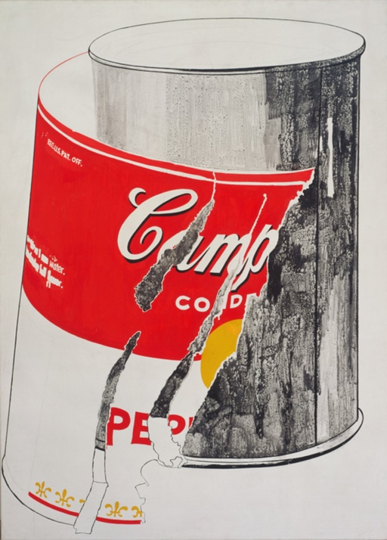

Andy Warhol, Big Torn Campbell's Soup Can (Pepper Pot), 1962
The Andy Warhol Museum, Pittsburgh; Founding Collection, Contribution The Andy Warhol Foundation for the Visual Arts, Inc.
© The Andy Warhol Foundation for the Visual Arts, Inc.
1998.1.31

Discussion Questions
- What would you love to eat every day for twenty years?
- What would you not like to eat every day?
- Does repetition affect your taste for something? Explain your answer.
- When an artist repeats an image over and over again, what effect does it have on the viewer?
Why do you think Warhol made so many Campbell’s Soup Can paintings?

Materials
- Image of Warhol’s Campbell’s Soup Can
- Colored pencils
- Pens
- Handout: Ode to Soup Template
- Example: Ode to Soup

Vocabulary
- Ode: A lyric poem praising or glorifying a feeling, person, object, or event. Odes may vary in length and complexity.

Procedure
- Students write an ode about their food of choice (favorite, aversion, or other) and make an accompanying drawing of this food. (See example handout.)
- Explain what an ode is.
- Pass out materials and supplies. Students may start with the illustration or the ode or work back and forth between the two.

Wrap-Up
Students present their odes to the class and discuss the similarities and differences between the foods the class liked and disliked. First in their journals, then in a class discussion, students reflect on the following questions:
- Did you notice any cultural trends within the class?
- Are the class’s favorite foods advertised in the media? If so, how?
- Does the media affect our likes and dislikes when it comes to food? If so, how?

Assessment
The following assessments can be used for this lesson using the downloadable assessment rubric.
- Communication 2
- Creative process 2
- Creative process 3
- Creative process 6
- Critical thinking 2
- Critical thinking 3

Ode to a Food Handout
© The Andy Warhol Museum, one of the four Carnegie Museums of Pittsburgh. All rights reserved.
You may view and download the materials posted in this site for personal, informational, educational and non-commercial use only. The contents of this site may not be reproduced in any form beyond its original intent without the permission of The Andy Warhol Museum. except where noted, ownership of all material is The Andy Warhol Museum, Pittsburgh; Founding Collection, Contribution The Andy Warhol Foundation for the Visual Arts, Inc.

Ode to a Food

________________________________________________________________________________________________________________________________________________________________________________________________

Ode to a Food Handout
© The Andy Warhol Museum, one of the four Carnegie Museums of Pittsburgh. All rights reserved.
You may view and download the materials posted in this site for personal, informational, educational and non-commercial use only. The contents of this site may not be reproduced in any form beyond its original intent without the permission of The Andy Warhol Museum. except where noted, ownership of all material is The Andy Warhol Museum, Pittsburgh; Founding Collection, Contribution The Andy Warhol Foundation for the Visual Arts, Inc.

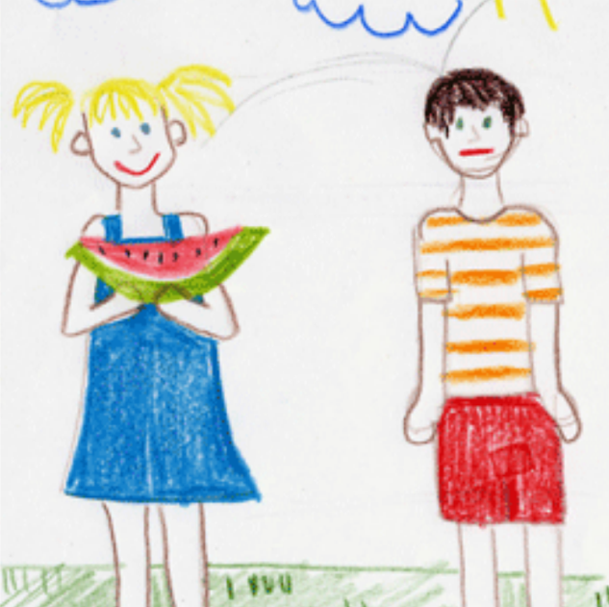
Ode to a Food

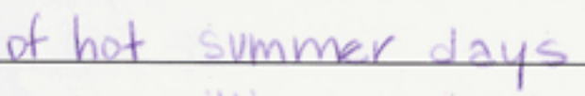
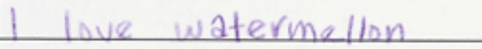
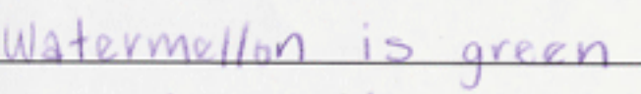
________________________________________________________________________________________________________________________________________________________________________________________________

An example of a completed Ode to a Food handout.

