Commissioned Portraits

© The Andy Warhol Museum, one of the four Carnegie Museums of Pittsburgh. All rights reserved.
You may view and download the materials posted in this site for personal, informational, educational and non-commercial use only. The contents of this site may not be reproduced in any form beyond its original intent without the permission of The Andy Warhol Museum. except where noted, ownership of all material is The Andy Warhol Museum, Pittsburgh; Founding Collection, Contribution The Andy Warhol Foundation for the Visual Arts, Inc.

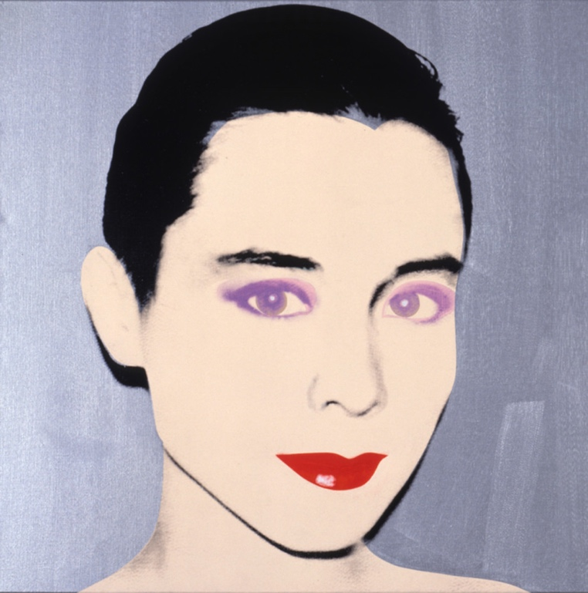

Overview
Students apply an easy collage process to alter their self-portraits using photographic images. Using Andy Warhol’s photographic silkscreen portraits, students explore portraiture and why artists are paid to create portraits.

Grade levels
- Elementary school
- Middle school
- High school

Subjects
- Arts
- Art history
- Social studies and history

Pennsylvania Standards for the Arts and Humanities
- 9.1.3.E - Demonstrate the ability to define objects, express emotions, illustrate an action or relate an experience through creation of works in the arts.
- 9.1.5.E - Know and demonstrate how arts can communicate experiences, stories or emotions through the production of works in the arts.
- 9.2.3.A - Explain the historical, cultural and social context of an individual work in the arts.
- 9.2.5.A - Explain the historical, cultural and social context of an individual work in the arts.
- 9.1.8.E - Communicate a unifying theme or point of view through the production of works in the arts.
- 9.1.12.E - Delineate a unifying theme through the production of a work of art that reflects skills in media processes and techniques.
- 9.2.8.A - Explain the historical, cultural and social context of an individual work in the arts.
- 9.2.12.A - Explain the historical, cultural and social context of an individual work in the arts.

Objectives
- Students identify formal aspects of portraiture.
- Students discuss the historical importance of portraits.
- Students assess the importance of portraiture in culture.
- Students compose portraits based on personality traits.

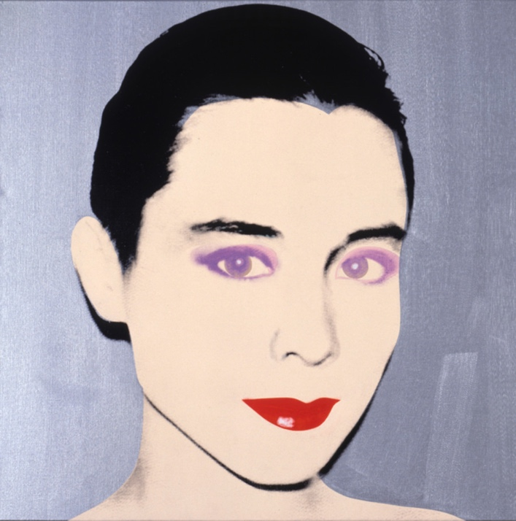

Andy Warhol, Tina Chow, 1985
The Andy Warhol Museum, Pittsburgh; Founding Collection, Contribution The Andy Warhol Foundation for the Visual Arts, Inc.
© The Andy Warhol Foundation for the Visual Arts, Inc.
1998.1.521

About the Art
Warhol started painting commissioned portraits in the early 1960s. These works developed into a significant aspect of his career and were a main source of his income in the 1970s. Many of his subjects were well known in international social circles, the art world, and the entertainment industry at the time.

Warhol began each commissioned portrait with a photo shoot using a Polaroid camera. The Polaroid afforded a very high contrast image that Warhol enlarged and transferred onto a silkscreen. Each portrait was “under-painted” first. Warhol traced simple outlines of the photographic image onto the canvas and painted in blocks of color. Some portraits were painted in slick, hard-edge styles, whereas others had solid fields of color or more gestural brushwork. Once this initial painted layer was dry, Warhol printed the photographic silkscreen image on top.

Points of View
“I think eventually people competed to be portrayed by Warhol because that appeared to give them instant immortality, of the sort usually enjoyed only by the greatest of stars or the most celebrated products, as if they were also part of the common consciousness of the time.”
Arthur C. Danto, The Nation, April 3, 1989

“If there were a portrait commission, we’d have a lunch. It was fun and helped to relax people who were nervous about having their portrait done . . . You never knew who was going to be at lunch. You could have a pop star, if it was somebody very famous, we wouldn’t say that they were coming, we would tone down the lunch. I heard later that people were a little intimidated about coming to lunch . . . We had impromptu things happen, like when Georgia O’Keeffe came to get her portrait, I was videotaping Paloma Picasso and John Richardson, so by chance I also taped Georgia O’Keeffe and Paloma talking about Paloma’s father. Once I was taping a lunch, and Rupert brought John Lennon in while Andy was photographing Liza Minelli. Not every day at 860 was exciting, but you had many times where great people came in that you wouldn’t normally have a chance to really talk to. Andy was the whole reason for it being such a center of energy.”
Vincent Fremont, One Stop Warhol Shop, 2000

Discussion Questions
- Compare and contrast the formal aspects of Warhol’s portraits (e.g., his use of color and shape, each artwork’s overall balance and unity, and the sitter’s pose).
- Are portraits important to us today? Why or why not?
- Why have artists painted portraits throughout the ages?
- If you could make a portrait of anyone in the world, who would it be? Why?

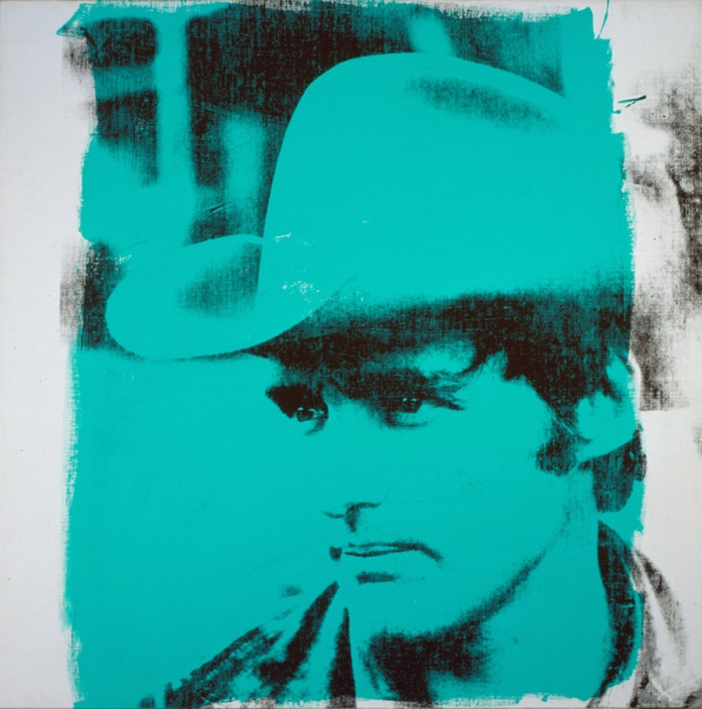

Andy Warhol, Dennis Hopper, 1971
The Andy Warhol Museum, Pittsburgh; Founding Collection, Contribution The Andy Warhol Foundation for the Visual Arts, Inc.
© The Andy Warhol Foundation for the Visual Arts, Inc.
1998.1.573

Materials
- Photocopier
- Acetates or “transparency film” for toner copiers
- Camera
- Colored background paper
- Clear tape
- Scissors
- Colored markers
- Glue
- Colored construction paper
- Metallic markers
- Foil paper
- Stickers

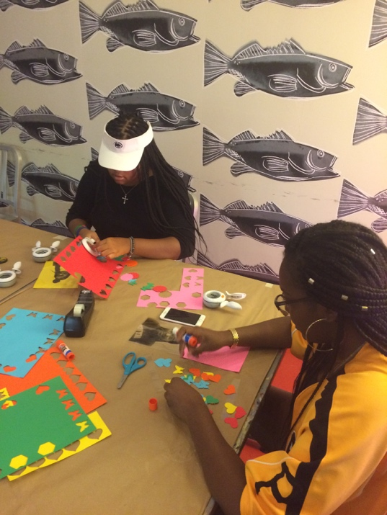

Two students cutting shapes out of construction paper.

Procedure
- Plan your portrait, deciding which personality trait you would like to convey. Try different poses, then take the photographs with a digital camera,phone, or polaroid camera. (This could be done as a selfie or students could work in pairs and photograph one another.)
- Using a photocopier, manipulate the photographs to the desired size. If you reduce the image to 5 1⁄2 by 8 1⁄2″, you can place two images per one piece of 8 1⁄2″ by 11″ acetate. Try to make the image high contrast by using the copy machine’s “lighter” and “darker” functions.
- Copy this image onto photocopy acetate. (Acetate can be ordered through most ofﬁce supply stores.)
- Make two to four acetates of each portrait so you can experiment with color and shape.
- Choose colored background papers of the same size and hinge the acetate to the background paper using clear tape. To make the hinge, place the tape on one edge of the acetate, and then fold it over to stick on the backside of the background paper. Once this is done, your two papers should open like a book.
- Now you are ready to “under-paint” your portrait. Warhol would paint on the canvas first, and then print the photographic silkscreen image on top. For this project, the acetate acts as the final printed layer. The image on the acetate has certain see–through areas; whatever is underneath those areas is visible. Using cut or torn paper, create a collage-type pattern on the background paper so the pattern colors show through the acetate.
- Colored foil paper, stamps, and colored markers can also be used for the under-painting. Metallic or permanent markers can be used to draw on top of the acetate surface.
- Create variation among the portraits by changing elements such as color and paper edges (e.g. ripped/torn edges and cut/smooth edges), adding linear elements using markers, and working with the background areas as well as the subject areas.

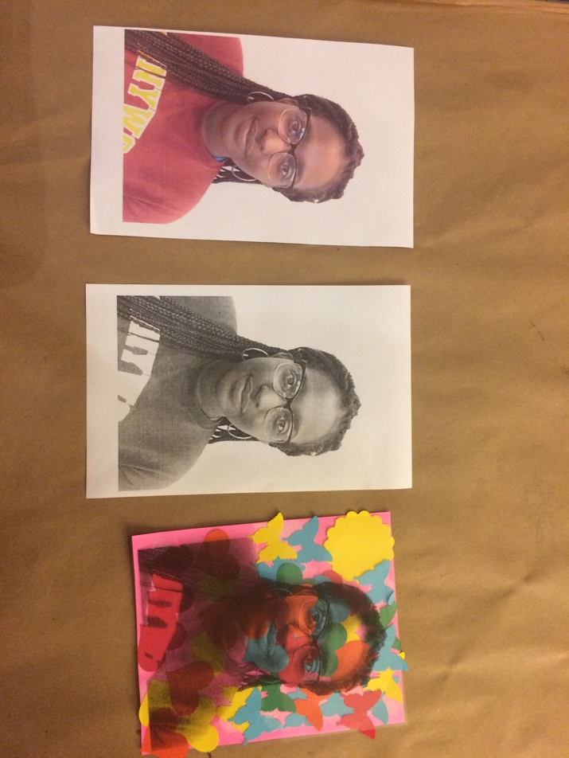

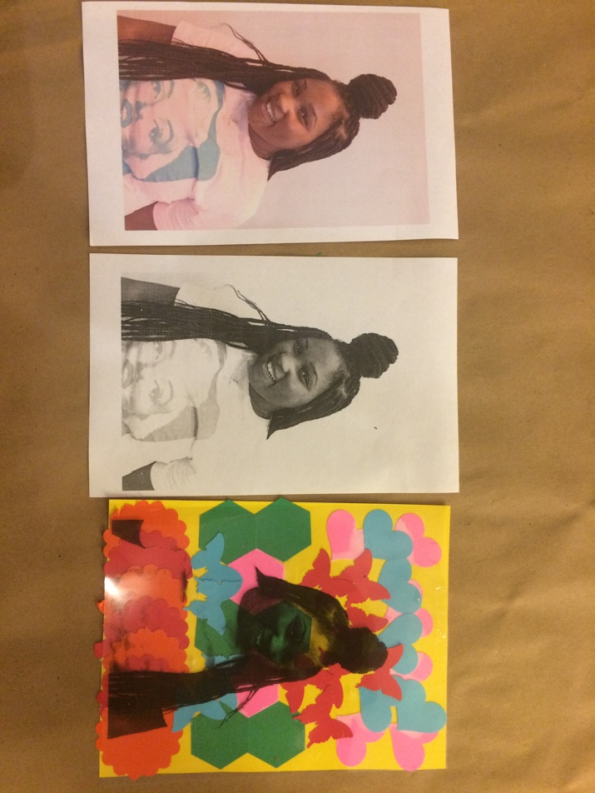

Wrap-up
In a class critique, students present their artwork and answer the following questions:
- What personality trait were you trying to convey in your portrait?
- Why did you choose certain colors and compositional elements?

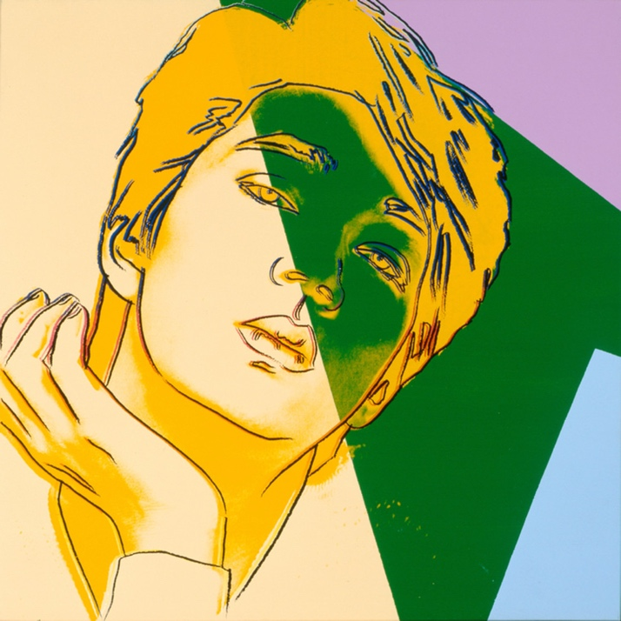

Andy Warhol, Ryuichi Sakamoto, 1983
The Andy Warhol Museum, Pittsburgh; Founding Collection, Contribution The Andy Warhol Foundation for the Visual Arts, Inc.
© The Andy Warhol Foundation for the Visual Arts, Inc.
1998.1.644

Assessment
The following assessments can be used for this lesson using the downloadable assessment rubric.
- Aesthetics 2
- Aesthetics 3
- Creative process 3
- Creative process 4
- Creative process 5
- Critical thinking 1
- Critical thinking 2

