Death and Disasters: Appropriating and Manipulating News Imagery

© The Andy Warhol Museum, one of the four Carnegie Museums of Pittsburgh. All rights reserved.
You may view and download the materials posted in this site for personal, informational, educational and non-commercial use only. The contents of this site may not be reproduced in any form beyond its original intent without the permission of The Andy Warhol Museum. except where noted, ownership of all material is The Andy Warhol Museum, Pittsburgh; Founding Collection, Contribution The Andy Warhol Foundation for the Visual Arts, Inc.

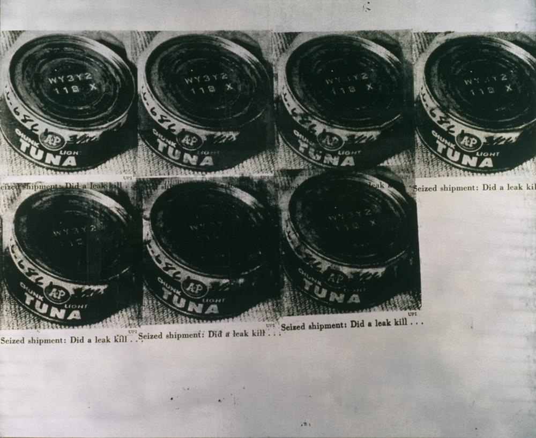

Overview
Students look through contemporary newspapers to critically examine the use of photojournalism to report the news or to tell a story. Students create their own interpretation and story using Andy Warhol’s processes of appropriation, cropping, and repositioning.

Grade Levels
- Middle school
- High school

Subjects
- Arts
- English and language arts
- Social studies and history

Pennsylvania Standards for the Arts and Humanities
- 9.2.8.E - Analyze how historical events and culture impact forms, techniques and purposes of works in the arts (e.g., Gilbert and Sullivan operettas).
- 9.2.12.E - Analyze how historical events and culture impact forms, techniques and purposes of works in the arts (e.g., Gilbert and Sullivan operettas)

Objectives
- Students interpret visual data from art and source materials.
- Students differentiate between journalism and art.
- Students predict how the meaning of an image changes through journalistic and artistic editing.
- Students edit visual information to convey new meanings.

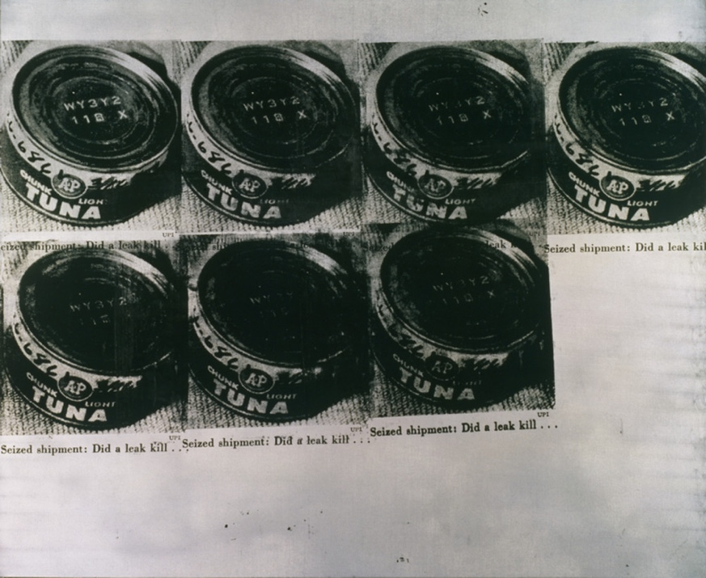

Andy Warhol, Tunafish Disaster, 1963
The Andy Warhol Museum, Pittsburgh; Founding Collection, Contribution The Andy Warhol Foundation for the Visual Arts, Inc.
© The Andy Warhol Foundation for the Visual Arts, Inc.
1998.1.17

About the Art
Warhol loved all forms of daily media and collected various newspapers, magazines, and supermarket tabloids. He recognized the power of mass-circulated media images in American culture and appropriated these as source material for his artwork. To create this version of Tunafish Disaster, Warhol used a page from Newsweek dated April 1, 1963, featuring a story about a can of contaminated tuna that killed two housewives in a suburb of Detroit. He repeated the image of the tuna can with its cut-off caption seven times on a silver ground. In his Death and Disaster series, Warhol explored the impact of cropped images taken out of a journalistic framework and placed repeatedly into the context of art. Some of the photographs that Warhol chose as source images for this series depict horrific scenes, such as race riots, car crashes, suicides, and nuclear explosions. Others focus on a narrative that may not be obvious but is symbolic of death and disaster nonetheless, such as the Electric Chair and Jackie series. In all of these works, Warhol used the repetition of images to mirror the repetition evident in society through media and technology.

Points of View
“In 1963, while Warhol was working on his Death and Disaster paintings, Artnews published an interview between Gene Swenson and the artist.
G.S. When did you start with the ‘Death’ pictures?
A.W. I guess it was the big plane crash picture, the front page of the newspaper: 129 Die. I was also painting the Marilyns. I realized that everything I was doing must have been Death. It was Christmas or Labor Day—a holiday—and every time you turned on the radio they said something like ‘4 million are going to die.’ That started it. But when you see a gruesome picture over and over again, it really doesn’t have any effect.”
Andy Warhol in an interview with Gene Swenson, Artnews, 1963

“Warhol’s art [Death and Disasters] will convey the range, power and empathy underlying his transformation of these commonplace catastrophes. Finally, one can sense in this art an underlying human compassion that transcends Warhol’s public effect of studied neutrality.”
Walter Hopps, foreword to Andy Warhol: Death and Disasters, The Menil Collection (Houston: Houston Fine Art Press, 1988), p. 9.

“Warhol’s repetitions of car crashes, suicides and electric chairs are not like the repetition of similar and yet different terrible scenes day in and day out in the tabloids. These paintings mute what is present in the single front page each day, and emphasize what is present persistently day after day in slightly different variations. Looking at the papers, we do not consciously make the connection between today’s, yesterday’s, and tomorrow’s ‘repetitions’ which are not repetitions.”
Gene Swanson, Artnews, 1963

Discussion Questions
- What do you think is conveyed in Tunafish Disaster?
- How do journalists manipulate images by cutting and cropping out information in order to suit their story? (Use examples from tabloids, magazines, the Internet, etc.)
- What is the difference between journalism and art?
- How does meaning change in these images when they are used in Warhol’s art?
- Do you think it is okay for artists to work from other people’s photographs? Why or why not?
- In the current age of digital media, photoshop, and “fake news,” are photographs still viewed as factual or the source of truth?

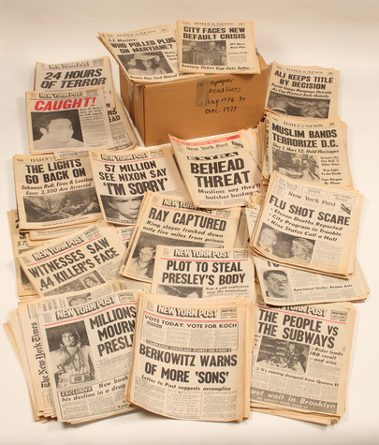

Andy Warhol, Time Capsule 1975-1977; Bulk: 1976-1977
The Andy Warhol Museum, Pittsburgh; Founding Collection, Contribution The Andy Warhol Foundation for the Visual Arts, Inc.
TC170

Materials
- Image of Tunafish Disaster
- Erasers
- Pencils
- Pens
- Scissors
- Current newspapers/news journals
- Glue sticks
- Handout: Newspaper Activity

Vocabulary
- Appropriation: In the visual arts, the term “appropriation” is often used to refer to the use of borrowed elements to create a new work, such as images, forms, or styles from art history, popular culture, and non-art contexts.
- Manipulation: The modiﬁcation of images, including cutting and pasting, tonal adjustments, and cropping, using manual processes or image editing software.

Procedure
- Explain and discuss the vocabulary terms.
- Using Warhol’s method of appropriation, look through current newspapers/news journals to ﬁnd headlines and images you ﬁnd interesting.
- Cut or crop your image, editing out any information you don’t want.
- Glue your image into the template; choose either a horizontal or vertical layout.
- Use an eraser to lighten areas of the newsprint. Use a pencil to darken or add contrast to areas of the newsprint.
- Answer the questions on the Handout: Newspaper Activity.

Wrap-up
- In small groups, students share their work with peers and explain the choices they made in the creation of their images. Students use a 1–5 rating scale to assess their artworks (1=unacceptable; 2=needs work; 3=mediocre; 4=well done; 5=outstanding).
- Decide as a group if the work was a success. How well did the artist transform the meaning of their image? Did they use Warhol’s processes of appropriation, cropping, and repositioning to successfully convey their intended meaning?

Assessment
The following assessments can be used for this lesson using the downloadable assessment rubric.
- Aesthetics 2
- Communication 1
- Creative process 3
- Creative process 4
- Critical thinking 2
- Historical context 4

Appropriation and Manipulation of News Images Handout
© The Andy Warhol Museum, one of the four Carnegie Museums of Pittsburgh. All rights reserved.
You may view and download the materials posted in this site for personal, informational, educational and non-commercial use only. The contents of this site may not be reproduced in any form beyond its original intent without the permission of The Andy Warhol Museum. except where noted, ownership of all material is The Andy Warhol Museum, Pittsburgh; Founding Collection, Contribution The Andy Warhol Foundation for the Visual Arts, Inc.

Explain:
- Why you chose this photo
- The changes you made to it or would make to it given time and technology (ie, dimensions to enlarge, repetition, color, etc.)
- What you think the image might mean with your alterations
________________________
________________________________________________________________________________________________________________________

Appropriation and Manipulation of News Images Handout
© The Andy Warhol Museum, one of the four Carnegie Museums of Pittsburgh. All rights reserved.
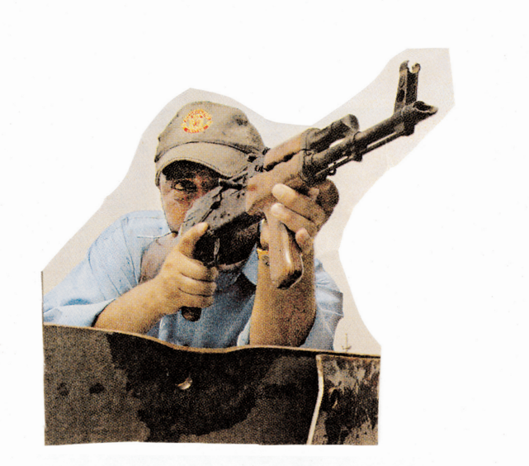
You may view and download the materials posted in this site for personal, informational, educational and non-commercial use only. The contents of this site may not be reproduced in any form beyond its original intent without the permission of The Andy Warhol Museum. except where noted, ownership of all material is The Andy Warhol Museum, Pittsburgh; Founding Collection, Contribution The Andy Warhol Foundation for the Visual Arts, Inc.
Explain:
- Why you chose this photo
- The changes you made to it or would make to it given time and technology (ie, dimensions to enlarge, repetition, color, etc.)
- What you think the image might mean with your alterations

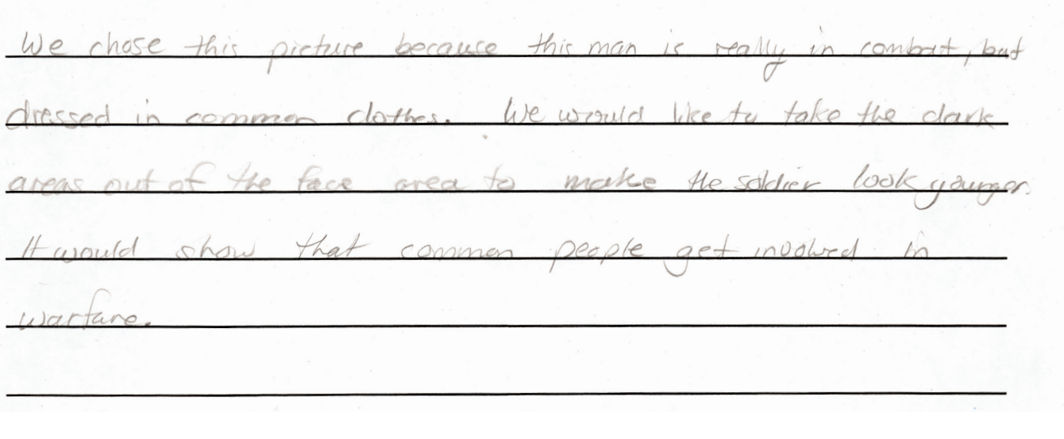

Appropriation and Manipulation of News Images Handout
© The Andy Warhol Museum, one of the four Carnegie Museums of Pittsburgh. All rights reserved.
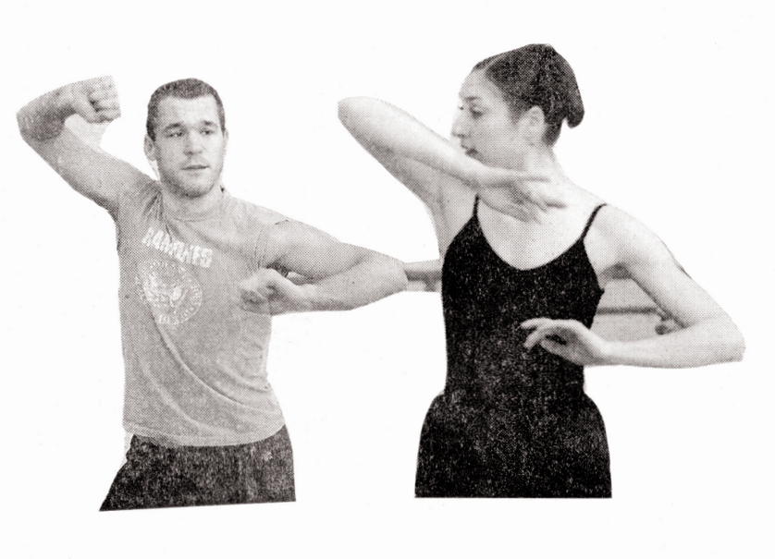
You may view and download the materials posted in this site for personal, informational, educational and non-commercial use only. The contents of this site may not be reproduced in any form beyond its original intent without the permission of The Andy Warhol Museum. except where noted, ownership of all material is The Andy Warhol Museum, Pittsburgh; Founding Collection, Contribution The Andy Warhol Foundation for the Visual Arts, Inc.
Explain:
- Why you chose this photo
- The changes you made to it or would make to it given time and technology (ie, dimensions to enlarge, repetition, color, etc.)
- What you think the image might mean with your alterations

