Diversity of Voice: Views on Guns in America

© The Andy Warhol Museum, one of the four Carnegie Museums of Pittsburgh. All rights reserved.
You may view and download the materials posted in this site for personal, informational, educational and non-commercial use only. The contents of this site may not be reproduced in any form beyond its original intent without the permission of The Andy Warhol Museum. except where noted, ownership of all material is The Andy Warhol Museum, Pittsburgh; Founding Collection, Contribution The Andy Warhol Foundation for the Visual Arts, Inc.

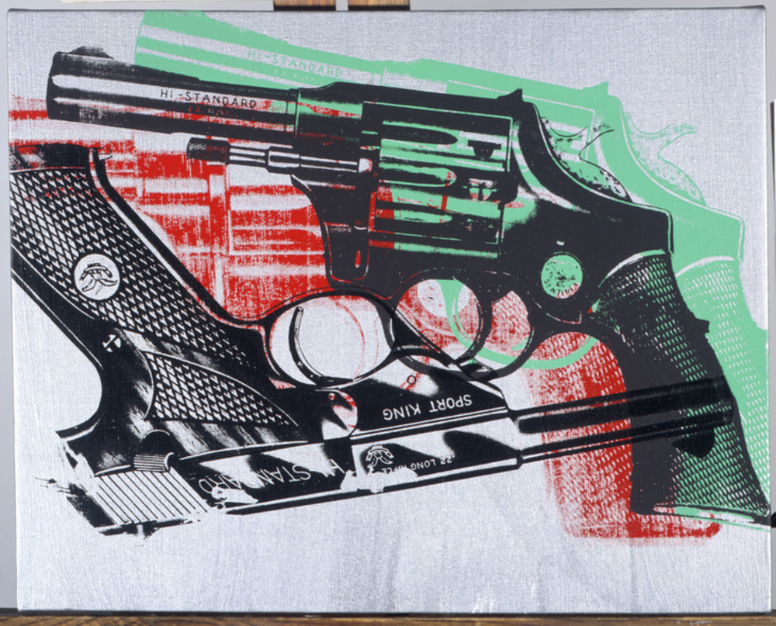

Overview
This lesson uses Andy Warhol’s artwork as a springboard for discussing diverse points of view about gun ownership, gun use, and gun imagery in contemporary culture. Students read texts, ranging from people’s personal viewpoints to the Bill of Rights, in order to debate cultural values.

Grade levels
- High school

Subjects
- Arts
- Art history
- English and language arts
- Social studies and history

Pennsylvania Standards for the Arts and Humanities
- 9.3.8.G - Compare and contrast critical positions or opinions about selected works in the arts and humanities (e.g., critic’s review and comparison of Alvin Ailey’s Revelations to Tchaikovsky’s Swan Lake).
- 9.3.12.G - Analyze works in the arts by referencing the judgments advanced by arts critics as well as one’s own analysis and critique.

Objectives
- Students describe personal and cultural associations with an artwork.
- Students associate meanings with popular symbols.
- Students explain the meaning of historical and cultural documents and sources.
- Students compare and contrast historical and cultural values.
- Students formulate individual points of view about an artwork in writing
- Students assess the role of art in communicating cultural values.

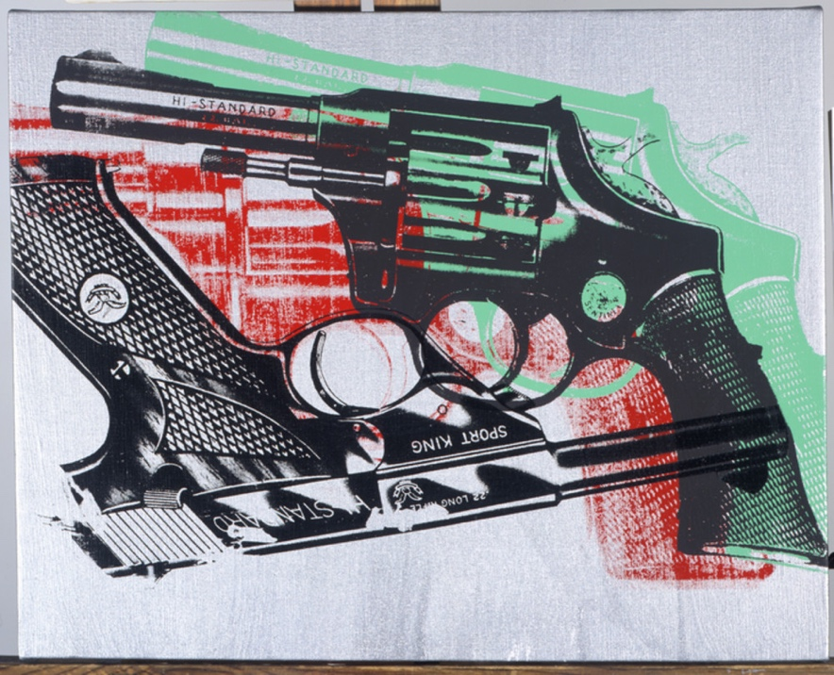

Andy Warhol, Guns, 1981-1982
The Andy Warhol Museum, Pittsburgh; Founding Collection, Contribution The Andy Warhol Foundation for the Visual Arts, Inc.
© The Andy Warhol Foundation for the Visual Arts, Inc.
1998.1.277

About the Art
In the early 1980s Warhol painted a variety of iconic objects, including guns, knives, and crosses. Warhol rejected the idea that his work functioned as social criticism and instead described himself as an American artist who was merely depicting his environment. This description suggests that his paintings of guns be read in the same way as his images of Campbell’s Soup, Marilyn Monroe, or Coca-Cola—images of American icons. Yet, as with many of Warhol’s statements and works, there are multiple possible meanings. Gun ownership is popular in America, in part because it gives people a sense of security. Hollywood imagery and video games add to the allure of guns. The gun is also, through its widespread use and availability in America, a tool of real and commonplace violence. This particular gun, a .32 snub-nosed pistol, is similar to the one that Valerie Solanas used in her 1968 assassination attempt on Warhol.

Points of View

“When you hurt another person, you never know how much it pains. Since I was shot, everything is such a dream to me. I don’t know what anything is about. Like, I don’t know whether I’m alive or whether I died. I wasn’t afraid before. And having been dead once, I shouldn’t feel fear. But I am afraid. I don’t understand why.”
Andy Warhol, 1968, quoted by Victor Bockris, Warhol: The Biography, 2009

“What country can preserve its liberties if its rulers are not warned from time to time that their people preserve the spirit of resistance? Let them take arms.”
Thomas Jefferson to William Stephens Smith, November 13,1787, quoted in Saul Padover, Jefferson On Democracy, 2013

“We essentially have two realities, when it comes to guns, in this country. You’ve got the tradition of lawful gun ownership. It is very important for many Americans to be able to hunt, fish, take their kids out, teach them how to shoot. Then you've got the reality of 34 Chicago public school students who get shot down on the streets of Chicago. We can reconcile those two realities by making sure the Second Amendment is respected and that people are able to lawfully own guns, but that we also start cracking down on the kinds of abuses of firearms that we see on the streets.”
Barack Obama, 44th President of the United States, January 15, 2008, Democratic debate in Las Vegas, Nevada

“I stood up in a social studies class—the teacher wanted a discussion—and said I could never kill anyone or condone anyone who did kill anyone. But that I could on some level, understand these kids in Colorado, the killers [reference to school shooting at Columbine High School in Colorado where 12 students were shot by two classmates]. Because day after day, slight after slight, exclusion after exclusion, you can learn how to hate . . . After class I was called to the principal’s ofﬁce and told that I had to agree to undergo ﬁve sessions of counseling or be expelled from school, as I had expressed ‘sympathy’ with the killers in Colorado and the school had to be able to explain itself if I ‘acted out.’ In other words, for speaking freely, and to cover their ass, I was not only branded a weird geek, but a potential killer, that will sure help deal with violence in America.”
Jay in the Southeast, April 26, 1999, news.slashdot.org

Discussion Questions
- What associations do you have when looking at this gun? Make a list of words that come to mind.
- Who do you usually associate with guns? Do these people impact your daily life?
- How many times in one week do you think you see guns on television, in movies, or in other video imagery? Do these images affect you?
- Do you think our culture is obsessed with violence? Why or why not?
- Does this artwork celebrate or critique America’s gun culture? Can it do both? Why or why not?

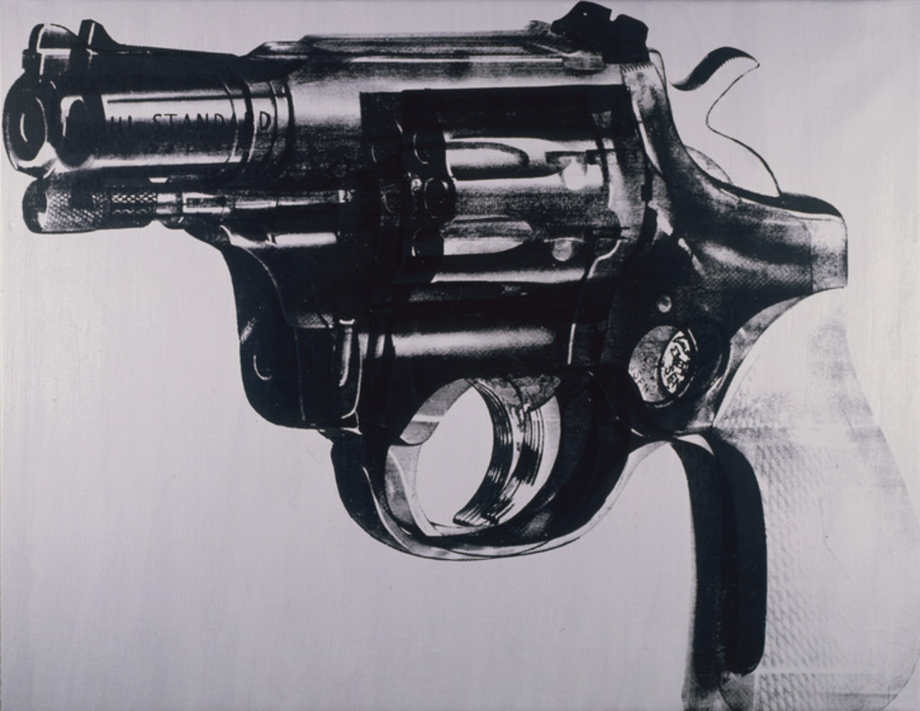

Andy Warhol, Gun, 1981-1982
The Andy Warhol Museum, Pittsburgh; Founding Collection, Contribution The Andy Warhol Foundation for the Visual Arts, Inc.
© The Andy Warhol Foundation for the Visual Arts, Inc.
1998.1.274

Materials
- Paper
- Writing utensil
- Diversity of Voice handout

Procedure
- Students should read and discuss each point of view. The attached handout includes the points of view, supplemental information, and possible discussion questions.
- Students write their own points of view about Warhol’s Gun paintings.

Wrap-up
In small groups, students should discuss the following questions:
- Should art communicate cultural values and/or morals? Why or why not?
- What do you think the role of art is and should be in culture?

After the small group discussions, each group presents a synopsis of its discussion to the class.

Extension
Discuss or write an essay addressing the above questions.

Assessment
The following assessments can be used for this lesson using the downloadable assessment rubric.
- Aesthetics 2
- Communication 1
- Creative process 3
- Creative process 4
- Critical thinking 2
- Historical context 3

Point of View Handout
© The Andy Warhol Museum, one of the four Carnegie Museums of Pittsburgh. All rights reserved.
You may view and download the materials posted in this site for personal, informational, educational and non-commercial use only. The contents of this site may not be reproduced in any form beyond its original intent without the permission of The Andy Warhol Museum. except where noted, ownership of all material is The Andy Warhol Museum, Pittsburgh; Founding Collection, Contribution The Andy Warhol Foundation for the Visual Arts, Inc.

 | Point of View | Additional Information and Discussion Questions
I. | “When you hurt another person, you never know how much it pains. Since I was shot, everything is such a dream to me. I don’t know what anything is about. Like, I don’t know whether I’m alive or whether I died. I wasn’t afraid before. And having been dead once, I shouldn’t feel fear. But I am afraid. I don’t understand why.”  Andy Warhol, 1968, quoted by Victor Bockris, Warhol: The Biography, 2009 | Andy Warhol claimed not to wear the title of social critic in his paintings, but he simultaneously expressed his fears after being shot with a gun.  • Can you read the artist’s emotions or thoughts in this piece? Why or why not?  • Look again at Warhol’s painting, considering all of these points of view. Does his gun painting have a message? What do you think it is?

II. | “What country can preserve its liberties if its rulers are not warned from time to time that their people preserve the spirit of resistance? Let them take arms.”  Thomas Jefferson to William Stephens Smith, November 13,1787, quoted in Saul Padover, Jefferson On Democracy, 2013 | In 1787, the 13 new American states sent delegates to create the Constitution for the united nation. At the height of the debate Thomas Jefferson wrote to James Madison emphasizing the need for statements in the Constitution clarifying individual rights. These ideas  were popular and the first ten amend-ments to the Constitution, now known as the Bill of Rights were drafted by 1791. This document placed primary value on the individual rather than on any government in America. This radical idea included the concept that individuals in a free society must be able to overthrow  any government if it does not represent them. The second amendment to the United States Constitution Article [II.] reads:  "A well-regulated Militia, being necessary to the security of a free State, the right of the people to keep and bear Arms, shall not be infringed."  Identify and discuss what the second amendment to the Constitution means.  What is a militia? A free state?  Do all countries give their citizens the right to “keep and bear arms”? Why not?

III. | “We essentially have two realities, when it comes to guns, in this country. You’ve got the tradition of lawful gun ownership. It is very important for many Americans to be able to hunt, fish, take their kids out, teach them how to shoot. Then you've got the reality of 34 Chicago public school students who get shot down on the streets of Chicago. We can reconcile those two realities by making sure the Second Amendment is respected and that people are able to lawfully own guns, but that we also start cracking down on the kinds of abuses of firearms that we see on the streets.”  Barack Obama, 44th President of the United States, January 15, 2008, Democratic debate in Las Vegas, Nevada | There is a fierce debate over guns in America. As Barack Obama states in this quote from a political debate, an increasingly polar landscape for and against  gun control has put the nation at odds over what is to be done about rising gun violence in America.  Examine the idea of "two realities" How do guns symbolize different things for different people?  Discuss the arguments for and against gun ownership. What can explain the polarity in arguments for or against gun control?  Try to identify your own values; clarify when and why people should be able to own and use guns and when and why they should not.

IV. | “I stood up in a social studies class—the teacher wanted a discussion—and said I could never kill anyone or condone anyone who did kill anyone. But that I could on some level, understand these kids in Colorado, the killers [reference to school shooting at Columbine High School in Colorado where 12 students were shot by two classmates]. Because day after day, slight after slight, exclusion after exclusion, you can learn how to hate . . . After class I was called to the principal’s ofﬁce and told that I had to agree to undergo ﬁve sessions of counseling or be expelled from school, as I had expressed ‘sympathy’ with the killers in Colorado and the school had to be able to explain itself if I ‘acted out.’ In other words, for speaking freely, and to cover their ass, I was not only branded a weird geek, but a potential killer, that will sure help deal with violence in America.”  Jay in the Southeast, April 26, 1999, news.slashdot.org | Jay was cast under suspicion after expressing an understanding of the hard social conditions the two Columbine killers may have been enduring. Research some of the stories around this high school shooting in Littleton, Colorado. Not disputing the fact that the two killers had an arsenal of guns available to them, what  other factors led to this tragedy?  • What are some of the reasons kids get angry?  • What are the biggest problems you see in youth culture affecting kids' ability to cope with their emotions?  • Discuss oppressive social circumstances: teasing, bullying, discrimination, etc.  • From the Columbine shooting in 1999, to Sandy Hook in 2012, to Pulse in Orlando in 2016, mass shootings continue to plague the United States. What is the best way to diminish violence in a culture?  • What responsibility do artists (including musicians, writers, movie directors, etc.) and artworks have in such moral issues?

