Everyday Objects and Transformation

© The Andy Warhol Museum, one of the four Carnegie Museums of Pittsburgh. All rights reserved.
You may view and download the materials posted in this site for personal, informational, educational and non-commercial use only. The contents of this site may not be reproduced in any form beyond its original intent without the permission of The Andy Warhol Museum. except where noted, ownership of all material is The Andy Warhol Museum, Pittsburgh; Founding Collection, Contribution The Andy Warhol Foundation for the Visual Arts, Inc.

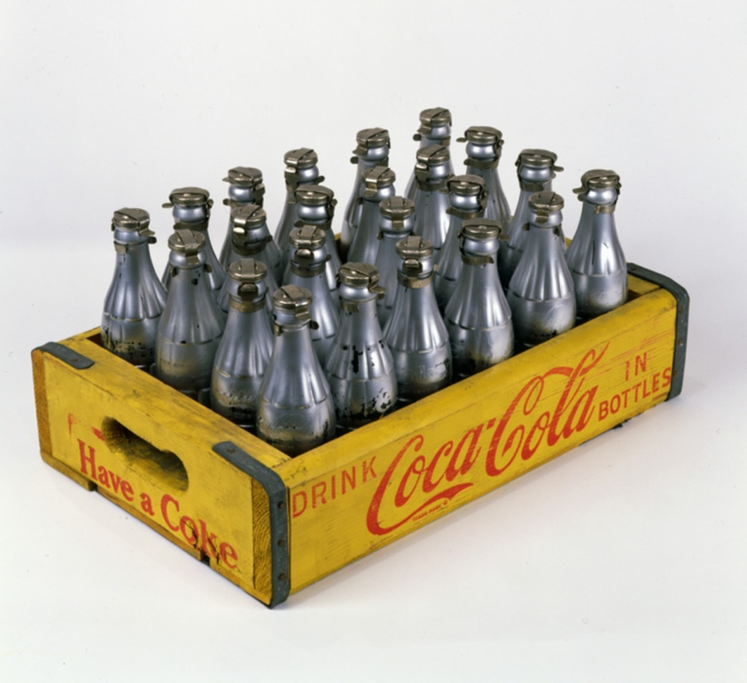

Overview
Just as Andy Warhol transformed everyday objects into works of art, students transform their own commonplace objects into unique sculptures. Through wrapping and covering, each student modifies an object while maintaining its recognizable form. This lesson introduces students to aesthetic and critical response through a “4C” approach to evaluating art.

Grade levels
- Middle school
- High school

Subjects
- Arts

Pennsylvania Standards for the Arts and Humanities
- 9.4.8.B - Compare and contrast informed individual opinions about the meaning of works in the arts to others (e.g., debate philosophical opinions within a listserv or at an artist’s website).
- 9.4.12.A - Evaluate an individual’s philosophical statement on a work in the arts and its relationship to one’s own life based on knowledge and experience.
- 9.4.12.D - Analyze and interpret a philosophical position identified in works in the arts and humanities.

Objectives
- Students discuss the difference between found objects, or “ready-mades,” and the transformation of an everyday object into a work of art.
- Students transform an everyday object into a work of art using a wide variety of materials.
- Students critique artworks using the "4Cs" (context, concept, creativity, and craftsmanship).

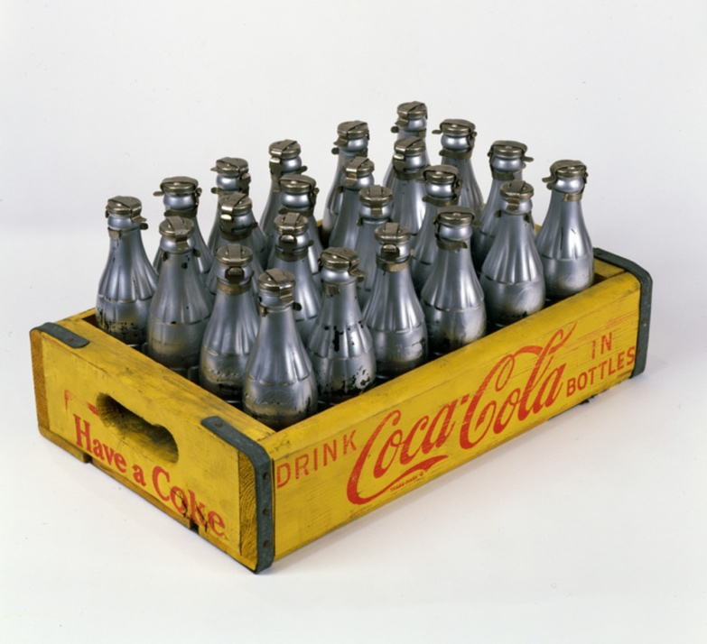

Andy Warhol, You're In, 1967
The Andy Warhol Museum, Pittsburgh; Founding Collection, Contribution The Andy Warhol Foundation for the Visual Arts, Inc.
© The Andy Warhol Foundation for the Visual Arts, Inc.

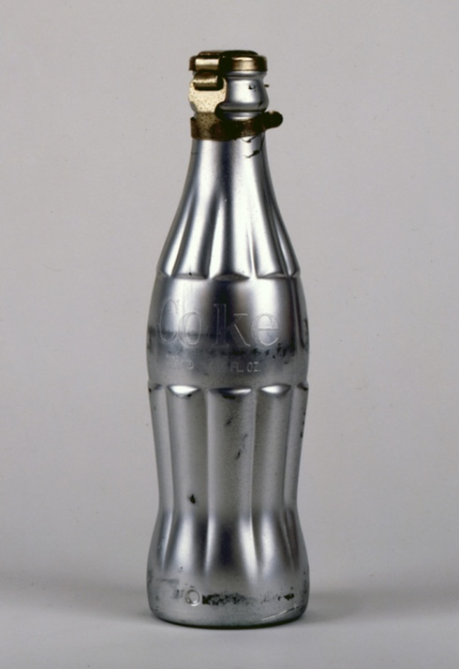

Andy Warhol, You're In, 1967
The Andy Warhol Museum, Pittsburgh; Founding Collection, Contribution The Andy Warhol Foundation for the Visual Arts, Inc.
© The Andy Warhol Foundation for the Visual Arts, Inc.
1998.1.789a-x

About the Art
For Warhol, popular mass-produced food items represented the best of American consumerist society. What could be better than a product, such as Campbell’s Soup or Coca-Cola, which was distributed in vast quantities worldwide and the quality consistent and the price affordable? Although he had made paintings of Coke bottles in the early 1960s, in 1967 the artist turned to a sculptural intervention using actual soda pop bottles (originally conceived by the renowned designer Raymond Loewy), which he coated with silver paint. Three years later, Warhol went a step further by capping 100 silver bottles and ﬁlling them with perfume, which he rakishly labeled “You’re In”/“Eau d’Andy.” Unsurprisingly, the Coca-Cola Company responded with a cease and desist letter.

Points of View
“What’s great about this country is that America started the tradition where the richest consumers buy essentially the same things as the poorest. You can be watching TV and see Coca-Cola, and you can know that the President drinks Coke, Liz Taylor drinks Coke, and just think, you can drink Coke, too. A Coke is a Coke and no amount of money can get you a better Coke than the one the bum on the corner is drinking. All the Cokes are the same and all the Cokes are good. Liz Taylor knows it, the President knows it, the bum knows it, and you know it.”
Andy Warhol, The Philosophy of Andy Warhol (From A to B and Back Again), 1975

Vocabulary
- Ready-made: An everyday manufactured object, as a bottle rack, a snow shovel, a urinal, or a comb, that may, by the creative act of selection and designation by an artist, attain status as a work of art: associated almost exclusively with the aesthetic activities of Marcel Duchamp during the period 1915 to 1917.

Discussion Questions
- What effect does Warhol’s silver paint have on the coke bottle? What does it imply to drink from a silver bottle versus one made of glass? What associations do you make with the color silver?
- If Warhol had painted these bottles white, would they have a different impact on the viewer?
- By painting these bottles silver, Warhol transformed them into a work of art. How does something change from an object to an artwork? Who is involved in this artistic process?
- What is the difference between an everyday object that has been transformed through artistic process and a found object or “ready-made”? Does one have more artistic value? Why or why not?

Student Examples

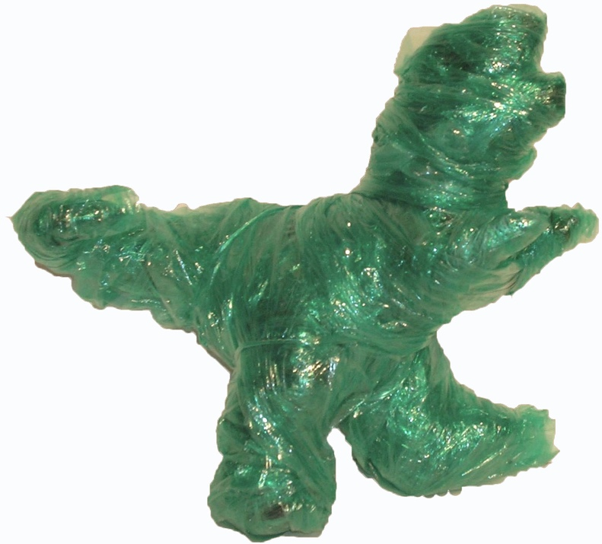

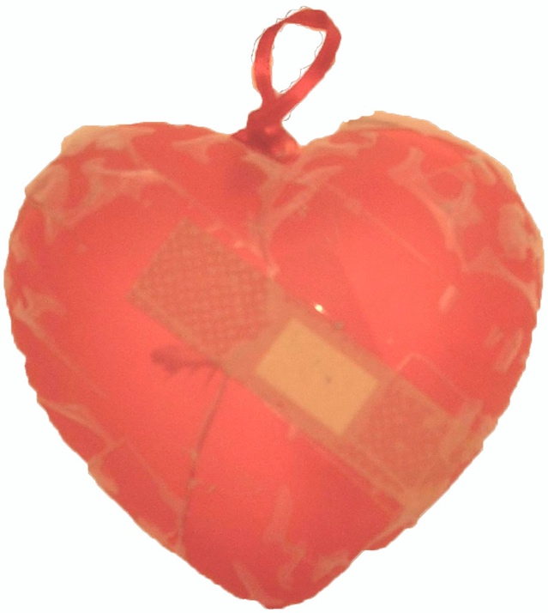

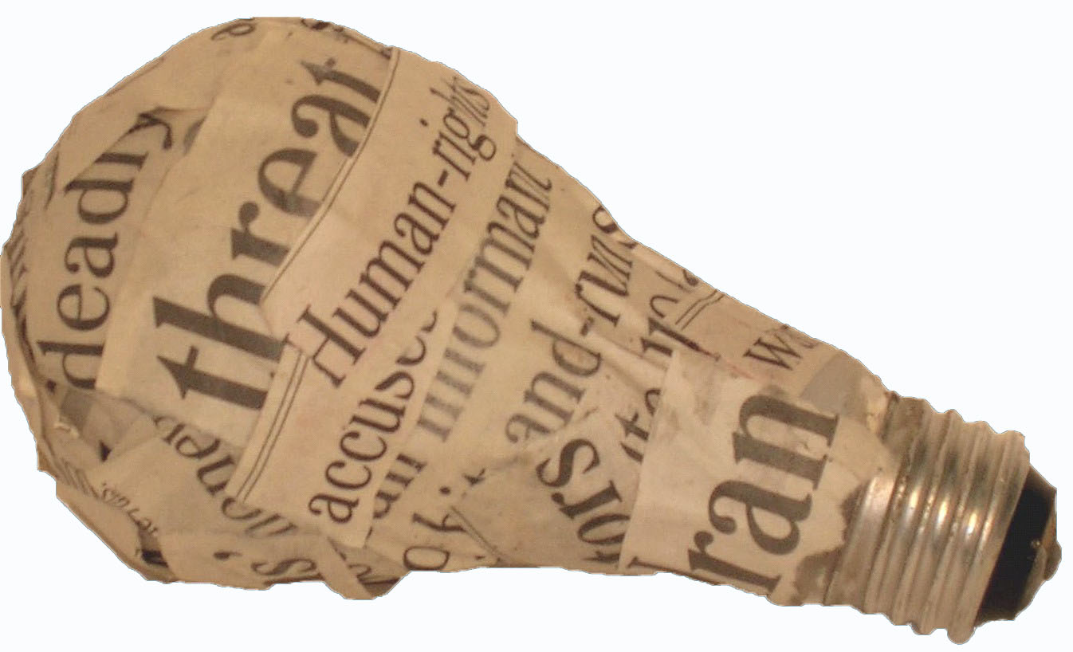

Note
This project works best as an overnight assignment so that students can be responsible for finding materials to match their ideas. If you conduct it in a studio, you may need the following materials.

Materials
- Found objects (e.g. bottles, toys, books, stuffed animals, shoes, silverware, etc.)
- Various materials (e.g. magazines, newspapers, wire, plastic, bandages, hardware, candy, fabric, etc.)
- Adhesives (e.g. glue, hot glue, clear tape, duct tape, paper maché)
- Tools (e.g. pliers, wire snips)
- The 4Cs handout
- Glenn Kaino handout

Procedure
- Use the discussion questions to introduce Warhol’s silver Coke bottles, You’re In.
- Give students Handout: Glenn Kaino and ask them to compare and contrast Warhol’s You’re In with Kaino’s work Graft (Ostrich).
- Have students select an everyday object from home, or have a selection on hand in the classroom. Suggestions include plastic ﬁgurines, tools, bottles, toys, and packaging. It is easiest to work with items that are larger than a two-inch cube, but smaller than a shoe box.
- Instruct students to wrap their object with a covering that creates a dialogue with the object, in a manner that allows the original object’s form to remain evident.
- When completed, set out all wrapped objects in front of the students.
- Give students Handout: The 4Cs. Explain and discuss the deﬁnitions of context, concept, creativity, and craftsmanship. (You may want to state that context and concept are closely related, but note that context serves as the guideline for this assignment.)
- Have students individually choose three objects to evaluate using the 4Cs.
- Discuss the selections and evaluations.

Wrap-up
Aesthetics questions for discussion:
- What types of objects were the most compelling? Why?
- Did the objects with the strongest concepts seem the most interesting?
- Did you ﬁnd objects that seemed weak in concept became more interesting after hearing the artist’s ideas? Or did the artist’s concept for any of your chosen objects weaken your view of them?
- What role did creativity play in your selections?
- Did all of the objects require great craftsmanship to convey their message?
- What would an object with no craftsmanship need to be considered a worthy art object?
- What role do your own personal tastes play in what you ﬁnd strong or weak?

Optional
Critically respond to Warhol’s You're In and Kaino’s Graft (Ostrich) using the 4Cs evaluation system.

Assessment
The following assessments can be used for this lesson using the downloadable assessment rubric.
- Aesthetics 3
- Communication 4
- Creative process 4
- Creative process 5
- Critical thinking 2
- Historical context 1

The 4Cs for Evaluating Art

Created by Megan Bonistalli, Seneca Valley High School, Art Department
© The Andy Warhol Museum, one of the four Carnegie Museums of Pittsburgh. All rights reserved.
You may view and download the materials posted in this site for personal, informational, educational and non-commercial use only. The contents of this site may not be reproduced in any form beyond its original intent without the permission of The Andy Warhol Museum. except where noted, ownership of all material is The Andy Warhol Museum, Pittsburgh; Founding Collection, Contribution The Andy Warhol Foundation for the Visual Arts, Inc.

Context: the set of facts or circumstances that surround a situation or event. Example: “a historical context.” The context could be the parameters of the assignment.
Concept: the message, communicating what something is about.
Creativity: the experience of thinking, reacting, and working in an imaginative and idiosyncratic way, which is characterized by a high degree of innovation and originality, divergent thinking, and risk taking.
Craftsmanship: the application of a skill and dexterity in creating a work of art.

Directions

Choose three of the items on display. Rate them with a scale of 1 = weakest to

5 = strongest on Context, Concept, Creativity, and Craftsmanship. Explain briefly your rating of each object.

- Object:_____________________________ Wrapped in:__________________

Context: 1 2 3 4 5

Concept: 1 2 3 4 5

Creativity: 1 2 3 4 5

Craftsmanship: 1 2 3 4 5
- Object:_____________________________ Wrapped in:__________________

Context: 1 2 3 4 5

Concept: 1 2 3 4 5

Creativity: 1 2 3 4 5

Craftsmanship: 1 2 3 4 5

- Object:_____________________________ Wrapped in:__________________

Context: 1 2 3 4 5

Concept: 1 2 3 4 5

Creativity: 1 2 3 4 5

Craftsmanship: 1 2 3 4 5

Transformation Handout: Kaino
© The Andy Warhol Museum, one of the four Carnegie Museums of Pittsburgh. All rights reserved.
You may view and download the materials posted in this site for personal, informational, educational and non-commercial use only. The contents of this site may not be reproduced in any form beyond its original intent without the permission of The Andy Warhol Museum. except where noted, ownership of all material is The Andy Warhol Museum, Pittsburgh; Founding Collection, Contribution The Andy Warhol Foundation for the Visual Arts, Inc.

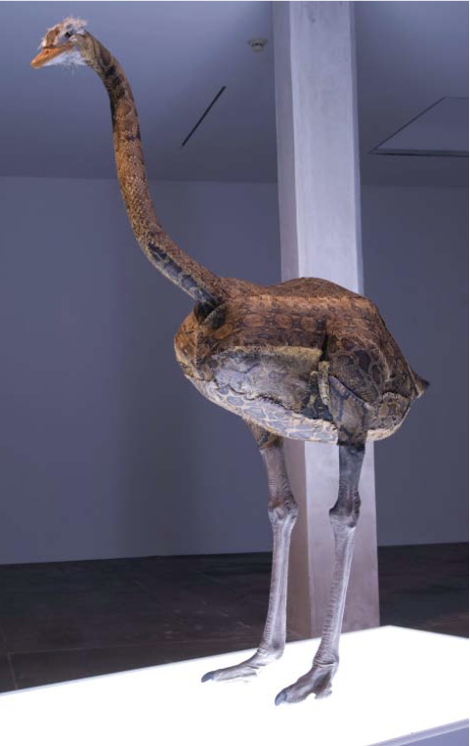
Glenn Kaino, Graft (Ostrich), 2006, Python skin, ostrich feathers, plastic, thread, and paint, Courtesy of the artist and The Project, New York, Installation view at The Andy Warhol Museum, Pittsburgh, Photos by: Maria Bernazzoli.

Glenn Kaino, a Japanese American artist born, raised, and currently working in Los Angeles, has versatile skills as an art maker and director of large media projects. Weaving in and out of fi ne and commercial art realms Kaino has worked as a co-founder of Deep River Gallery in LA and as chief creative offi cer of Napster. He has also taught at UCLA and University of Southern California. Kaino’s work has been shown at the Whitney Biennial at the Whitney Museum of American Art in New York, The Studio Museum in New York, the Museum of Contemporary Art San Diego, The Walker Art Center in Minneapolis, and The Andy Warhol Museum, Pittsburgh.

Transforming commonplace objects and iconic cultural symbols, Kaino (like Andy Warhol) references the subtleties and ironies of popular culture. He often explores issues of cultural identity through both still and kinetic sculptures. In Graft, a proud and ominous ostrich stands atop a light box. The Ostrich is a plastic, life-sized reproduction, but the artist has sewn the bird’s exterior—by hand—using real python snake skin. Kaino gives careful consideration to his materials and process in order to evoke meaning. Possible associations a person might make after viewing Graft range from plastic surgery and second skins, to fashion accessories and trends. In grafting new skin onto this nomadic, head-in-the-sand herbivore Kaino creates a new bird—a likely predator capable of dealing death by its grip. The inner nature of the tightly bound bird is hidden in plain sight. Like taxidermied animals found in hunting lodges and natural history museums around the world, this once-fast hybrid ostrich is now permanently stilled.

Discussion Questions
1. What are the characteristics of an ostrich, a python?
Compare and contrast these descriptions.
2. What choices did the artist make in combining these two animals? What are the results of this combination?
3. What do you think the title Graft implies?
4. What do you think this work means? Does it have cultural implications about appearances, race, or identity? Why
or why not?

Additional Links
Artist’s website http://gkaino.uber.com/
About the exhibition at the Warhol http://www.carnegiemuseums.org/cmag/article.php?id=94
Interview with the artist http://www.discovernikkei.org/forum/en/node/2351

