Hammer & Sickle: Interpreting Symbols and Meaning

© The Andy Warhol Museum, one of the four Carnegie Museums of Pittsburgh. All rights reserved.
You may view and download the materials posted in this site for personal, informational, educational and non-commercial use only. The contents of this site may not be reproduced in any form beyond its original intent without the permission of The Andy Warhol Museum. except where noted, ownership of all material is The Andy Warhol Museum, Pittsburgh; Founding Collection, Contribution The Andy Warhol Foundation for the Visual Arts, Inc.

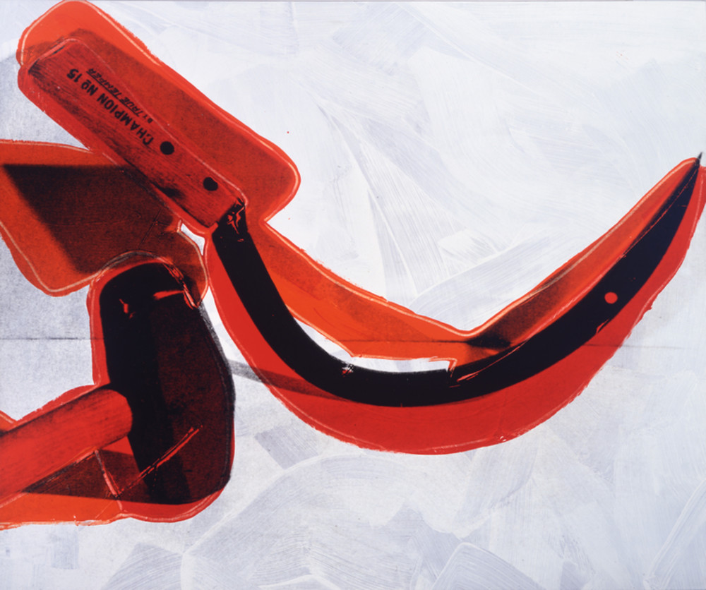

Overview
This lesson features artworks that incorporate powerful symbols: the hammer and sickle and the American ﬂag. Students ﬁrst deconstruct how the symbol is treated in the artwork and then infer meaning by comparing and contrasting the aesthetic qualities of the artworks. This lesson can be extended into a research project through investigating the historic and cultural contexts behind each of the featured works.

Grade levels
- Middle school
- High school

Subjects
- Arts
- Art history
- English and language arts
- Social studies and history

Pennsylvania Standards for the Arts and Humanities
- 9.2.8.E - Analyze how historical events and culture impact forms, techniques and purposes of works in the arts (e.g., Gilbert and Sullivan operettas).
- 9.2.8.J - Identify, explain and analyze historical and cultural differences as they relate to works in the arts (e.g., PLAYS BY Shakespeare, works by Michelangelo, ethnic dance and music).
- 9.2.12.E - Analyze how historical events and culture impact forms, techniques and purposes of works in the arts (e.g., Gilbert and Sullivan operettas)
- 9.2.12.J - Identify, explain and analyze historical and cultural differences as they relate to works in the arts (e.g., PLAYS BY Shakespeare, works by Michelangelo, ethnic dance and music).
- 9.4.8.A - Compare and contrast examples of group and individual philosophical meanings of works in the arts and humanities (e.g., group discussions on musical theatre versus the individual’s concept of musical theatre).
- 9.4.12.B - Describe and analyze the effects that works in the arts have on groups, individuals and the culture (e.g., Orson Welles’ 1938 radio broadcast, War of the Worlds).

Objectives
- Students intuitively respond to works of contemporary art.
- Students connect symbols to meanings.
- Students associate personal feelings and thoughts with artworks.
- Students formulate ideas for new artworks referencing either the hammer and sickle symbol or the American ﬂag.

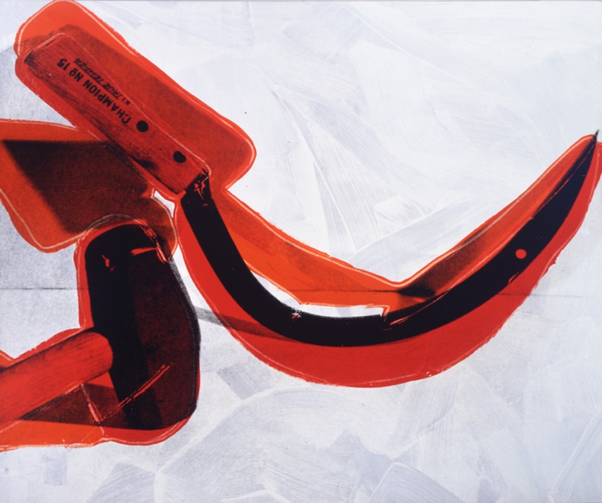

Andy Warhol, Hammer and Sickle, 1976
The Andy Warhol Museum, Pittsburgh; Founding Collection, Contribution The Andy Warhol Foundation for the Visual Arts, Inc. © The Andy Warhol Foundation for the Visual Arts, Inc. 1998.1.186

About the Art
Andy Warhol created his Hammer and Sickle series in 1976 after a trip to Italy where the most common grafﬁti in public spaces was this symbol found on Soviet ﬂags. Under communist control, it signiﬁed the union of industrial and farm workers’ interests. In Italy, a democratic country since the end of WWII, the repeated grafﬁti symbol was to Warhol more pop art than political. After returning to the United States, Warhol asked his studio assistant Ronnie Cutrone to ﬁnd source pictures of this symbol. The reproductions found in books were like the Soviet ﬂag, ﬂat in appearance, and Warhol wanted something different. Cutrone purchased a double-headed hammer and a sickle at a local hardware store and arranged and photographed the tools in many positions. Warhol used the Cutrone photographs for his silkscreened series. In 1977, these works were exhibited under the ambiguous title Still Lifes at the Castelli Gallery in New York City. Warhol disavowed any political ties to his work, though he was aware of the power of symbols and the cultural climate of the Cold War. This war between superpowers, America and the Soviet Union, from the early 1940s through the 1980s was characterized not by actual military combat but by a climate of tension and mutual perceptions of hostility between East and West, communism and capitalism, resulting in the build-up of arms, nuclear weapons, and inﬂuence peddling around the globe.

Points of View
“Little did I know that I would also be included on an FBI list, probably for this little art project of ours. I would ﬁnd myself sneaking along the skyscrapers of the Big Apple and darting into a Red bookstore, looking over my shoulder, I’d ﬁnd a couple of books and brown-bag them and nonchalantly walk out into the broad daylight. I’d return with the books, heart racing, and Andy would say, half-joking, half-serious, “Were you followed by anybody?” I would answer, “I don’t think so, but if I was, I think I’m a little too old to say I’m a college student studying the Russian Revolution.” Then he’d say, “Did you ﬁnd any good ones?” I never really did. They were too ﬂat or too graphic. The answer was to go down to Canal Street, into a hardware store, and buy a real hammer and a real sickle. Then I could shoot them, lit with long menacing shadows. And add the drama that was missing from the ﬂat-stenciled book versions. A third dimension of rough outlines would be added and when the paintings were ﬁnished they always looked like Amusement Park rides to me. Step right up and ride The Hammer and Sickle. Only 25 cents, if you dare. Not for the weak or faint of heart. It always amused me that Andy the ultimate Capitalist, and me, the ultimate Libertarian, could be suspected of Communist activity.”
Warhol’s assistant Ronnie Cutrone, Hammer and Sickle, 2002

“Politics cannot be banished entirely from this image, of course. But even if Mr. Warhol is not exactly in the forefront of the international labor movement he can certainly claim the status of an experienced (he is 50 this year) and industrious workman. In these new paintings he has taken something from sculpture (Calder’s stabiles, Claes Oldenburg’s giant variants of household objects), something from architecture (from the towers of San Gimignano to the World Trade Center), and something of painting (spreading the color as a schoolboy spreads jam on his ﬁrst day at summer camp) and come up with an end‐result that combines imagination with punch.”
John Russell, The New York Times, January 21, 1977

“Most of the people buying the Soviet paraphernalia were Americans and West Europeans. All would be sickened by the thought of wearing a swastika. None objected, however, to wearing the hammer and sickle on a T-shirt or a hat. It was a minor observation, but sometimes, it is through just such minor observations that a cultural mood is best observed. For here, the lesson could not have been clearer: while the symbol of one mass murder ﬁlls us with horror, the symbol of another mass murder makes us laugh.”
Anne Applebaum, Gulag, 2003

“The punk period witnessed a renaissance of tattooing—a practice which visibly asserts our ritualistic :uncivilized” past and in whose pictorial language the skull looms large. Because of a slew of ‘primitive’ and sexual associations, the tattoo is proscribed by traditional western conventions. But tattoos persist, serving to decorate, seduce, shock, scare, to declare nonconformity . . . [Warhol’s] own tattoo-like exhibitionism at the 1977 opening for his “Hammer and Sickle” paintings drew together various structures of power and pleasure: the art world/gallery system brand of capitalism; a communist emblem rendered in paintings titled Still Lifes, in which the shadow seems more real (threatening) association with leather, homosexuality, and gay rights and aesthetics; disco madness as the latest social marketplace and entertainment industry.”
Gary Garrels, Discussions in Contemporary Culture, No. 2, 1989

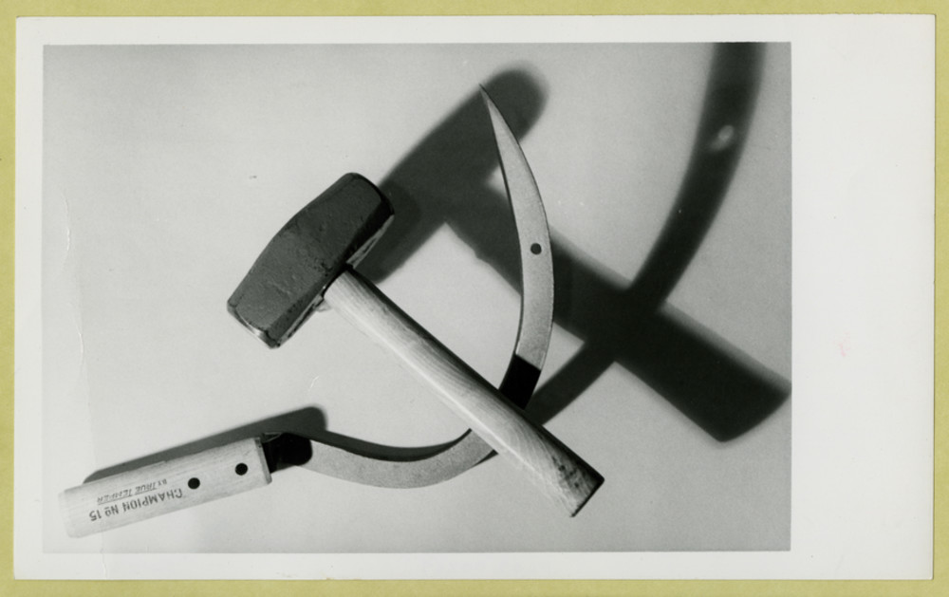

Andy Warhol, Hammer and Sickle, 1976
The Andy Warhol Museum, Pittsburgh; Founding Collection, Contribution The Andy Warhol Foundation for the Visual Arts, Inc. © The Andy Warhol Foundation for the Visual Arts, Inc.
2001.2.613

Discussion Questions
- Warhol exhibited his Hammer and Sickle paintings in an exhibition titled Still Lifes. Does this title ﬁt the subject matter of the artwork? Why or why not?
- What controversy surrounds this symbol?
- Create a list of symbols. Classify them into categories: political, cultural, functional, and religious—create your own categories as needed. Discuss these symbols as a group.
- Discuss the symbols that have power in American and Russian culture.

Materials
- Hammer and Sickle handout
- Pencils

Vocabulary
- Symbol: a shape, sign, motif, or icon used to represent an object, belief, or idea, especially something invisible or intangible (e.g. the lion is a symbol of courage, a heart represents love, the color white represents life and purity.)

Procedure
- Deﬁne symbol.
- Discuss (using the activity handouts).
  - The world is supported by useful symbols, whether they have a function in math, science, technology, or in ﬁelds of communication and cultural expression.
  - Artists often focus on symbols. American artists have taken many national symbols representing both political and cultural values and explored their meaning and impact.
  - Jasper Johns, Barbara Kruger, and Donald Lipski have all worked with the symbolism of the American ﬂag to explore political and cultural messages.
  - Likewise, Leonid Sokov and Alexej Kalima use the communist symbol to vary meaning and impact in artworks.
- Record your personal responses on the activity handouts to either the hammer and sickle artworks or to the American flag artworks.

Wrap-up
As a class, discuss students’ descriptions, associations, and interpretations from their grids. On the back of their handout, have students answer the following questions:
- In your opinion, which representation of the American ﬂag or hammer and sickle is the most powerful? Support your position with reasoning.
- If you were to create an artwork using the hammer and sickle or the American ﬂag, how would you represent it? (Discuss materials, colors, meanings, etc.)

Assessment
The following assessments can be used for this lesson using the downloadable assessment rubric.
- Communication 1
- Communication 2
- Communication 3
- Creative process 1
- Critical thinking 2
- Historical context 3
- Historical context 4

Interpreting Symbols Handout

© The Andy Warhol Museum, one of the four Carnegie Museums of Pittsburgh. All rights reserved.
You may view and download the materials posted in this site for personal, informational, educational and non-commercial use only. The contents of this site may not be reproduced in any form beyond its original intent without the permission of The Andy Warhol Museum. except where noted, ownership of all material is The Andy Warhol Museum, Pittsburgh; Founding Collection, Contribution The Andy Warhol Foundation for the Visual Arts, Inc.

Research the historical and cultural context of each artwork. Use the following information to guide your search. Hypothesize about the intended audience for each artwork. What do you think the artist might be trying to communicate to the audience?

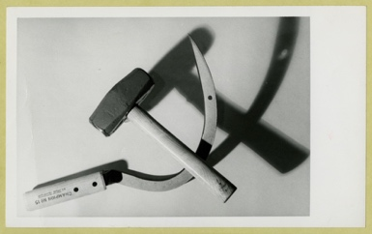  Pop Art, Cold War  Andy Warhol, Hammer and Sickle, 1971 | 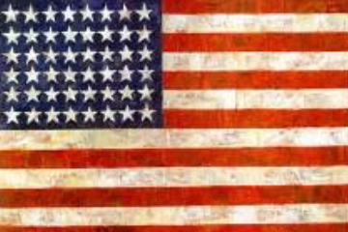  Early Pop Art, Age of Baby Boomers, Youth Revolution  Jasper Johns, Flag, 1954-55
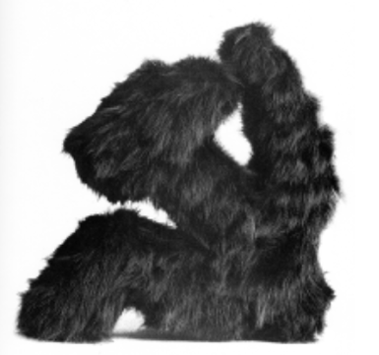  Sotz Art, Soviet Union Withdraws Troops from Afghanistan  Leonid Sokov, Sickle and Hammer, 1988 | 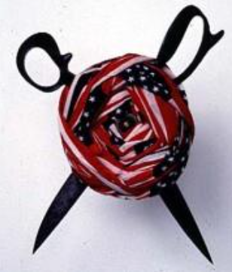  Post-Reagan Years, Cuts in Welfare and Healthcare in the US  Donald Lipski, "No. 10, from Who's Afraid of Red, White, and Blue," 1990
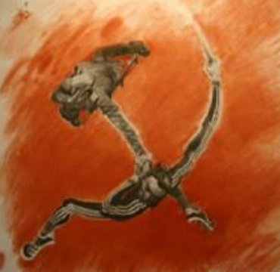  Post-Soviet Russia, Chechen Conflict | 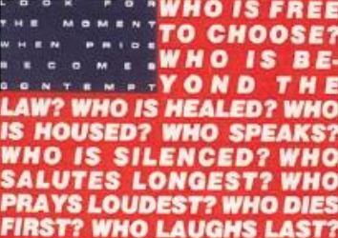  Post 9-11 Climate in the US, Global Protests of War in Iraq  Barbara Kruger, Untitled (Questions) 1991

Work of Art | 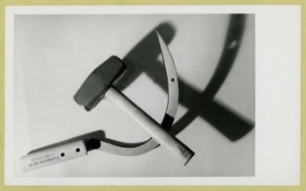  Andy Warhol, Hammer and Sickle, 1971 | 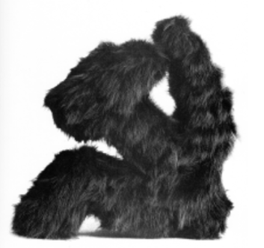  Leonid Sokov, Sickle and Hammer, 1988 | 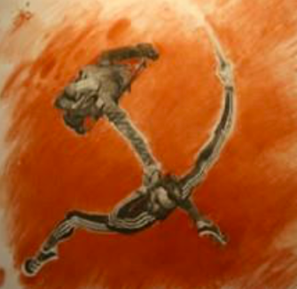
Adjectives:
List characteristics that describe this work.
Associations:
Using the word “like” or “as,” list connections you can make to this artwork.
Ideas:
List the ideas, feelings, and meanings that this artwork conveys.

Work of Art | Jasper Johns, Flag, 1954-55 | 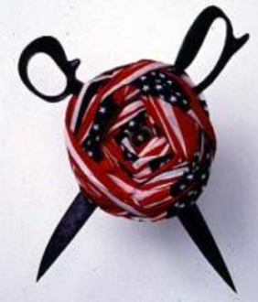  Donald Lipski, "No. 10, from Who's Afraid of Red, White, and Blue," 1990 | Barbara Kruger, Untitled (Questions) 1991
Adjectives:
List characteristics that describe this work.
Associations:
Using the word “like” or “as,” list connections you can make to this artwork.
Ideas:
List the ideas, feelings, and meanings that this artwork conveys.

