Jackie: Flashbulb Memory Activity

© The Andy Warhol Museum, one of the four Carnegie Museums of Pittsburgh. All rights reserved.
You may view and download the materials posted in this site for personal, informational, educational and non-commercial use only. The contents of this site may not be reproduced in any form beyond its original intent without the permission of The Andy Warhol Museum. except where noted, ownership of all material is The Andy Warhol Museum, Pittsburgh; Founding Collection, Contribution The Andy Warhol Foundation for the Visual Arts, Inc.

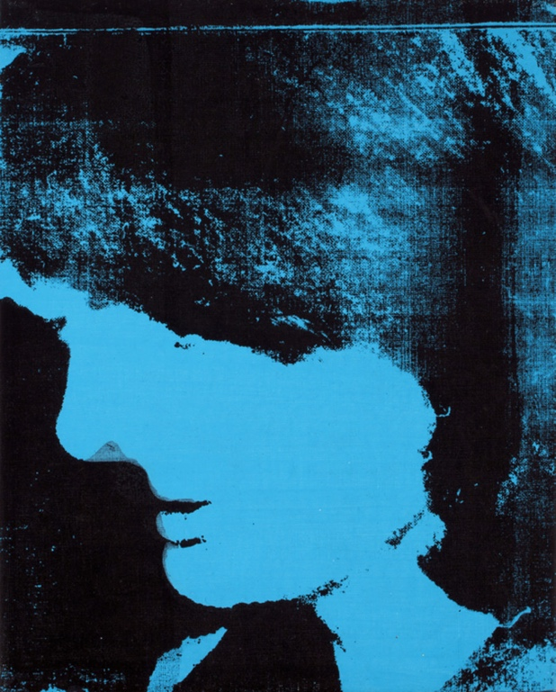

Overview
This lesson explores the phenomena of “flashbulb memory” and the ability of powerful images to bring back personal recollections. Students are introduced to the historical context behind Andy Warhol’s portraits of Jacqueline Kennedy and are able to make comparisons and to write about their own memories of events.

Grade levels
- Middle school
- High school

Subjects
- Arts
- English and language arts
- Social studies and history

Pennsylvania Standards for the Arts and Humanities
- 9.1.5.E - Know and demonstrate how arts can communicate experiences, stories or emotions through the production of works in the arts.

Objectives
- Students infer emotions from visual clues.
- Students differentiate between flashbulb memory and collective memory.
- Students discuss and share responses.
- Students examine cause and effect.
- Students analyze the cause and effect of images on memory.

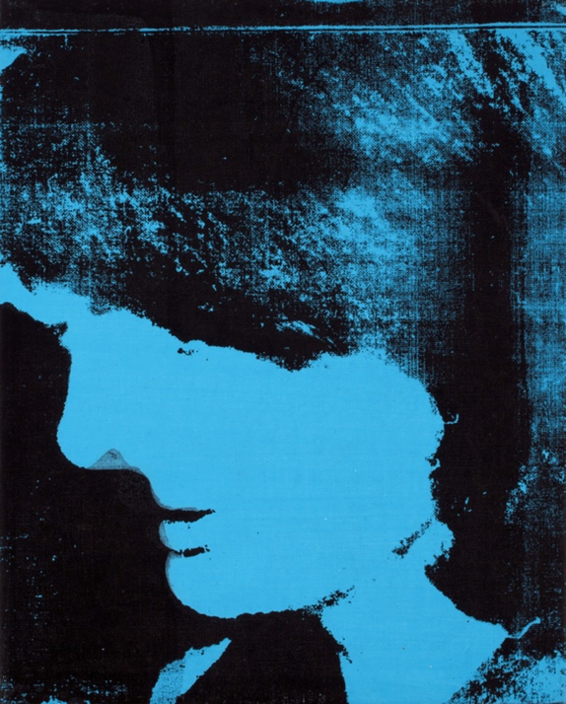

Andy Warhol, Jackie, 1964
The Andy Warhol Museum, Pittsburgh; Founding Collection, Contribution The Andy Warhol Foundation for the Visual Arts, Inc.
© The Andy Warhol Foundation for the Visual Arts, Inc.
1998.1.84

About the Art
America experienced change throughout the early 1960s, from the civil rights movement to space exploration. John F. Kennedy’s short presidency from 1961 until his shocking death by assassination on November 22, 1963, set the tone for the remainder of the decade. The youngest president ever elected in the United States, JFK and his wife, Jackie, quickly became American icons, not just for JFK’s progressive policies, but also for their youth, glamour, and style.
Deeply affected by JFK’s assassination, Warhol began a large portrait series of his widow, Jackie. Based on images from magazines and newspapers, these portraits were shown individually and in groups. Warhol’s isolation and repetition of Jackie’s image suggest both the solitary and collective experience of the widow and the nation witnessing the tragedy. Commentators have remarked that television became a unifying force during this time as people obsessively watched the events unfold in Dallas and at the funeral throughout the following week. Warhol’s multiple images offer the viewer an obsessive reenactment of this event in American history. Even later in his life Warhol was amazed at the power Jackie’s image held as a reminder of the assassination: “As we walked through the galleries every person recognized Jackie. They didn’t come too close. They stopped for a minute, looked, and whispered. You could hear her name in the air: ‘Jackie. Jackie.’ It’s a very strange feeling. There is so much awe and respect for her. Being with her is like walking with a saint.” ( Andy Warhol’s Exposures 1980)

Points of View
“When President Kennedy was shot that fall, I heard the news over the radio while I was alone painting in my studio.... I’d been thrilled having Kennedy as president; he was handsome, young, smart—but it didn’t bother me that much that he was dead. What bothered me was the way the television and radio were programming everybody to feel so sad.... It seemed like no matter how hard you tried, you couldn’t get away from the thing.”
Andy Warhol, POPism: The Warhol Sixties, 1980

“Well, Kennedy was sort of this savior, this prince, and they called his administration Camelot. And when he died it seemed that he took the dreams—I was 13—the dreams of the future generations were shattered when he was killed.... I’ve never looked at government and politics in quite the same way after that. I no longer think that our elected officials are competent.”
Interview with New York woman, Roy Rosenzweig and David Thelen, The Presence of the Past: Popular Uses of History in American Life, 1998

“Her face is as familiar to me as that of my mother. As a small child I even associated Jacqueline Kennedy with Mom: poised and elegant, with the same thick dark hair, tailored suits, pillbox hats and white gloves. But here, Jackie seems less a maternal object than a religious icon. The thirty-two jewel-colored squares look like a wall of stained glass. Do the images reveal the gracious First Lady or the stunned widow? The photos seem to tell both stories. Do the multiple images enable us to empathize with Jackie, or do they destroy her uniqueness by making her a commodity? If she has become a brand-name product, like Warhol’s Campbell’s Soup Cans and Marilyns, can we ever recover the ‘real’ Jackie? And what are we, as insatiable consumers of gossip about her and the Kennedy family?”
Paula Kane, Point of View Labeling Project, The Andy Warhol Museum, 2001

“Warhol rendered Jackie—celebrity/victim—in his standard grid, repeating images as if they were mug shots, frames of documentary film footage, or a fan’s clippings. Repetition implies mourning: the Dallas scene is a trauma, and mourning takes the form of recycling and recall, a process that unsettles chronology…. Repetition implies commodification: Jackie no longer has control over her own image…. Repetition implies obsession: the Jackie photos are cropped—narrowing the focus onto Jackie alone, myopically isolating her from context…. A narrative emerges, and it is not the story of Jackie’s life or the growth of Jackie’s soul—but the narrative of the image and of our relation to the image.”
Wayne Koestenbaum, Jackie Under My Skin: Interpreting an Icon, 1995

“Collective memory has been defined as ‘an image bequeathed to posterity.’ It is shared memory, and it is important. Historians may question the accuracy of an individual’s memory, but they often rely on collective memory when assessing the meaning of the past. This classification of memory begins as a mixture of both actual experiences and communicated information about experiences. As time goes by the importance of firsthand experience lessens and communicated information becomes dominant.”
Conover Hunt, JFK for a New Generation, 1996

“In the real world, something is happening and no one knows what is going to happen. In the image-world, it has happened, and it will forever happen in that way.”
Susan Sontag, On Photography, 1977

Discussion Questions
- Look at the images. Who is this woman? If you do not know who this is, try to guess.
- For example, is there any evidence that she is famous?
- Warhol cropped this image from larger pictures of events. Speculate what is happening in the background.
- Describe this woman’s emotions. What clues do the paintings give to make you think this?

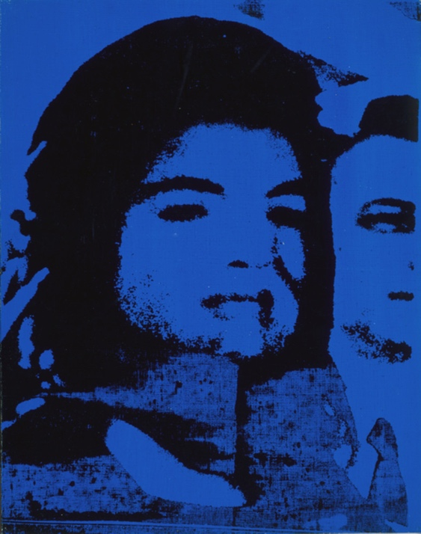

Andy Warhol, Jackie, 1964
The Andy Warhol Museum, Pittsburgh; Founding Collection, Contribution The Andy Warhol Foundation for the Visual Arts, Inc.
© The Andy Warhol Foundation for the Visual Arts, Inc.
1998.1.127

Materials
- PDF of images of Warhol’s Jackie paintings
- Handout: Flashbulb Memory
- Computers with Internet connection and printer
- Photocopier
- Markers
- Scissors
- Colored paper
- Glue or glue sticks
- Tape
- Large pieces of paper or mat board

Procedure
- Introduce flashbulb memory and collective memory.
- Students write about a flashbulb memory of an event or an important moment that had an impact on their lives.
- Students pair with someone and share their responses.
- Students discuss the following questions: What are some events that have affected everyone’s life? What experience have you lived through that you wouldn’t want other people to forget? What are your personal memories of that moment? Make a group list of the events. Pick one that seems to have the broadest impact.
- Students define collective memory as a group using the written responses to support their definition.
- Collect reproductions from the Internet and media representing the news event chosen from Step 4. Students work in small groups to crop, copy, enlarge, or reduce the pictures in preparation for a repetitive collage. Using Warhol’s Jackies as a guide, collage and repeat the images using different color variations and compositions. Mount the finished project on a large piece of paper or mat board. Each group should prepare a short artist statement.

Flashbulb Memory
A flashbulb memory is the recall of very specific images or details surrounding a vivid, rare, or significant personal event.
Vivid and long-lasting, flashbulb memories are extraordinarily complete and durable and often mark the chapters of a life. Sometimes flashbulb memories concern personal events, such as an early morning telephone call that tells of the birth of a baby or the sudden death of a loved one. Others involve news of national importance or significant events such as the assassinations of President Kennedy and Martin Luther King, Jr., or the Challenger space-shuttle explosion and the terrorist attack on the World Trade Center.

In the 1970s, scientists speculated about the nature of this memory phenomenon, hypothesizing that these memories resulted from a special physiological mechanism that was triggered by events that were highly consequential and emotional for an individual. The individual’s resulting memory was unusually salient and often included such intricate personal details as where they were, what they were doing, and what outfit they were wearing.

Later studies suggest that although there is not such a special memory mechanism, almost everyone experiences extremely vivid memories, and some of these “flashbulb” memories are unusually accurate and virtually permanent.

Extension
- Present the following quote by Susan Sontag: “In the real world, something is happening and no one knows what is going to happen. In the image-world, it has happened, and it will forever happen in that way.” Students discuss or write a reflective essay on the quote and Sontag’s use of the term “image-world.”
- Listen to the collection of recorded memories.: https://soundcloud.com/thewarholmuseum/sets/flashbulb-memories-audio-interviews Have students compare and contrast these memories with those they collected during the assignment.

Wrap-up
In a class critique, students read their artist statements and discuss their finished projects, their decision-making processes, and the effect repetition has in each work.

Possible discussion questions:
- Does repetition strengthen or weaken the emotional value of the work?
- In what ways does your artwork reflect collective memory?

Assessment
The following assessments can be used for this lesson using the downloadable assessment rubric.
- Communication 1
- Communication 2
- Critical thinking 1
- Critical thinking 2
- Historical context 1
- Historical context 2
- Historical context 4

Flashbulb Memory Activity
© The Andy Warhol Museum, one of the four Carnegie Museums of Pittsburgh. All rights reserved.
You may view and download the materials posted in this site for personal, informational, educational and non-commercial use only. The contents of this site may not be reproduced in any form beyond its original intent without the permission of The Andy Warhol Museum. except where noted, ownership of all material is The Andy Warhol Museum, Pittsburgh; Founding Collection, Contribution The Andy Warhol Foundation for the Visual Arts, Inc.

1. Look at these images or insert your own.
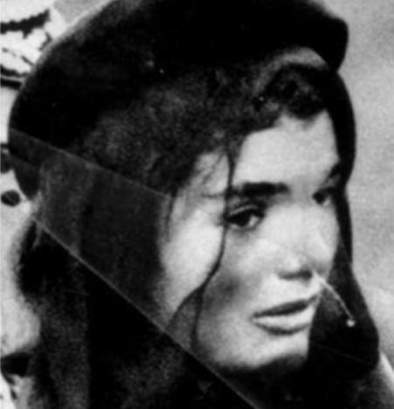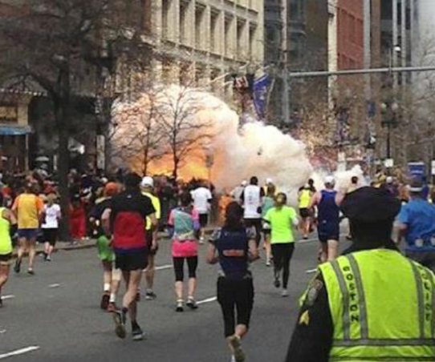
Select a photograph of an event that had a particularly strong impact on you or about which every detail of the memory seems sharp.

2. What do you remember about the event? Write down your memory including as many details as you can about how you experienced it.
________________________________________________________________________

3. How were you impacted then? Does the event still impact your life today? Explain. ________________________________________________

4. What do you think younger generations who did not live through this event should remember or know about it? What is the legacy of this event? ________________________________________________

