Oxidations and Abstraction

© The Andy Warhol Museum, one of the four Carnegie Museums of Pittsburgh. All rights reserved.
You may view and download the materials posted in this site for personal, informational, educational and non-commercial use only. The contents of this site may not be reproduced in any form beyond its original intent without the permission of The Andy Warhol Museum. except where noted, ownership of all material is The Andy Warhol Museum, Pittsburgh; Founding Collection, Contribution The Andy Warhol Foundation for the Visual Arts, Inc.

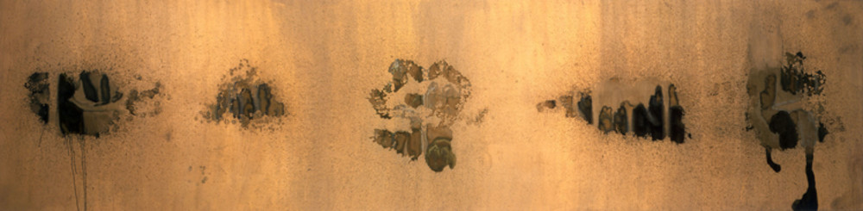

Overview
Using Andy Warhol’s Oxidation Painting, students discuss how he and his collaborators experimented with pattern and color on a metallic background. Students explore how oxidation occurs by using various acids and bases to create their own abstract paintings. Students also brainstorm for where abstractions can be found in nature and discuss how they might have occurred.

Grade levels
- Middle school
- High school

Subjects
- Arts
- Art history
- Science

Pennsylvania Standards for the Arts and Humanities
- 9.1.8.D - Demonstrate knowledge of at least two styles within each art form through performance or exhibition of unique works.
- 9.1.12.B - Recognize, know, use and demonstrate a variety of appropriate arts elements and principles to produce, review and revise original works in the arts.
- 9.3.8.D - Evaluate works in the arts and humanities using a complex vocabulary of critical response.
- 9.3.12.D - Analyze and interpret works in the arts and humanities from different societies using culturally specific vocabulary of critical response.

Objectives
- Students discuss, compare, and contrast Warhol’s pop art works with his abstract paintings from the 1970s and 1980s.
- Students discuss how oxidation occurs, then hypothesize how Warhol created oxidation in his paintings.
- Using photos of abstractions found in nature, students guess what the images depict and how the abstractions might have formed.
- Students use various liquids on copper-based paint to create abstract paintings.
- Students analyze the variables in the process of creating an abstract work of art using chemical experimentation.

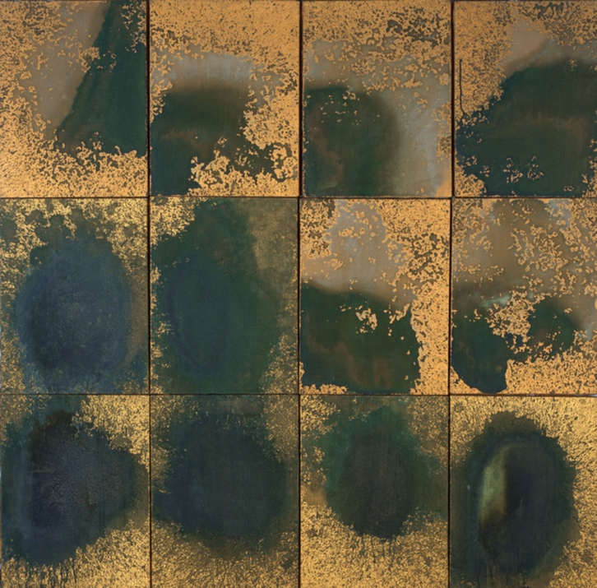

Andy Warhol, Oxidation Painting (in 12 parts), 1978
The Andy Warhol Museum, Pittsburgh; Founding Collection, Contribution The Andy Warhol Foundation for the Visual Arts, Inc.
© The Andy Warhol Foundation for the Visual Arts, Inc.
1998.1.214

About the Art
In the late 1970s and early 1980s, Warhol explored abstraction. While early experiments in the 1950s and repetitive patterns in his 1960s works suggested abstraction, it wasn’t until the late 1970s and 1980s that Warhol created works with no discernable representational imagery. With these paintings, often done in large series that included mural-sized pieces, the artist seemed to dive into the beauty and mood of color and texture in a way he had not done before. Yet Warhol’s embrace of abstraction was never without coy references and play between the real and the abstract. For example, in his 1978–79 Shadows series, Warhol created abstract paintings depicting what is ostensibly a “real” shadow. In December 1977, he began Oxidations, iridescent canvases made up of coppery yellows, oranges, and green. Surprisingly, the only paint the artist used in this painterly work was the metallic gold ground. Warhol invited friends and acquaintances to urinate onto a canvas covered in metallic paint to cause oxidation. The uric acid reacted with the copper, removing components of the pure metal to form mineral salts. Some colors developed immediately while others like blue and green would form later on top of the red or brown copper oxides. Warhol and his collaborators experimented with both pattern and coloration by using a variety of metallic background paints and by varying the maker’s fluid and food intake. Critics have made numerous comparisons between the Oxidation series and Jackson Pollock’s famous drip paintings from the 1940s and early 1950s.

Points of View
“It was just copper paint and you would wonder sometimes why it did turn green and sometimes it didn’t. It would just turn black or something. I don’t know what made it do that.”
Andy Warhol in Mark Francis, Andy Warhol: 1956-86, Mirror of His Time, 1996

“’Andy paid Victor [Hugo] to be the ‘collaborator’ ...He would come to the Factory to urinate on canvases that had already been primed with copper-based paint by Andy.’ [The uric acid would oxidize the metal in the copper ground, causing it to discolor, allowing for patterns to be created according to the ‘movement’ of the ‘painter’.]”
Bob Colacello, After Andy Warhol: Piss & Sex Paintings and Drawings, 2002

Discussion Questions
- Compare and contrast Warhol’s Campbell’s Soup Cans to his Shadow and Oxidation paintings. While some of the differences are obvious, how are they similar?
- What is the difference between realism and abstraction?
- Warhol created beautiful colors and forms through what some consider an offensive process. Do you think artists should be allowed to make art out of any material or process?

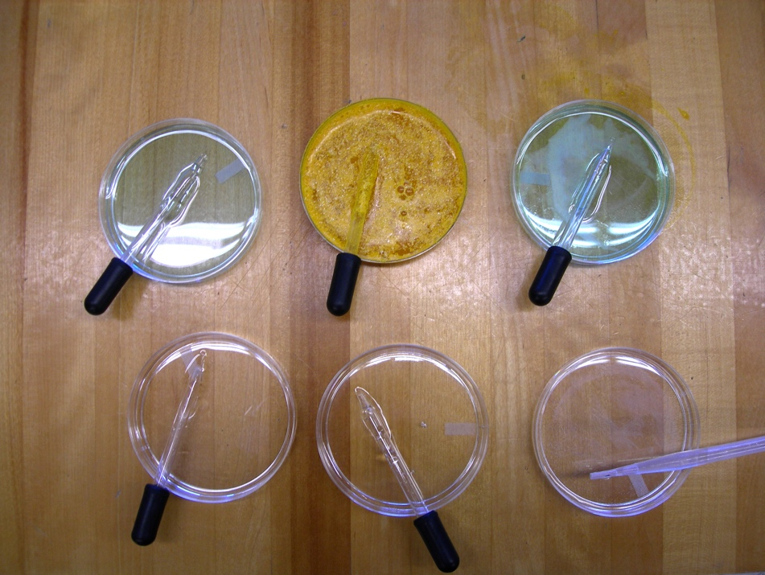

Petri dishes with acids and bases.

Materials
- Canvas squares or heavy white paper
- Modern Masters copper paint (Water-based metallic paints contain real metal particles that tarnish naturally over time and when exposed to the elements.)
- Modern Masters patinas (These aging solutions can be used over the metallic paints. The solutions speed the aging process to create beautiful, authentic black, blue, or green patinas.)
- Petri dishes
- Paint trays
- Eye droppers
- Paintbrushes
- Nature Cards handout
- Acids and Bases handout

Vocabulary
- Oxidation: Any chemical reaction in which a material gives up electrons, as when the material combines with oxygen. Burning is an example of rapid oxidation; rusting is an example of slow oxidation.

Procedure
- Discuss where abstractions are found in nature.
- Print Handout: Nature Cards. Cut individual cards and distribute these to the class. Ask students to guess what the photos are and to describe how they were formed.
- Discuss acids and bases using Handout: Acids and Bases.
- Explain the basic chemical process of oxidation.
- Prepare the painting surface using 6″ by 6″ or 10″ by 10″ stretched canvas or heavy paper; apply two coats of copper paint.
- Set up various petri dishes with both acids and bases (e.g. vinegar, water, patinas) along with eye droppers. Paint trays and paintbrushes can also be used.
- Students should experiment with the acids and bases by dropping liquid onto their copper paintings.
- Ask students to take notes while working and to hypothesize how they think their paintings will turn out. Which liquid do they think will work better than others to oxidize their paintings? Why?
- As the liquid dries, have students note how their paintings change over time.

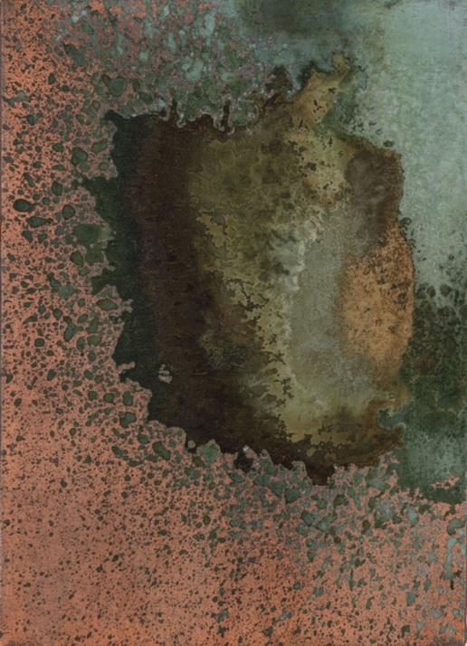

Andy Warhol, Oxidation Painting, 1978
The Andy Warhol Museum, Pittsburgh; Founding Collection, Contribution The Andy Warhol Foundation for the Visual Arts, Inc.
© The Andy Warhol Foundation for the Visual Arts, Inc.
1998.1.220

Wrap-up
Form one large abstract painting using the individual oxidations. Through discussion or writing students should complete the following:
- Review their notes and explain how they used various materials.
- Identify the effects of different acids and bases on the coloration of the metallic ground.
- Evaluate whether or not the grouping of paintings is a successful abstraction. Do they evoke a sense of wonder, feeling, or emotion? Are they beautiful or appealing?
- Explain what they would do differently if they used this process again.

Chemistry Extension
Explore the chemistry behind corrosion. Write the chemical equations for the materials used in each painting.

Assessment
The following assessments can be used for this lesson using the downloadable assessment rubric.
- Communication 4
- Creative process 3
- Creative process 4
- Creative process 5
- Critical thinking 3
- Critical thinking 4

Nature Cards
© The Andy Warhol Museum, one of the four Carnegie Museums of Pittsburgh. All rights reserved.
You may view and download the materials posted in this site for personal, informational, educational and non-commercial use only. The contents of this site may not be reproduced in any form beyond its original intent without the permission of The Andy Warhol Museum. except where noted, ownership of all material is The Andy Warhol Museum, Pittsburgh; Founding Collection, Contribution The Andy Warhol Foundation for the Visual Arts, Inc.

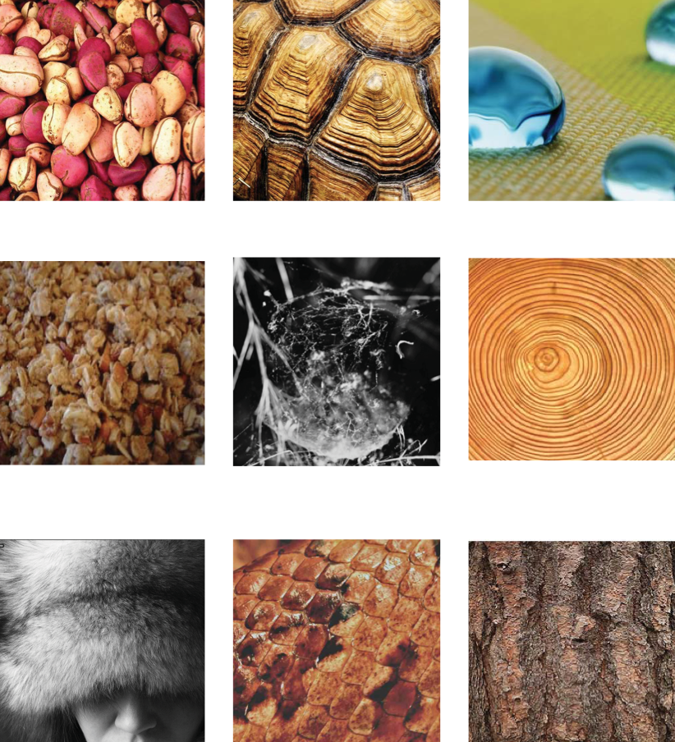

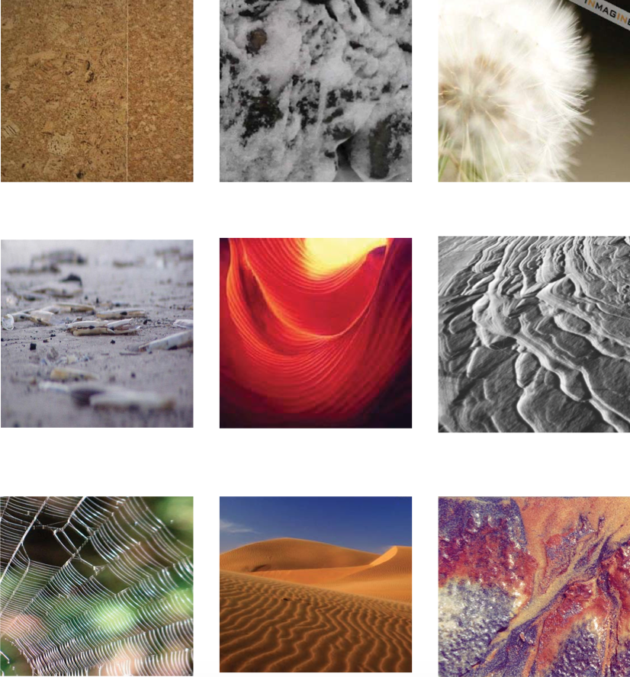

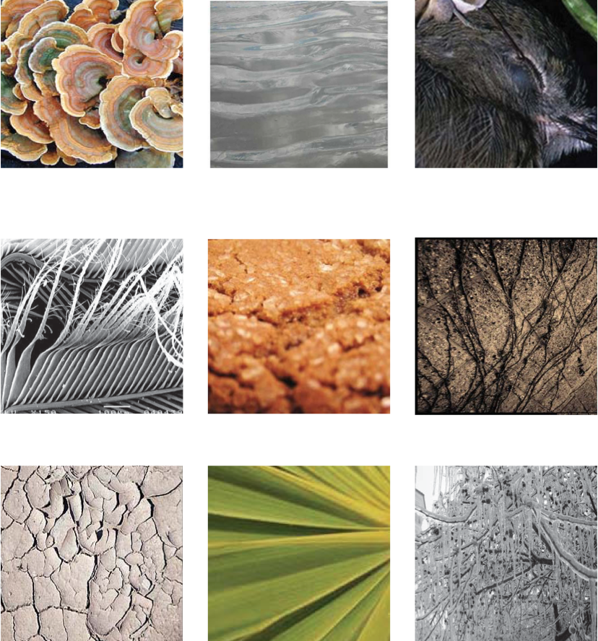

Acids and Bases
© The Andy Warhol Museum, one of the four Carnegie Museums of Pittsburgh. All rights reserved.
You may view and download the materials posted in this site for personal, informational, educational and non-commercial use only. The contents of this site may not be reproduced in any form beyond its original intent without the permission of The Andy Warhol Museum. except where noted, ownership of all material is The Andy Warhol Museum, Pittsburgh; Founding Collection, Contribution The Andy Warhol Foundation for the Visual Arts, Inc.

More information
For online directions and easy explanations, go to this website: http://chem4kids.com/files/react_acidbase.html

Common acids and bases found in everyday items:
Common Acids | pH | Common Bases | pH
Lemons | 2.3 | Human saliva | 6-8
Vinegar | 2.9 | Distilled water | 7
Apples | 3.1 | Eggs | 7.8
Oranges | 3.5 | Seawater | 7.9
Grapes | 4 | Milk of magnesia | 10.5
Sour milk | 4.4 | Ammonia water | 11.6
White bread | 5.5 | Limewater | 12.4
Fresh milk | 6.6 | Caustic soda (Baking) | 14

