Screen Tests

© The Andy Warhol Museum, one of the four Carnegie Museums of Pittsburgh. All rights reserved.
You may view and download the materials posted in this site for personal, informational, educational and non-commercial use only. The contents of this site may not be reproduced in any form beyond its original intent without the permission of The Andy Warhol Museum. except where noted, ownership of all material is The Andy Warhol Museum, Pittsburgh; Founding Collection, Contribution The Andy Warhol Foundation for the Visual Arts, Inc.

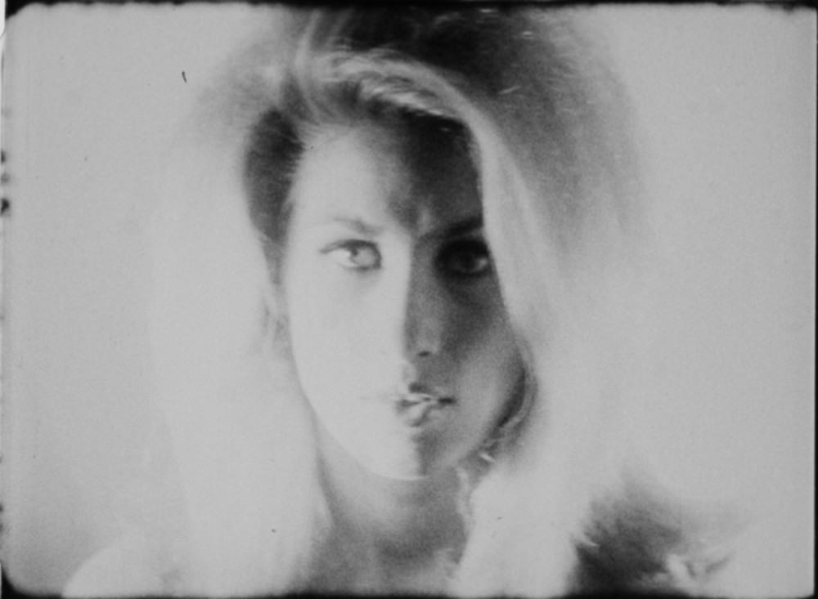

Overview
After viewing and discussing Warhol’s Screen Tests, students develop their own on-screen personality and film one another, using Warhol’s “recipe.” Students compare and contrast Warhol’s Screen Tests to Hollywood screen tests and discuss how “living portraits” can be created using film.

Grade levels
- Middle school
- High school

Subjects
- Arts
- English and language arts

Pennsylvania Standards for the Arts and Humanities
- 9.1.8.K - Incorporate specific uses of traditional and contemporary technologies in furthering knowledge and understanding in the humanities.
- 9.1.12.K - Analyze and evaluate the use of traditional and contemporary technologies in furthering knowledge and understanding in the humanities.

- 9.3.8.D - Evaluate works in the arts and humanities using a complex vocabulary of critical response.
- 9.3.12.B - Determine and apply criteria to a person’s work and works of others in the arts (e.g., use visual scanning techniques to critique the student’s own use of sculptural space in comparison to Julio Gonzales’ use of space in Woman Combing Her Hair).

Objectives
- Students distinguish between Hollywood screen tests and Warhol’s Screen Tests.
- Students explore formal qualities in Warhol’s films.
- Students develop personalities through facial expressions and body language.
- Students produce a video based on Warhol’s “recipe” or artistic formula.
- Students assess screen tests to determine hypothetical roles for individuals.
- Students summarize characteristics of successful screen tests.

Andy Warhol, Screen Test: Jane Holzer [ST141], 1964
The Andy Warhol Museum, Pittsburgh; Founding Collection, Contribution The Andy Warhol Foundation for the Visual Arts, Inc.
© 2015 The Andy Warhol Museum, Pittsburgh, PA, a museum of Carnegie Institute. All rights reserved.
1997.4.113.141

About the Art
Warhol’s Screen Tests are revealing portraits of hundreds of different individuals, filmed between 1963 and 1966. In these short films, Warhol created his own cache of Superstars. Superstars are actors interesting enough to carry a film on their own—not by playing a particular role but simply by being themselves. His subjects included both famous and anonymous visitors to the studio, including poet Allen Ginsberg, actor Dennis Hopper, and artist Salvador Dalí. When asked to pose, subjects were lit and Warhol filmed them with his stationary 16mm Bolex camera on silent, black-and-white, 100-foot rolls of film. Each Screen Test took exactly three minutes to create, lasting as long as the roll of film took to spool through the camera. The standard formula of subject and camera remaining almost motionless for the duration of the film results in a “living portrait.” When Warhol showed the films, he slowed them down slightly, extending their run time to about four minutes each, imparting a dreamy, slow-motion effect to the finished works.
While Warhol’s process was standardized, there are subtle lighting and focus variations in the Screen Tests. Jane Holzer’s is in soft focus and suffused with light, creating an ethereal, hypnotic effect, while Piero Heliczer’s is darker in mood. In addition, there are a number of Screen Tests that diverge from this format entirely, the sitter purposely moving, gesticulating, or using props.

These film portraits, referred to by the Hollywood term of “screen test,” were not created for the purpose of actually testing or auditioning actors. A traditional Hollywood screen test is a method used to judge whether an actor is suitable on film, and beyond that, if he or she is right for a specific character. Usually he or she is given a scene, a script, and instructions to perform in front of a camera. The director then watches the test to make a determination about the actor’s appearance and qualities on film.

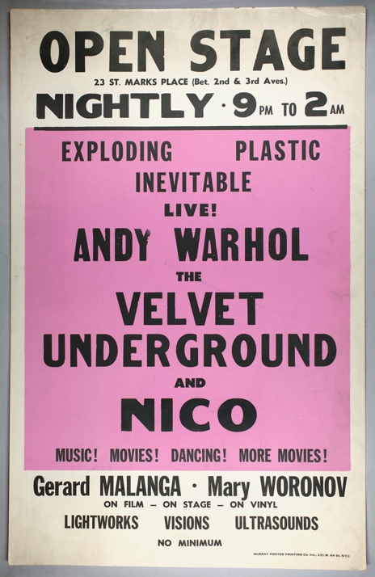

Unknown, Concert poster (Open Stage: Andy Warhol and The Velvet Underground and Nico, at 23 St. Marks Place (Polska Narodny Dom ("The Dom")), New York, NY), 1966
The Andy Warhol Museum, Pittsburgh; Founding Collection, Contribution The Andy Warhol Foundation for the Visual Arts, Inc.
1998.3.4562

Points of View
“Beauties in photographs are different from beauties in person. It must be hard to be a model, because you’d want to be like the photograph of you, and you can’t ever look that way. And so you start to copy the photograph. Photographs usually bring in another half-dimension. (Movies bring in another whole dimension. That screen magnetism is something secret—if you could only figure out what it is and how to make it, you’d have a really good product to sell. But you can’t even tell if someone has it until you actually see them up there on the screen. You have to give screen tests to find out.)”
Andy Warhol, The Philosophy of Andy Warhol (From A to B and Back Again), 1975

“The resulting films drastically reduced the roles of director and viewer alike. The director’s function was limited to choosing the subject, setting up the shot, turning the camera on and off and deciding whether or not to exhibit the result. And the viewer, for the first time in the history of the commercial exploitation of persistence-of-vision, was relieved of the obligation—perhaps even a large part of the desire—to pay attention to the screen. The standard ‘film-as-wallpaper’ definition of the early Warhol films doesn’t stand up, since their entire meaning and effect spring from the fact of their projection on a screen in a darkened room.”
Writer Tony Rayns, Andy Warhol: Film Factory, 1989

“The many Screen Tests evidence a variety of behavior of its portrait subjects, but amazingly little improvisation. The subjects actually look like they are captured and about to be interrogated, but the interrogation never happens, because Andy wanted to capture the essence of the person only, no interference, just like no interference with the camera as it recorded each “moving” still-life. The Screen Tests rank in the Warhol pantheon along with the Campbell’s Soup cans, Marilyns, and self-portraits.”
Factory photographer and assistant Billy Name in Callie Angell, Andy Warhol Screen Tests, 2006

Discussion Questions

- Watch Marlene Dietrich's 1929 Hollywood screen test for the movie The Blue Angel and one of Warhol’s Screen Tests. How does a Hollywood screen test differ from a Warhol Screen Test? What are the formulas or recipes for each?
- Are these films more or less realistic than a photograph and a painted portrait?
- Discuss the formal qualities of Warhol’s films (light, movement, focus, etc.) that differ in each Screen Test. What do you think Warhol means when he says, “Movies bring in another whole dimension”?
- What is “screen magnetism”?
- As you look at a Warhol Screen Test what clues or elements in the film reveal the person’s aura or character to you? What can you tell about a person by observing his or her gestures, such as blinks and swallows?

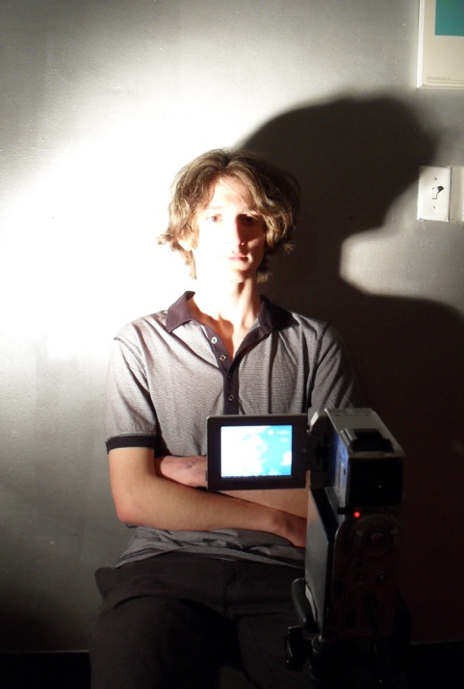

Student sits for his screen test.

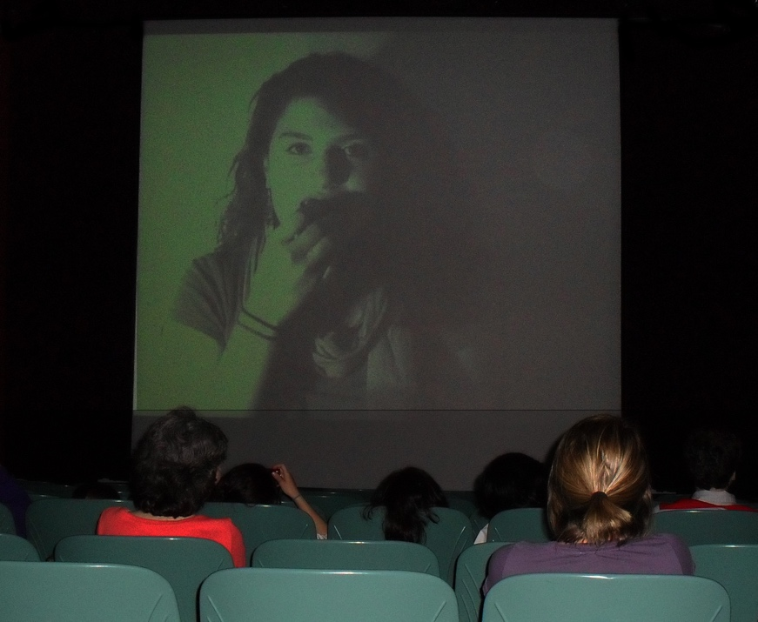

Student mimics Warhol’s film Eat by eating an apple during her screen test.

Materials
- Video camera or smartphone with video capabilities
- Computer for uploading and viewing digital videos
- Direct light source (to create strong contrast between light and shadow)
- Variety of props and costumes (wigs, hats, sunglasses, feather boas, etc.)

Procedure
- Familiarize yourself with a few of Warhol’s Screen Tests by searching and viewing videos on YouTube. Notice that:
- Subject sits in a chair facing the camera.
- Subject is very still with as little motion as possible.
- Each screen test is originally filmed for three minutes in length, but Warhol slows them down to four minutes after filming.
- The chair is illuminated by a directed light source.
- Subjects are filmed in black and white.
- Decide whether to portray an aspect of your own personality or an imagined one.
- You may use simple props to accentuate personality characteristics.
- A single person or a group can be filmed at one time. The filming space should be dark with only a directed light source shining on the subject(s).
- Sit in front of the camera, look directly at the lens, and stay as motionless as possible for three minutes during filming. (You may film for shorter segments to save time.)
- Consider the following when filming:
- Set the phone or digital camera to black-and-white or sepia mode
- Stabilize the device on a tripod or table surface to minimize shaking
- Set a timer to indicate when three minutes of filming is complete
- Rotate roles so each person or group gets a chance to be filmed.
- View student screen tests as a group by compiling and uploading digital videos to a computer and projecting them onto a screen or wall using a digital projector.

Extension
Students create a written character sketch of three different personalities captured in the class screen test.

Wrap-up
As a group, watch the screen tests and discuss the on-screen personalities. Based on the footage, students determine which person would be best suited for various film roles: a villain, a best friend, a hero, a royal personage, etc. Students also critique the formal qualities of their screen tests.

Assessment
The following assessments can be used for this lesson using the downloadable assessment rubric.
- Communication 3
- Communication 4
- Creative process 3
- Creative process 6
- Critical thinking 3
- Critical thinking 4

