Space Fruit and the Color Wheel

© The Andy Warhol Museum, one of the four Carnegie Museums of Pittsburgh. All rights reserved.
You may view and download the materials posted in this site for personal, informational, educational and non-commercial use only. The contents of this site may not be reproduced in any form beyond its original intent without the permission of The Andy Warhol Museum. except where noted, ownership of all material is The Andy Warhol Museum, Pittsburgh; Founding Collection, Contribution The Andy Warhol Foundation for the Visual Arts, Inc.

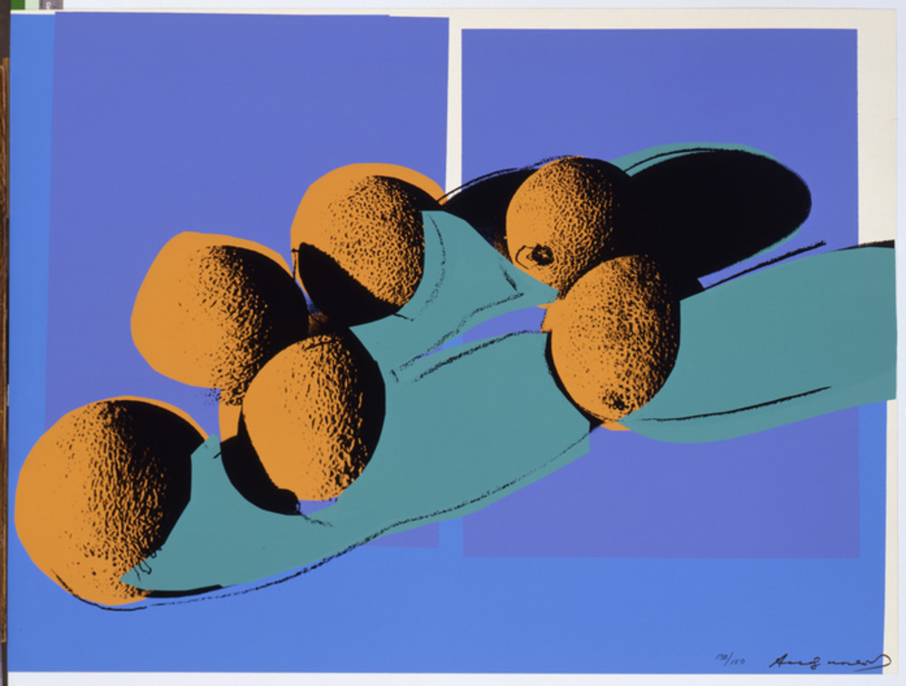

Overview
Students use Warhol’s Space Fruit print series to develop a working knowledge of the color wheel and its terminology. Through observation and writing, students examine how the printing process allowed Warhol to create endless color combinations and compositions.

Grade levels
- Elementary school
- Middle school
- High school

Subjects
- Arts

Pennsylvania Standards for the Arts and Humanities
- 9.1.5.A - Know and use the elements and principles of each art form to create works in the arts and humanities.
- 9.1.5.C - Know and use fundamental vocabulary within each of the arts forms.
- 9.1.8.A - Know and use the elements and principles of each art form to create works in the arts and humanities.
- 9.1.8.C - Identify and use comprehensive vocabulary within each of the arts forms.
- 9.1.12.A - Know and use the elements and principles of each art form to create works in the arts and humanities.
- 9.1.12.C - Integrate and apply advanced vocabulary to the arts forms.

Objectives
- Students investigate and analyze Warhol’s use of color in his print series Space Fruit.
- Students develop a working knowledge of the color wheel.
- Students apply their knowledge of the color wheel through writing activities.

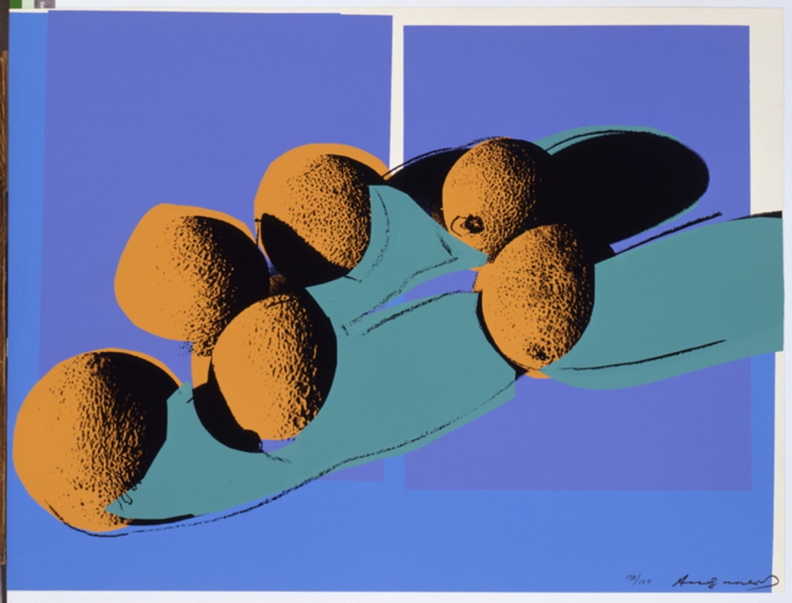

Andy Warhol, Space Fruit: Still Lifes (Cantaloupes I), 1979
The Andy Warhol Museum, Pittsburgh; Founding Collection, Contribution Dia Center for the Arts
2002.4.19.4

About the Art
Throughout his career, Warhol worked with assistants and printers to create numerous print portfolios. In 1977 he met printer Rupert Jasen Smith who worked with him to create the series Space Fruit. These prints demonstrate Warhol’s experimentation with a centuries-old genre in painting—the still life. Still lifes by their very nature are choreographed compositions focusing on shape, color, space, and oftentimes symbolism. Warhol was interested in using shadows as a compositional element. He first placed one or more pieces of fruit on a white background, lit the arrangement from an angled position so that shadows were cast onto the white paper, and then photographed these compositions. He also used collage and drawing to create the source imagery for the additional screens used in each print. This artwork is an example of a multilayer or multicolor” silkscreen print since each color represents a different silkscreened layer. This printing process allowed Warhol endless color combinations within each composition.

Points of View
“When I look at things, I always see the space they occupy. I always want the space to reappear, to make a comeback, because it’s lost space when there’s something in it.”
Andy Warhol, The Philosophy of Andy Warhol (From A to B and Back Again), 1975

“When I have to think about it, I know the picture is wrong. And sizing is a form of thinking and coloring is too. My instinct about painting says, 'If you don’t think about it, it's right'. As soon as you have to decide and choose, it's wrong. And the more you decide about, the more wrong it gets. Some people, they paint abstract, so they sit there thinking about it because their thinking makes them feel they're doing something. But my thinking never makes me feel I'm doing anything.”
Andy Warhol, The Philosophy of Andy Warhol (From A to B and Back Again), 1975

Discussion Questions
- Look carefully at the print Space Fruit: Still Lifes (Cantaloupes I). How did Warhol use photography, collage, and drawing in this print?
- Analyze all of the prints together in the Space Fruit series using the following prompts:
- What color combinations does Warhol use? Are the colors realistic? Are they appealing? Why or why not?
- How is the fruit arranged? How does Warhol use shadows in the compositions?

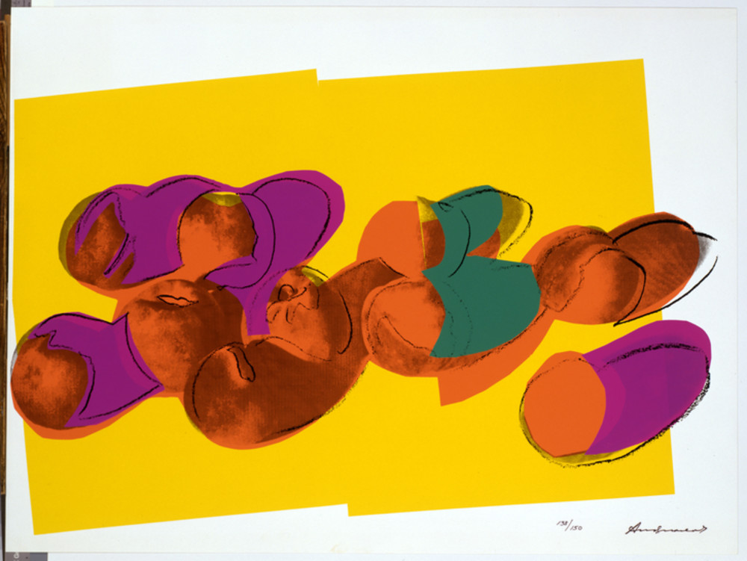

Andy Warhol, Space Fruit: Still Lifes (Peaches), 1979
The Andy Warhol Museum, Pittsburgh; Founding Collection, Contribution Dia Center for the Arts
© The Andy Warhol Foundation for the Visual Arts, Inc.
2002.4.19.5

Materials
- Color wheels
- Pencils
- Color Terminology handout
- Cards of Warhol’s Space Fruit Series handout
- Student Worksheet handout

Vocabulary
- Color wheel: a circle with different colored sections used to show the relationship between colors and the essential elements of mixing color.
- Color scheme: the combination of colors on the color wheel implemented by artists, designers, and illustrators.
For more information on the color wheel and color theory visit Color Matters.

Procedure
- Introduce the concept of the color wheel to students and why artists use it.
- Break students into groups of two to four and give each group a color wheel and a color terminology handout. (A word bank of color terminology could also be written on the board.)
- Briefly discuss the terminology.
- Give each group two Space Fruit cards and a Student Worksheet handout. Instruct students to work together to answer the questions on the sheet.
- When all groups are finished, review the questions as a class.

Wrap-up
Ask students to decide:
- What three colors they would use to make a triad still-life print.
- What four colors they would use to make a tetrad still-life print.

Extension
As a follow up to this activity, use Lesson 1 in our Silkscreen Printing unit on color and shape.

Assessment
The following assessments can be used for this lesson using the downloadable assessment rubric.
- Communication 3
- Creative process 2
- Creative process 6

Color Terminology Handout
© The Andy Warhol Museum, one of the four Carnegie Museums of Pittsburgh. All rights reserved.
You may view and download the materials posted in this site for personal, informational, educational and non-commercial use only. The contents of this site may not be reproduced in any form beyond its original intent without the permission of The Andy Warhol Museum. except where noted, ownership of all material is The Andy Warhol Museum, Pittsburgh; Founding Collection, Contribution The Andy Warhol Foundation for the Visual Arts, Inc.

Color Terminology
Hue: another name for a color.
Value: the lightness and darkness of a color.
Key color: dominant color in a color scheme or mixture.
Intensity or chroma: the brightness or dullness of a color.
Temperature (warm and cool colors): a color’s perceived sense of warmth or coolness. Aggressive (warm) colors: reds, oranges, and yellows. Receding (cool) colors: greens, blues, and violets.
Color Wheel: the essential elements of mixing color.
Color scheme: the combination of colors on the Color Wheel implemented by artists, designers, and illustrators.
Shade: color + black.
Tint: color + white.
Tone: color + gray.
Primary colors: red, yellow, and blue – cannot be mixed from any other colors.
Secondary colors: two primary colors mixed together resulting in orange, green, and violet. Tertiary colors: one primary color and one secondary color mixed together.
Complementary color scheme: combining a shade, tint, or tone of one color and the color opposite on the Color Wheel.
Analogous color scheme: using any shades, tints, or tones of colors that lie adjacent to each other on the Color Wheel.
Split-complementary color scheme: choosing one color and using the color to each side of its complement on the Color Wheel.
Diad: using two colors that are two colors apart on the Color Wheel. Example: red and orange.
Triad: color scheme in which three colors are equally spaced from each other. Example: the three primary colors – red, yellow, and blue.
Tetrad: a contrast of four or more colors on the Color Wheel.
Monochromatic: using any shade, tint, or tone of one color.
Achromatic: a colorless scheme using blacks, whites, and grays.
Neutral gray: combination of black and white.

Color Wheel
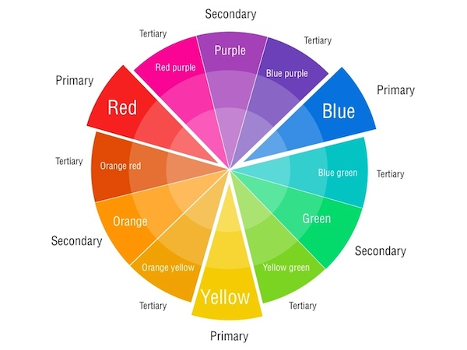

Space Fruit Cards
© The Andy Warhol Museum, one of the four Carnegie Museums of Pittsburgh. All rights reserved.
You may view and download the materials posted in this site for personal, informational, educational and non-commercial use only. The contents of this site may not be reproduced in any form beyond its original intent without the permission of The Andy Warhol Museum. except where noted, ownership of all material is The Andy Warhol Museum, Pittsburgh; Founding Collection, Contribution The Andy Warhol Foundation for the Visual Arts, Inc.

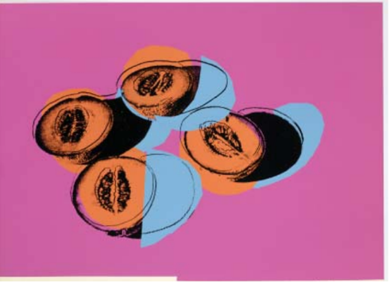  Andy Warhol, Space Fruit: Still Lifes (Cantaloupes II), 1979 Screen print on Lenox Museum Board, 30 x 40 in. © AWF | 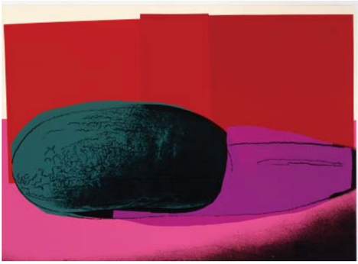  Andy Warhol, Space Fruit: Still Lifes (Watermelon), 1979 Screen print on Lenox Museum Board, 30 x 40 in.© AWF
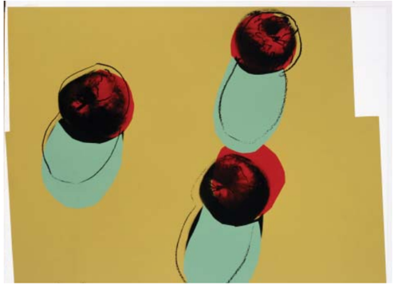  Andy Warhol, Space Fruit: Still Lifes (Apples), 1979 Screen print on Lenox Museum Board, 30 x 40 in. © AWF | 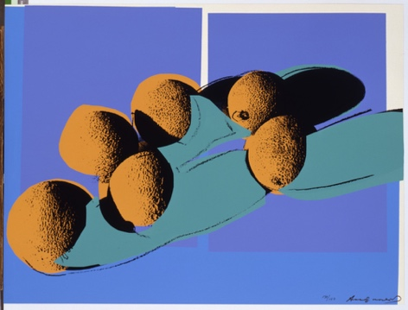  Andy Warhol, Space Fruit: Still Lifes (Cantaloupes I), 1979 The Andy Warhol Museum, Pittsburgh; Founding Collection © AWF
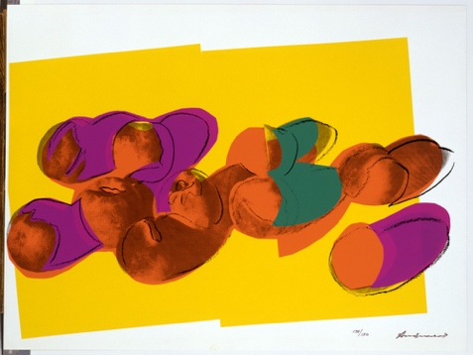  Andy Warhol, Space Fruit: Still Lifes (Peaches), 1979 Screen print on Lenox Museum Board, 30 x 40 in. © AWF | 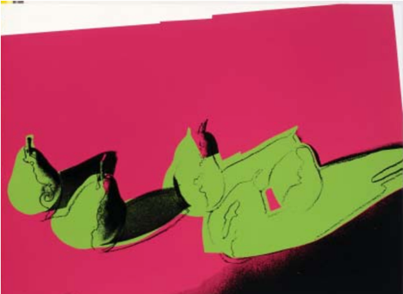  Andy Warhol, Space Fruit: Still Lifes (Pears), 1979 Screen print on Lenox Museum Board, 30 x 40 in. © AWF

Space Fruit Worksheet
© The Andy Warhol Museum, one of the four Carnegie Museums of Pittsburgh. All rights reserved.
You may view and download the materials posted in this site for personal, informational, educational and non-commercial use only. The contents of this site may not be reproduced in any form beyond its original intent without the permission of The Andy Warhol Museum. except where noted, ownership of all material is The Andy Warhol Museum, Pittsburgh; Founding Collection, Contribution The Andy Warhol Foundation for the Visual Arts, Inc.

What 4 colors did Warhol use in this Space Fruit print?

1.
2.
3.
4.

Are the colors complementary, analogous, or both? ___________________________

Name the colors (if any) that are:

Primary ____________________________________

Secondary___________________________________

Tertiary_____________________________________

Are the colors warm, cool, or a combination of both? _________________________

Choose a color in the Space Fruit and describe what colors you would mix together to get that color:

Describe the order in which Warhol added layers to one of the Space Fruit prints.
What color did he use?

1st_____________________________________

2nd_____________________________________

3rd_____________________________________

4th _____________________________________

