Still Life and Observation Drawing

© The Andy Warhol Museum, one of the four Carnegie Museums of Pittsburgh. All rights reserved.
You may view and download the materials posted in this site for personal, informational, educational and non-commercial use only. The contents of this site may not be reproduced in any form beyond its original intent without the permission of The Andy Warhol Museum. except where noted, ownership of all material is The Andy Warhol Museum, Pittsburgh; Founding Collection, Contribution The Andy Warhol Foundation for the Visual Arts, Inc.

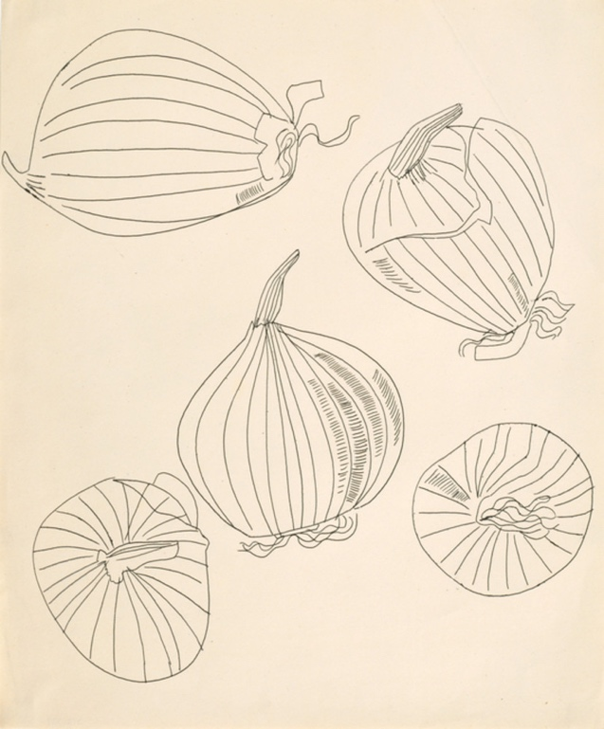

Overview
This drawing lesson outlines the basics of contour-line drawing using Andy Warhol’s artworks as examples. Students create simple contour-line drawings of onions, followed by longer observational drawings from simple still-life arrangements.

Grade levels
- Elementary school
- Middle school
- High school

Subjects
- Arts

Pennsylvania Standards for the Arts and Humanities
- 9.1.3.A - Know and use the elements and principles of each art form to create works in the arts and humanities.
- 9.1.5.A - Know and use the elements and principles of each art form to create works in the arts and humanities.
- 9.1.8.A - Know and use the elements and principles of each art form to create works in the arts and humanities.
- 9.1.12.A - Know and use the elements and principles of each art form to create works in the arts and humanities.

Objectives
- Students identify formal elements of drawing.
- Students apply contour-line techniques.
- Students translate visual data into line drawings.

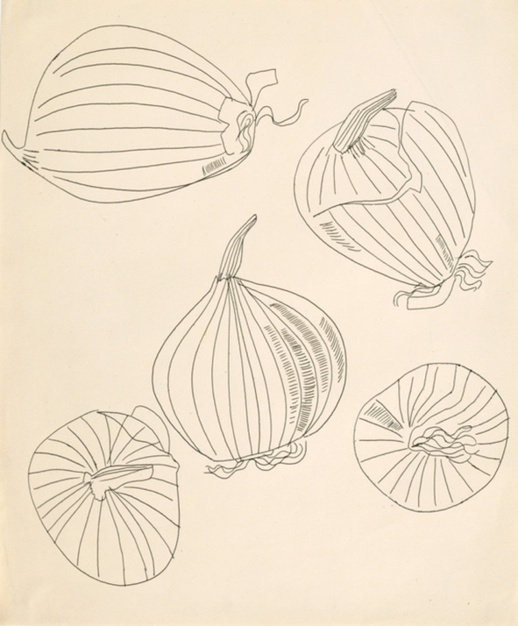

Andy Warhol, Five Views of an Onion, 1950s
The Andy Warhol Museum, Pittsburgh; Founding Collection, Contribution The Andy Warhol Foundation for the Visual Arts, Inc.
© The Andy Warhol Foundation for the Visual Arts, Inc.
1998.1.1750

About the Art
Although Warhol is best known for his silkscreen prints, he was also an excellent draughtsman. Drawing was a constant part of his artistic practice. As a child he took art classes at the Carnegie Museum of Art and later won awards for drawings he had made in high school. At Carnegie Institute for Technology (now Carnegie Mellon University, which Warhol graduated from with a degree in pictorial design), Warhol’s offbeat, nontraditional drawing style did not meet all his professors’ academic standards, and he was forced to do extra work in this area over summer break. In the 1950s, Warhol’s blotted line drawing technique defined his signature style for his commercial work. He also filled sketchbooks with freehand drawings, mostly done in ballpoint pen, of friends and still lifes. Several of his whimsical sketches and drawings from this era were published in magazines and books, such as The Best in Children’s Books series and a little-known vintage cookbook called Wild Raspberries. Other sketchbook drawings were exhibited as fine art, such as Studies for a Boy Book, displayed at the Bodley gallery in New York in 1956. In his pop artwork, Warhol used a combination of mechanical and hand-drawn techniques as well as an opaque projector to trace outlines of images in preparation for his paintings. He also incorporated drawn lines in his later silkscreened images, such as Mao Wallpaper, Mick Jagger, Gems, and his 1980s commercial work.

Points of View
“I was doing my [drawing] technique and then they told me I had to go to summer school, and if I didn’t go to summer school I couldn’t come back, so then I went to summer school and learned how to draw like they did.”
Andy Warhol in Donna M. de Salvo, Andy Warhol in Success is a Job in New York:The Early Art and Business of Andy Warhol, 1989

“One Sunday . . . we went down to the flower market and bought some irises and came back and spent the afternoon drawing . . . He would just draw one line and then leave it, and when I would draw things, I was always erasing, changing, and improving. And he never improved on anything. Rather than do that, he would draw a new one, which is some-thing I never thought of doing in those days.”
Charles Lisanby in Patrick Smith, Andy Warhol’s Art and Films, 1988

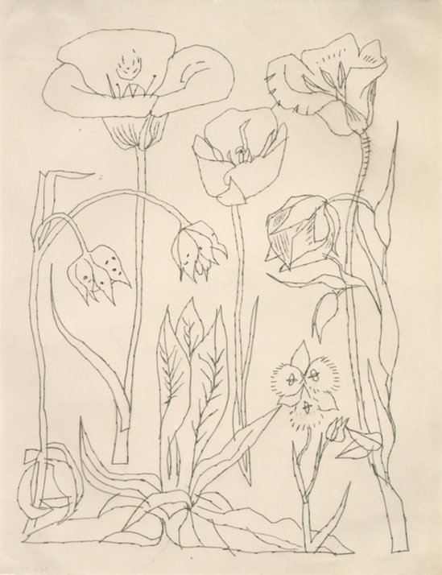

Andy Warhol, Flowers, 1950s
The Andy Warhol Museum, Pittsburgh; Founding Collection, Contribution The Andy Warhol Foundation for the Visual Arts, Inc.
© The Andy Warhol Foundation for the Visual Arts, Inc.
1998.1.1557

Discussion Questions
- As a group, explore Warhol’s drawing style during the 1950s using Five Views of an Onion and Still-Life: Flowers, then discuss the following:
- Describe the lines Warhol used to draw these items.
- How does he achieve volume without much use of shading?
- Warhol’s early drawings were sometimes referred to as whimsical and playful. Do you agree? Why or why not?
- Warhol did not use an eraser; he would just start a new drawing. Why do you think he did this? If you had to draw without an eraser, what might you do differently?

Materials
- Still life objects (onions, fruit, vegetables, flower arrangements, etc.)
- Paper
- Ballpoint pen, lithographic crayon, conte crayon, or pencil

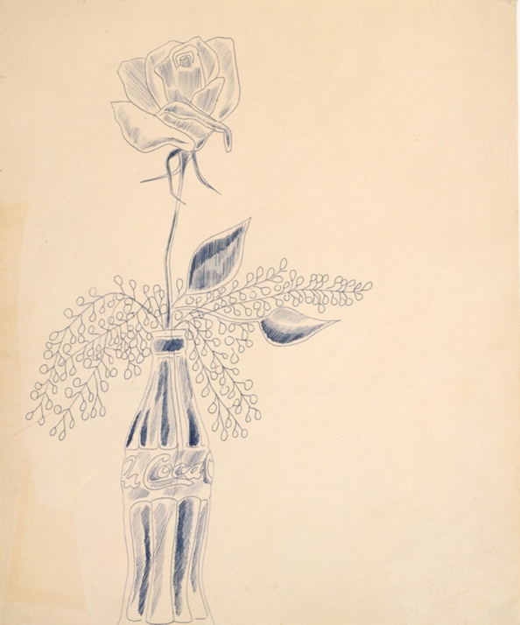

Andy Warhol, Still-Life (Flowers), 1950s
The Andy Warhol Museum, Pittsburgh; Founding Collection, Contribution The Andy Warhol Foundation for the Visual Arts, Inc.
© The Andy Warhol Foundation for the Visual Arts, Inc.
1998.1.1745

Vocabulary
- Contour lines: Lines that surround and define the edges of a subject, giving it shape and volume. These should not be confused with a form’s outlines. Outline is drawing a line around the periphery of a two-dimensional object. Contour is creating the effect of a third dimension using highlight and shadow. (artlex.com)
- Contour drawing: Drawing in which contour lines are used to represent subject matter. A contour drawing has a three-dimensional quality, indicating the thickness as well as height and width of the forms it describes.

Procedure
- Explain what a contour-line drawing is.
- Explain or demonstrate to students that a continuous line contour drawing is a classic drawing exercise in which a continuous-line drawing is produced without ever lifting the drawing instrument from the page. Sometimes this exercise is modified as a blind continuous line contour in which a continuous-line drawing is produced without ever looking at the paper. Both exercises are designed to improve students’ visual concentration.
- Give students materials to practice contour-line drawings of onions. Explain that the pattern on the skin of the onion helps students see cross-contour lines, which help give a shape volume. Try both drawing exercises with students in five to ten minute increments then adding more time if desired. For a continuous line contour drawing, direct students to fix their eyes on the contours of the onion and draw the contour very slowly with a steady, continuous line without lifting the drawing tool. For a blind continuous line contour, have students do the same but without looking at the paper.
- Create longer observation drawings from simple still-life arrangements. You may wish to include onions, fruit, vegetables, flower arrangements, etc.

Wrap-up
Students self assess their work and the work of their peers by using a rating scale from 1 to 5. 1=unacceptable; 2=needs work; 3=mediocre; 4=well done; 5=outstanding. Students group the drawings according to each rating. As a class, discuss the criteria the students used to make their choices.

Assessment
The following assessments can be used for this lesson using the downloadable assessment rubric.
- Aesthetics 1
- Aesthetics 3
- Creative process 3
- Creative process 5

