The Pocket Project

© The Andy Warhol Museum, one of the four Carnegie Museums of Pittsburgh. All rights reserved.
You may view and download the materials posted in this site for personal, informational, educational and non-commercial use only. The contents of this site may not be reproduced in any form beyond its original intent without the permission of The Andy Warhol Museum. except where noted, ownership of all material is The Andy Warhol Museum, Pittsburgh; Founding Collection, Contribution The Andy Warhol Foundation for the Visual Arts, Inc.

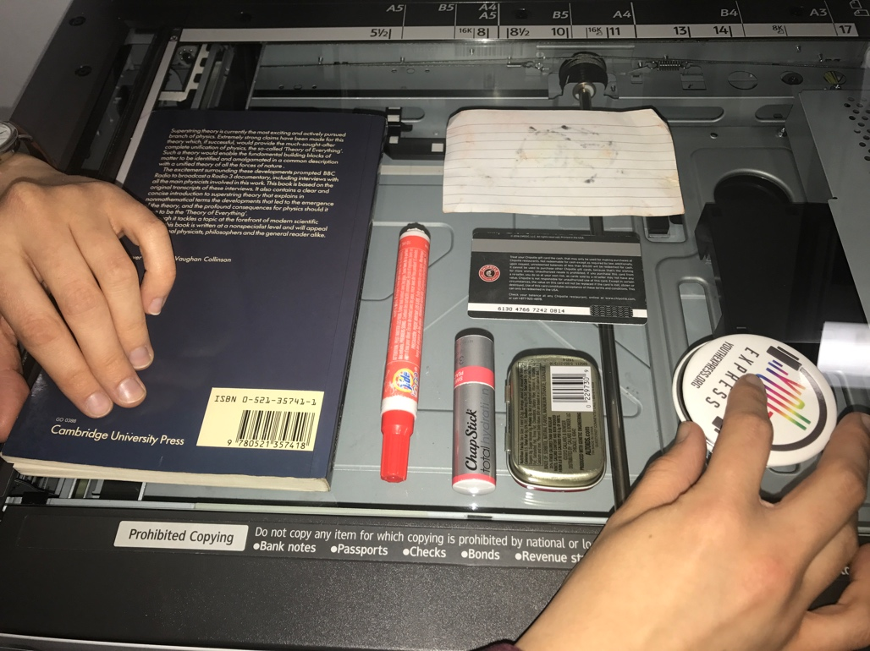

Overview
Students create a photocopied or scanned image of the contents of their pockets, purses, or backpacks to create a portrait of themselves and of their culture. This activity can be used on its own or as a warmup for the collecting lessons.

Grade levels
- Middle school
- High school

Subjects
- Arts
- English and language arts

Pennsylvania Standards for the Arts and Humanities
- 9.1.8.E - Communicate a unifying theme or point of view through the production of works in the arts.
- 9.1.12.E - Delineate a unifying theme through the production of a work of art that reflects skills in media processes and techniques.
- 9.3.8.F - Apply the process of criticism to identify characteristics among works in the arts.
- 9.3.12.C - Apply systems of classification for interpreting works in the arts and forming a critical response.

Objectives
- Students choose five to ten items from their pockets, purses, or backpacks.
- Students arrange these items into a composition.
- Students create a copy of their composition using a scanner or photocopier.
- Students analyze and evaluate their objects.
- Students draw conclusions about their class based on the objects.

Points of View
“I want to throw things right out the window as they’re handed to me, but instead I say thank you and and drop them into the box-of-the-month. But my other outlook is that I really do want to save things so they can be used again someday.”
Andy Warhol, The Philosophy of Andy Warhol (From A to B and Back Again), 1975

“When I think about poetry, I often think of pockets. Places where we keep things we need—pockets hide things, yet they also keep them close to us. Poems tend to expose the hidden things we carry with us—emotional things. And poets often find the emotional in the mundane, like the contents of pockets, or purses. Pockets also hide the talismans we keep with us out of superstition, or to provide us comfort. Often, we have difficulty explaining to others why certain things carry such emotional weight, why when we empty the pockets of one pair of pants, those same contents end up in the next pair we wear. Separated from their owners, these things carry their own mystery. They illustrate choices made. The small choices that add up, that create a secret snapshot of a life. Who knows what power or meaning these things hold for these individuals? All we know is that one day, they were in a pocket or purse, and here they are, spilled out from their dark homes especially for us. Can they be arranged into something meaningful like words of magnetic poetry? What interests me beyond the formal i.d. cards are the more subtle forms of identification—the choice of stamps, pens, drugs, cigarettes, mints, the receipts, ticket stubs, sunglasses, the snatches of personal notes. What’s more revealing, a condom or a Subway coupon? It’s a medley of the unrehearsed, the spontaneous revealed. One pocket includes a boarding pass from Tajikistan Airlines. I want to read that as Talisman Airlines. These photocopies take me on a magical flight.”
Jim Daniels in Point of View label for gallery interactive, “Pocket Project” in Andy Warholʼs Time Capsules (November 5–July 18, 2005), The Andy Warhol Museum, October 2005

Materials
- Photocopier or scanner with printer
- Writing utensils
- Place to hang up images
- Pocket Project handout

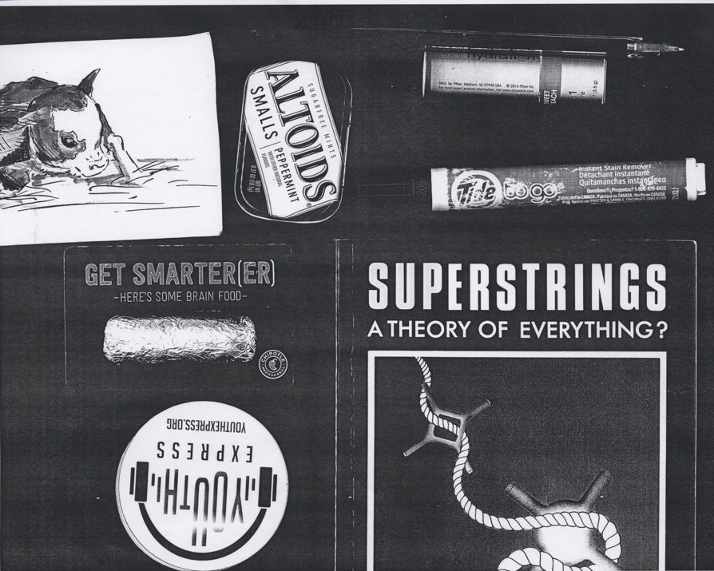

A student example of a collection, using the contents of a backpack and a photocopier.

Procedure
- Empty out the contents of your pocket, purse, or backpack.
- Select and place items that you think are interesting on a sheet of white paper.
- Transfer objects to scanner or photocopier to create a copy. White paper should be placed over the objects to block light as they are scanned.
- Hang up photocopied or scanned and printed images.
- Use the Pocket Project handout to analyze the objects as a group.
- Draw conclusions about your class based on the objects.

Wrap-up
While looking at the image of objects answer the following prompts:
- Describe what these objects are.
- If someone came across this paper and didn’t know you, what could they tell about you or your class?
- If someone 100 years from now came across your class’s collection of objects, what could they tell about you as a group?
- What would they learn about the current year?
- What important stories would they be able to tell?

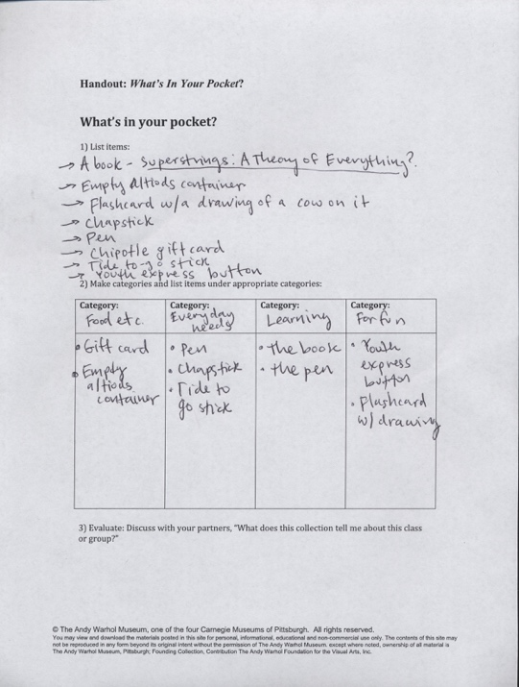

A student example using the Pocket Project handout to analyze the collection of objects.

Assessment
The following assessments can be used for this lesson using the downloadable assessment rubric.
- Communication 3
- Creative process 1
- Critical thinking 2

Pocket Project Handout: What’s In Your Pocket?

© The Andy Warhol Museum, one of the four Carnegie Museums of Pittsburgh. All rights reserved.
You may view and download the materials posted in this site for personal, informational, educational and non-commercial use only. The contents of this site may not be reproduced in any form beyond its original intent without the permission of The Andy Warhol Museum. except where noted, ownership of all material is The Andy Warhol Museum, Pittsburgh; Founding Collection, Contribution The Andy Warhol Foundation for the Visual Arts, Inc.

What’s in your pocket?
- List items:

- Make categories and list items under appropriate categories:

Category: | Category: | Category: | Category:

- Evaluate. Discuss with your partners, “What does this collection tell me about this class or group?”

