Time Capsule 21 Activity: A Day in the Life of Warhol

© The Andy Warhol Museum, one of the four Carnegie Museums of Pittsburgh. All rights reserved.
You may view and download the materials posted in this site for personal, informational, educational and non-commercial use only. The contents of this site may not be reproduced in any form beyond its original intent without the permission of The Andy Warhol Museum. except where noted, ownership of all material is The Andy Warhol Museum, Pittsburgh; Founding Collection, Contribution The Andy Warhol Foundation for the Visual Arts, Inc.

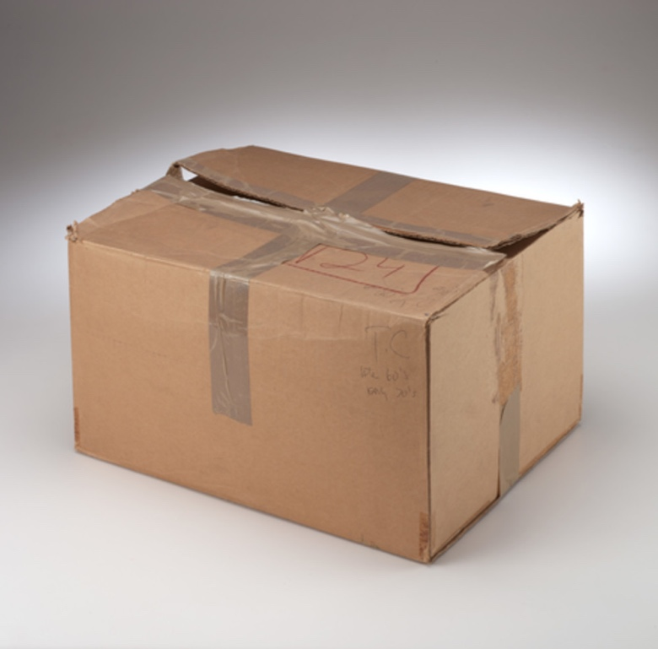

Overview
What can you learn about someone’s personality, interests, culture, and history through the objects they collect? This lesson begins to explore those questions in a simple activity using an Internet archive of one of Warhol’s 610 Time Capsules. Students explore the contents of Time Capsules 21, selecting objects to interpret and then write about the artist. This lesson encourages creative writing as well as research and analysis.

Grade levels
- Middle school
- High school

Subjects
- Arts
- English and language arts
- Social studies and history

Pennsylvania Standards for the Arts and Humanities
- 9.2.8.D - Analyze a work of art from its historical and cultural perspective.
- 9.2.12.D - Analyze a work of art from its historical and cultural perspective.

Objectives
- Students identify objects within a collection.
- Students compose fictional stories based upon objects.
- Students orally present narratives.
- Students assess the information revealed by objects in both historical and fictional contexts.

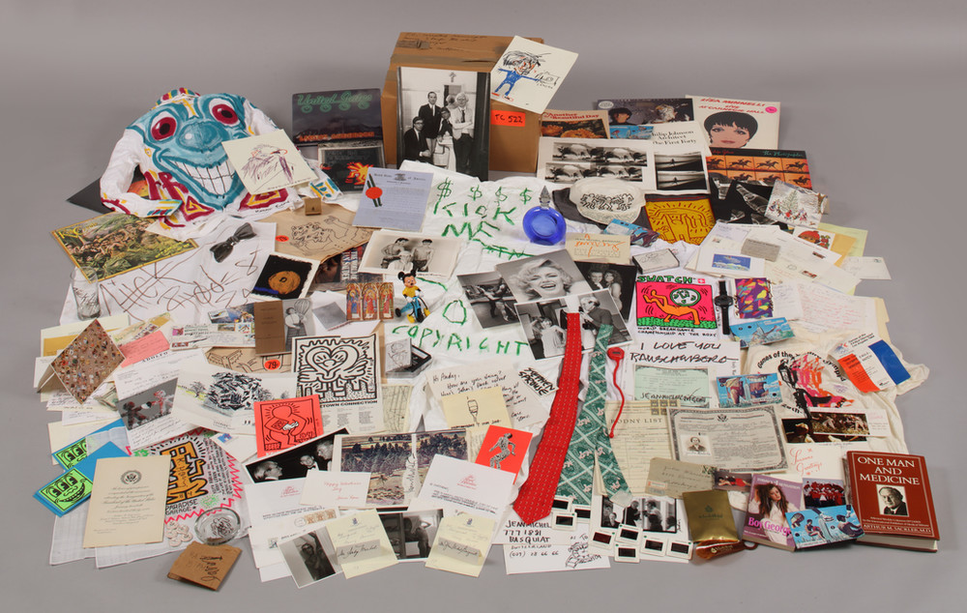

Andy Warhol, Time Capsule 522, 1862-1985, undated; Bulk: 1984
The Andy Warhol Museum, Pittsburgh; Founding Collection, Contribution The Andy Warhol Foundation for the Visual Arts, Inc.
TC522

About the Art
The Time Capsules is Warhol’s largest collecting project. He saved source material for his work and an enormous record of his daily life. Warhol started his Time Capsules in 1974 after relocating his studio. He recognized that cardboard boxes used in the move were an efficient method for dealing with all of his stuff. Warhol selected items from the daily flood of correspondence, magazines, newspapers, gifts, photographs, business records, and material that passed through his hands to put in an open cardboard box by his desk. Once the box was full, he sealed it with tape, marked it with a date and/or title, and put it in his archive. En masse, this material provides a unique view into Warhol’s private world, as well as a broad cultural backdrop illustrating the social and artistic scene during his lifetime. From the early 1970s, until his death in 1987, Warhol created 610 Time Capsules. Warhol’s Time Capsules were almost completely unknown until his death. Although various studio assistants frequently handled the boxes over the years, few people recognized the enormous mass of material as anything other than “Andy’s stuff.” When The Andy Warhol Museum opened in 1994, the Time Capsules became accessible to curators, scholars, and the general public, revealing new and important information about Warhol’s life and expanding the public’s understanding of his work and practice.

Points of View
“Took a few time capsule boxes to the office. They are fun—when you go through them there’s things you really don’t want to give up. Some day I’ll sell them for $4,000 or $5,000 apiece. I used to think $100, but now I think that’s my new price.”
Andy Warhol, The Andy Warhol Diaries, September 30, 1986

“Andy Warhol possessed both too much and too little. In his capacity to have done those things equally, he vitally characterizes how we engage with the profusion of objects made possible by life in industrial societies. On the one hand, by the time of his premature death, his house had become impassible because of the accumulated bulk of his art, furniture, tchotchkes, and personal effects, and the idea of his having to maintain what he called Time Capsules would be perfectly reasonable to anyone in the possession of that most modern of inventions, the storage unit.... His collections stagger us as we try to make sense of their meanings. He might begin to think that he was simply a pack rat unable to discard the mundane things he encountered in his daily life: he had too much. Simultaneously, as we begin to sort through the belongings that he gathered around him, we are tempted to wonder what he didn’t hold onto and whether we might discover the lost fragment (such as the precious discarded Rosebud of Citizen Kane) through which one life might be satisfyingly explained. No collection is ever complete and thus begs for those things that it fails to include: the collection always wants more. In short, Warhol’s collections could never be large enough to explain his life and art.”
Matthew Tinkcom, Possession Obsession, 2002

Discussion Questions
- Why do people collect and save objects?
- What can you find out about someone through his or her collections? What could someone
- find out about you if they opened your locker at school or your closet at home?
- Warhol created 610 Time Capsules over about twenty years. What do you think researchers are able to learn about Warhol and his life as all of these boxes are catalogued?
- What do they discover about American culture?

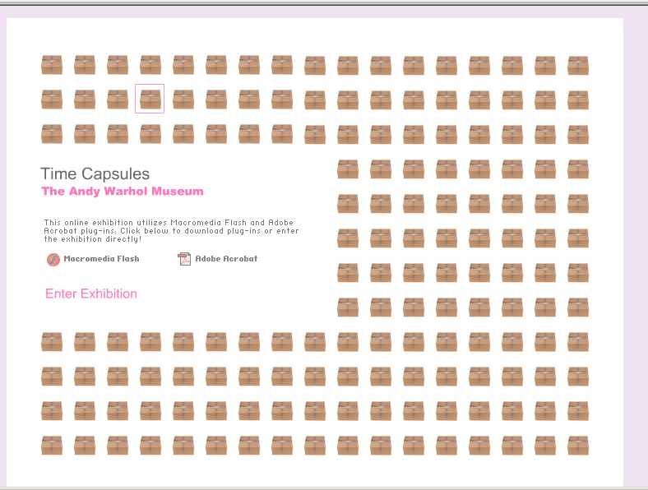

Screenshot of the Time Capsule 21 website.

Materials
- Time Capsule 21 Activity handout
- Pencils
- Computer with Internet connection
- Flashplayer downloaded for site
- Time Capsule 21 website: http://exhibitions.warhol.org/tc21/

Procedure
- Explore the website Time Capsule 21.
- Choose three to five items from Time Capsule 21.
- Use the handout to identify your objects.
- Write a brief description of each item and what it reveals about Warhol.
- Create a fictional story about one day in Warhol’s life incorporating your chosen objects as important elements within the narrative. Use your imagination and be creative.
- Present your narrative to the class.
- Discuss how objects reveal information about people, place, and cultures.

Assessment
The following assessments can be used for this lesson using the downloadable assessment rubric.
- Aesthetics 3
- Communication 2
- Communication 3
- Creative process 2
- Critical thinking 4
- Historical context 4

Time Capsule Handout
© The Andy Warhol Museum, one of the four Carnegie Museums of Pittsburgh. All rights reserved.
You may view and download the materials posted in this site for personal, informational, educational and non-commercial use only. The contents of this site may not be reproduced in any form beyond its original intent without the permission of The Andy Warhol Museum. except where noted, ownership of all material is The Andy Warhol Museum, Pittsburgh; Founding Collection, Contribution The Andy Warhol Foundation for the Visual Arts, Inc.

Andy Warhol |  | Yourself
Identify (draw or describe) three items from TC21 | Explain what these three items reveal about Andy Warhol | Identify (draw or describe) three items from your own life | Explain what these three items reveal about you

