Icon Portraits

© The Andy Warhol Museum, one of the four Carnegie Museums of Pittsburgh. All rights reserved.
You may view and download the materials posted in this site for personal, informational, educational and non-commercial use only. The contents of this site may not be reproduced in any form beyond its original intent without the permission of The Andy Warhol Museum. except where noted, ownership of all material is The Andy Warhol Museum, Pittsburgh; Founding Collection, Contribution The Andy Warhol Foundation for the Visual Arts, Inc.

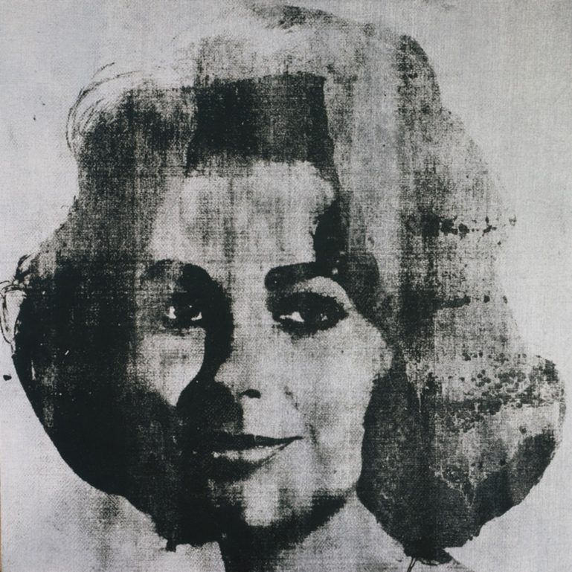

Overview
This lesson introduces Warhol’s Pop Art and silkscreening methods. Students learn how and why Warhol selected popular culture imagery to reﬂect trends and values. Students make their own art project using an iconic image that speaks to their generation. Teachers can adapt this lesson by substituting images of famous people or historical images.

Grade Levels
- Elementary school
- Middle school
- High school

Subjects
- Arts
- English and language arts
- Social studies and history

Pennsylvania Standards for the Arts and Humanities
- 9.1.3.A - Know and use the elements and principles of each art form to create works in the arts and humanities.
- 9.1.5.A - Know and use the elements and principles of each art form to create works in the arts and humanities.
- 9.1.8.A - Know and use the elements and principles of each art form to create works in the arts and humanities.
- 9.1.12.A - Know and use the elements and principles of each art form to create works in the arts and humanities.
- 9.2.3.E - Analyze how historical events and culture impact forms, techniques and purposes of works in the arts (e.g., Gilbert and Sullivan operettas)
- 9.2.5.E - Analyze how historical events and culture impact forms, techniques and purposes of works in the arts (e.g., Gilbert and Sullivan operettas).
- 9.2.8.E - Analyze how historical events and culture impact forms, techniques and purposes of works in the arts (e.g., Gilbert and Sullivan operettas).
- 9.2.12.E - Analyze how historical events and culture impact forms, techniques and purposes of works in the arts (e.g., Gilbert and Sullivan operettas)
- 9.3.8.E - Interpret and use various types of critical analysis in the arts and humanities.

Objectives
- Students identify and interpret visual data from iconic images.
- Students discuss cultural trends.
- Students choose and apply design elements.
- Students determine cause and effect.
- Students defend rationale for applied choices.

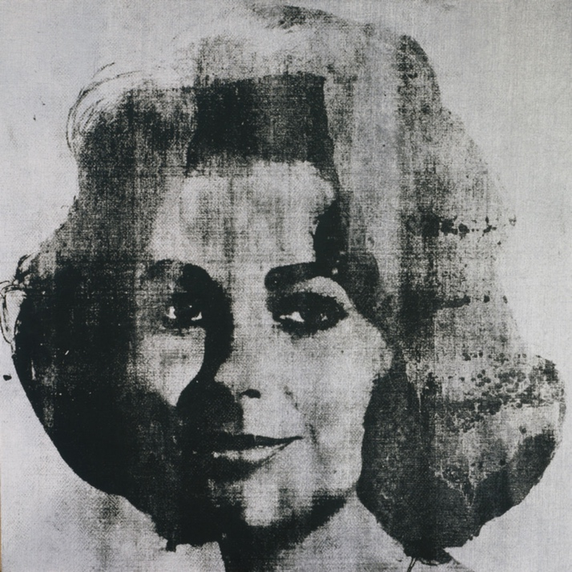

Andy Warhol, Silver Liz [Studio Type], 1963
The Andy Warhol Museum, Pittsburgh; Founding Collection, Contribution The Andy Warhol Foundation for the Visual Arts, Inc.
© The Andy Warhol Foundation for the Visual Arts, Inc.
1998.1.56

About the Art
Warhol was drawn to the glamorous worlds of Hollywood, fashion, and celebrity. His interest in pop culture manifested early in his childhood; he collected autographed celebrity photographs. Even as an adult, Warhol bought and read teen magazines and tabloids to stay current on what was popular. He carried this interest into his artwork, creating iconic paintings of megastars, such as Elvis Presley, Marilyn Monroe, and Elizabeth Taylor. Warhol appropriated images for his portraits from magazines, newspapers, or directly from publicity photographs.

Warhol used the photographic silkscreen printing process to create his celebrity portraits. This method creates a precise and deﬁned image and allows the artist to mass-produce a large number of prints with relative ease. Some of his celebrity portraits were first “under-painted” by tracing simple outlines of the photographic image onto the canvas and painted in blocks of color. Some were painted in slick, hard-edge styles, whereas others had solid fields of color or more gestural brushwork. Once this initial painted layer was dry, Warhol printed the photographic silkscreen image on top. Warhol adopted this method of mass production to make images of movie stars that were themselves mass-produced. Elvis Presley existed not only as a ﬂesh-and-blood person, but also as millions of pictures on album covers and movie screens, in newspapers and magazines. He was inﬁnitely reproducible. Similarly, using the silkscreen printing process, Warhol could produce as many Elvis paintings as he pleased.

Points of View
“The contradictory fusion of the commonplace facts of photography and the artful ﬁctions of a painter’s retouchings was one that, in Warhol’s work, became a particularly suitable formula for the recording of those wealthy and glamorous people whose faces seem perpetually illuminated by the aftermath of a ﬂash bulb.”
Robert Rosenblum in Tony Shafrazi, Carter Ratcliffe, Robert Rosenblum, Andy Warhol Portraits, 2009

Discussion Questions
- Compare and contrast the formal aspects of the portraits (e.g., Warhol’s use of color and shape, each artwork’s overall balance and unity, and sitters’ poses).
- Warhol not only made portraits from photographs he shot himself, but also from images he appropriated from mass media. What portraits do you see all the time on the television and in magazines and newspapers?
- What effect does this repetition have on culture?
- Are there different types of fame? Which type is most valuable?
- If you could make a portrait of anyone in the world, who would it be? Why?

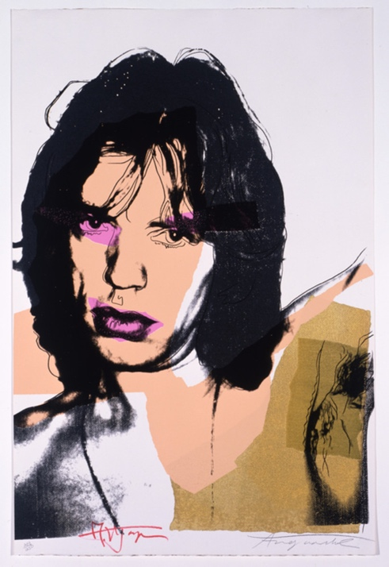

Andy Warhol, Mick Jagger, 1975
The Andy Warhol Museum, Pittsburgh; Founding Collection, Contribution The Andy Warhol Foundation for the Visual Arts, Inc.
© The Andy Warhol Foundation for the Visual Arts, Inc.
1998.1.2412.4

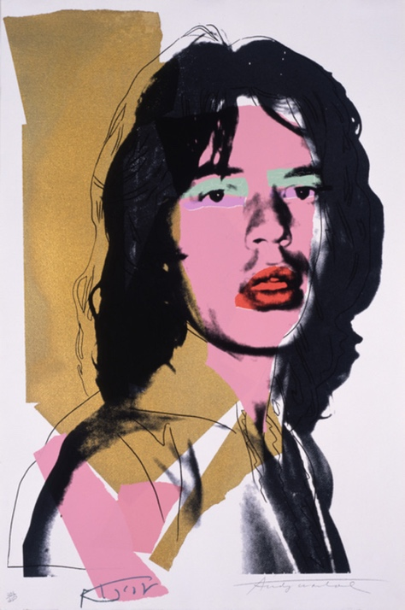

Andy Warhol, Mick Jagger, 1975
The Andy Warhol Museum, Pittsburgh; Founding Collection, Contribution The Andy Warhol Foundation for the Visual Arts, Inc.
© The Andy Warhol Foundation for the Visual Arts, Inc.
1998.1.2412.6

Materials
- Photocopier acetates (transparency film)
- Photographs/images of contemporary celebrities
- Colored background paper
- Clear tape
- Scissors
- Colored markers
- Glue
- Colored construction paper
- Metallic markers or permanent markers
- Foil paper
- Stickers

Procedure
Steps 1–4 should be completed prior to class or activity.
- Choose three to four images of current pop icons (magazine clippings and Internet sites are good sources for high contrast images). Examples include Beyoncé, Taylor Swift, Rihanna, Barack Obama, Adele etc.
- Using a photocopier, manipulate the images to the desired size. If you reduce the image to 5 1⁄2″ by 8 1⁄2″ you can place two images on one piece of 8 1⁄2″ by11″ acetate. Try to make the image high contrast (as black and white as possible with little to no gray tones) by using the copy machine’s “lighter” and “darker” functions. Usually this is indicated by the up and down arrows or under the “auto” or “image” density option.
- Copy this image onto photocopy acetate.
- Make two to four acetate copies of each pop icon.
- Have students choose a pop icon and colored background papers of the same size. Hinge the two together using clear tape. To make the hinge, place the tape on one edge of the acetate, and then fold it over to stick on the reverse side of the background paper. With this done, your two papers should open like a book.
- Create a base layer of color for your portrait. Warhol would paint on a canvas ﬁrst, and then print the photographic silkscreen image on top. For this project, the acetate acts as the ﬁnal printed layer. The image on the acetate has certain transparent areas; whatever is underneath those areas will be visible. Using cut or torn paper, create a collage pattern on the background paper so these colors show through the acetate.
- Colored foil paper, stamps, and markers can also be used for the “under-painting.” Metallic or permanent markers can be used to draw on top of the acetate surface.
- Have students create variation among their two to four acetates by changing elements, such as color and paper edges (ripped/torn edges and cut/smooth edges), adding linear elements using markers, and working with both the background areas and the subject areas.

Wrap-up
In a class critique, students present their artwork and discuss the following questions:
- Why did you choose certain colors and compositional elements?
- What is the cultural signiﬁcance of the pop icons selected?

Assessment
The following assessments can be used for this lesson using the downloadable assessment rubric.
- Aesthetics 2
- Creative process 3
- Creative process 5
- Critical thinking 1
- Critical thinking 2
- Historical context 1
- Historical context 4

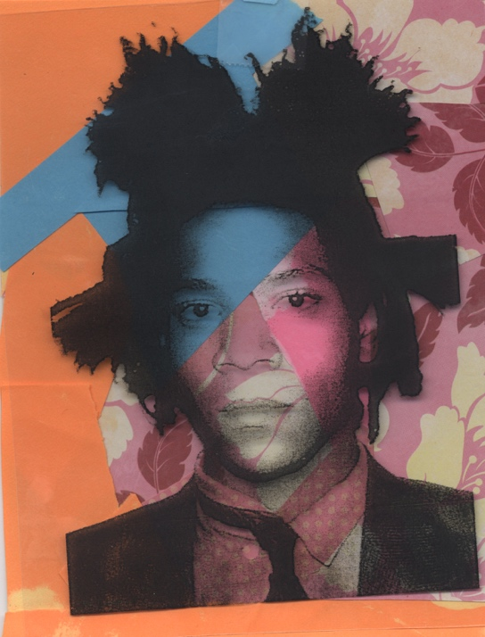

A student-made acetate collage featuring Jean-Michel Basquiat.

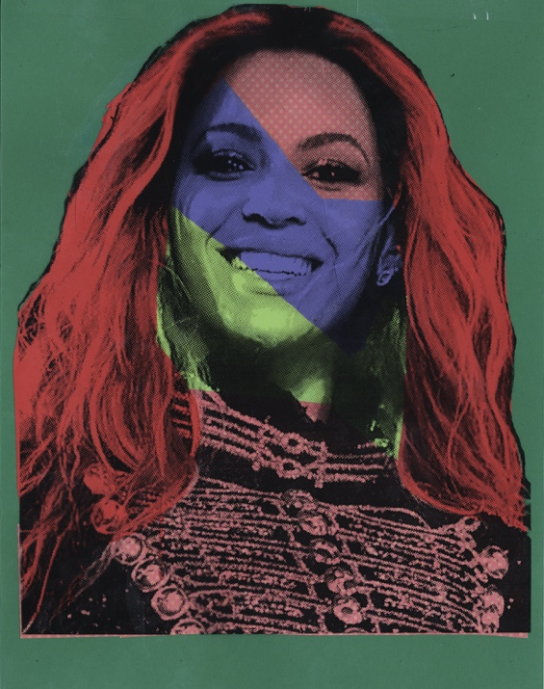

An acetate collage portrait of Beyoncé.

