Adobe Photoshop Tutorial
© The Andy Warhol Museum, one of the four Carnegie Museums of Pittsburgh. All rights reserved.
You may view and download the materials posted in this site for personal, informational, educational and non-commercial use only. The contents of this site may not be reproduced in any form beyond its original intent without the permission of The Andy Warhol Museum. except where noted, ownership of all material is The Andy Warhol Museum, Pittsburgh; Founding Collection, Contribution The Andy Warhol Foundation for the Visual Arts, Inc.

1. Open Photoshop, Click File---New. In the dialogue box, set your width and height in inches, (8.5 x 11 for small acetate, 13 x 19 for large), and set the DPI at 300. Hit Ok
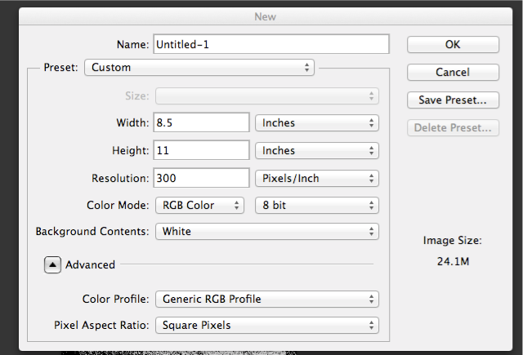

- You now have your “canvas” ready in the appropriate size. Next, you need to bring your image onto the canvas. Open your saved image in Photoshop. In the top toolbar, Click Select ---All. Then, hit Edit----Copy, also in the top toolbar.
- Go back to your new canvas and hit Edit----Paste. Your image is now on the canvas!
4. Now that you have pasted your image onto your new canvas, you need to resize it so it prints out as big as you desire. Using the Free Transform tool, Edit---Free Transform, Resize the image. Be sure to hold down the shift key so that your image stays proportional. To complete the transformation, hit the enter key.
- Turn your image Grayscale by clicking Image---Mode----Grayscale in the upper toolbar. Click ok to Discarding Layers.
- Next, you may want to adjust the contrast of the image so that there is less gray area for a more distinct looking, easier to print, final Bitmapped image. Image--- Adjustments---Brightness/Contrast. This may take some messing around with until you are satisfied with the image.
Example:
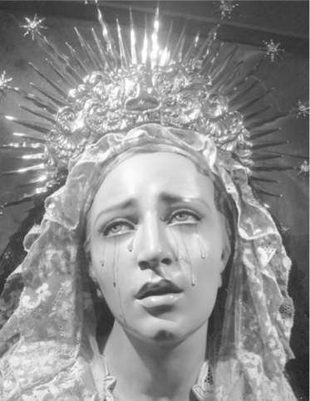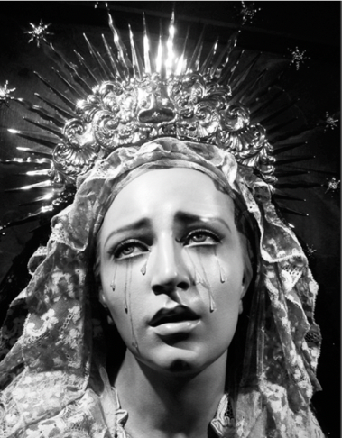

- After this has been completed, you will need to halftone your image to prepare for printing. Image----Mode---Bitmap. You will want the DPI to match, and yours is already set to 300, so make it 300, then choose halftone from the drop down menu.

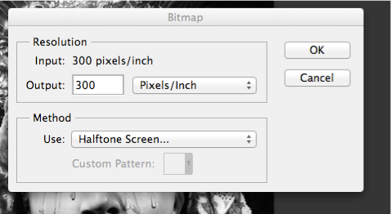
8. Hit Ok, and another dialogue box will come up:
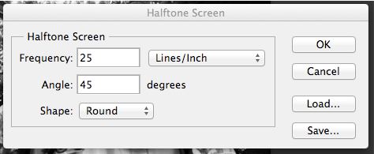

The number you put in frequency will affect how large or small the dots are that make up the image. It is advisable to never go above 30 for a silkscreen, as the dots will be too small to print well. Remember that the smaller the number, the larger the dots, the easier to print. This will also affect the look of the print, sometimes larger dots can be more visually appealing, but other times you want the the dots to not be noticeable. This is an artistic choice.
For now, keep the frequency at 45, as this affect the angle of the dot matrix. Under shape, you can choose the shape that will make up the dots. This is also an artistic choice you must make, but round and ellipse are used most commonly.
After clicking Ok, you will see your image has been bitmapped! It may look a little strange on the computer at first, but by zooming in and out (Command + and Command-) you can see what it will look like when printed. If you feel you need to readjust the contrast of the image, you can undo the bitmap and readjust, tweaking various setting like the Frequency until you have arrived at the image you like the best!
