Space Fruit Cards
© The Andy Warhol Museum, one of the four Carnegie Museums of Pittsburgh. All rights reserved.
You may view and download the materials posted in this site for personal, informational, educational and non-commercial use only. The contents of this site may not be reproduced in any form beyond its original intent without the permission of The Andy Warhol Museum. except where noted, ownership of all material is The Andy Warhol Museum, Pittsburgh; Founding Collection, Contribution The Andy Warhol Foundation for the Visual Arts, Inc.

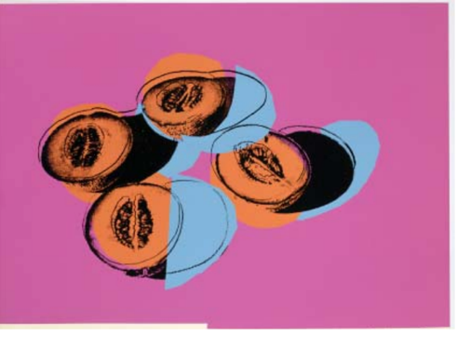  Andy Warhol, Space Fruit: Still Lifes (Cantaloupes II), 1979 Screen print on Lenox Museum Board, 30 x 40 in. © AWF | 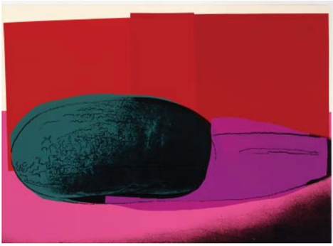  Andy Warhol, Space Fruit: Still Lifes (Watermelon), 1979 Screen print on Lenox Museum Board, 30 x 40 in.© AWF
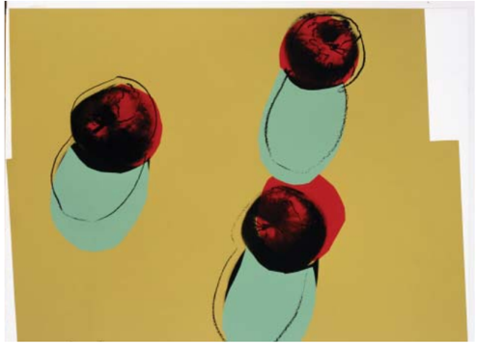  Andy Warhol, Space Fruit: Still Lifes (Apples), 1979 Screen print on Lenox Museum Board, 30 x 40 in. © AWF | 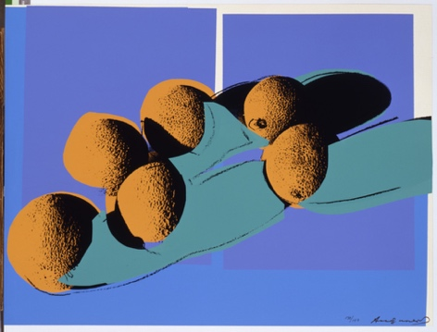  Andy Warhol, Space Fruit: Still Lifes (Cantaloupes I), 1979 The Andy Warhol Museum, Pittsburgh; Founding Collection © AWF
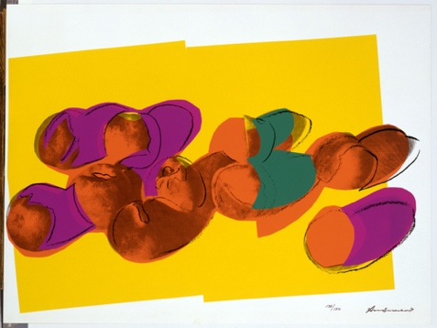  Andy Warhol, Space Fruit: Still Lifes (Peaches), 1979 Screen print on Lenox Museum Board, 30 x 40 in. © AWF | 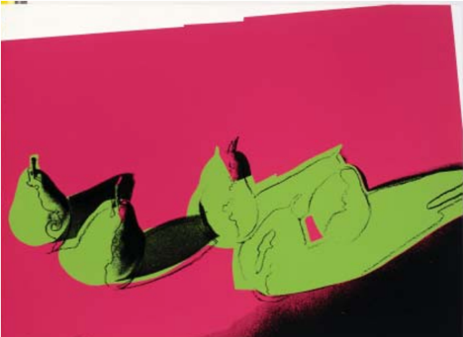  Andy Warhol, Space Fruit: Still Lifes (Pears), 1979 Screen print on Lenox Museum Board, 30 x 40 in. © AWF

