Color Terminology Handout
© The Andy Warhol Museum, one of the four Carnegie Museums of Pittsburgh. All rights reserved.
You may view and download the materials posted in this site for personal, informational, educational and non-commercial use only. The contents of this site may not be reproduced in any form beyond its original intent without the permission of The Andy Warhol Museum. except where noted, ownership of all material is The Andy Warhol Museum, Pittsburgh; Founding Collection, Contribution The Andy Warhol Foundation for the Visual Arts, Inc.

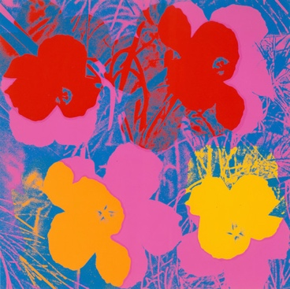  Andy Warhol, Flowers, 1970  The Andy Warhol Museum, Pittsburgh; Founding Collection, Contribution The Andy Warhol Foundation for the Visual Arts, Inc. © The Andy Warhol Foundation for the Visual  Arts, Inc. 1998.1.2395.3  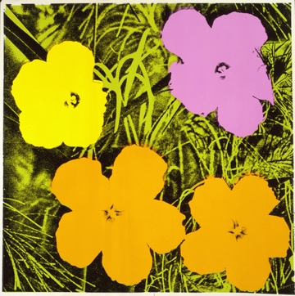  Andy Warhol, Flowers, 1970  The Andy Warhol Museum, Pittsburgh; Founding Collection, Contribution The Andy Warhol Foundation for the Visual Arts, Inc. © The Andy Warhol Foundation for the Visual  Arts, Inc. 1998.1.2395.4 | Hue: another name for a color.  Value: the lightness and darkness of a color.  Key color: dominant color in a color scheme or mixture.  Intensity or chroma: the brightness or dullness of a color.  Temperature (warm and cool colors): a color’s perceived sense of warmth or coolness. Aggressive (warm) colors: reds, oranges, and yellows. Receding (cool) colors: greens, blues, and violets.  Color Wheel: the essential elements of mixing color.  Color scheme: the combination of colors on the Color Wheel implemented by artists, designers, and illustrators.  Shade: color + black.  Tint: color + white.  Tone: color + gray.  Primary colors: red, yellow, and blue – cannot be mixed from any other colors.  Secondary colors: two primary colors mixed together resulting in orange, green, and violet. Tertiary colors: one primary color and one secondary color mixed together.  Complementary color scheme: combining a shade, tint, or tone of one color and the color opposite on the Color Wheel.  Analogous color scheme: using any shades, tints, or tones of colors that lie adjacent to each other on the Color Wheel.  Split-complementary color scheme: choosing one color and using the color to each side of its complement on the Color Wheel.  Diad: using two colors that are two colors apart on the Color Wheel. Example: red and orange.  Triad: color scheme in which three colors are equally spaced from each other. Example: the three primary colors – red, yellow, and blue.  Tetrad: a contrast of four or more colors on the Color Wheel.  Monochromatic: using any shade, tint, or tone of one color.  Achromatic: a colorless scheme using blacks, whites, and grays.  Neutral gray: combination of black and white.

