Introduction to Photographic Silkscreen Printing and Color Theory

© The Andy Warhol Museum, one of the four Carnegie Museums of Pittsburgh. All rights reserved.
You may view and download the materials posted in this site for personal, informational, educational and non-commercial use only. The contents of this site may not be reproduced in any form beyond its original intent without the permission of The Andy Warhol Museum. except where noted, ownership of all material is The Andy Warhol Museum, Pittsburgh; Founding Collection, Contribution The Andy Warhol Foundation for the Visual Arts, Inc.

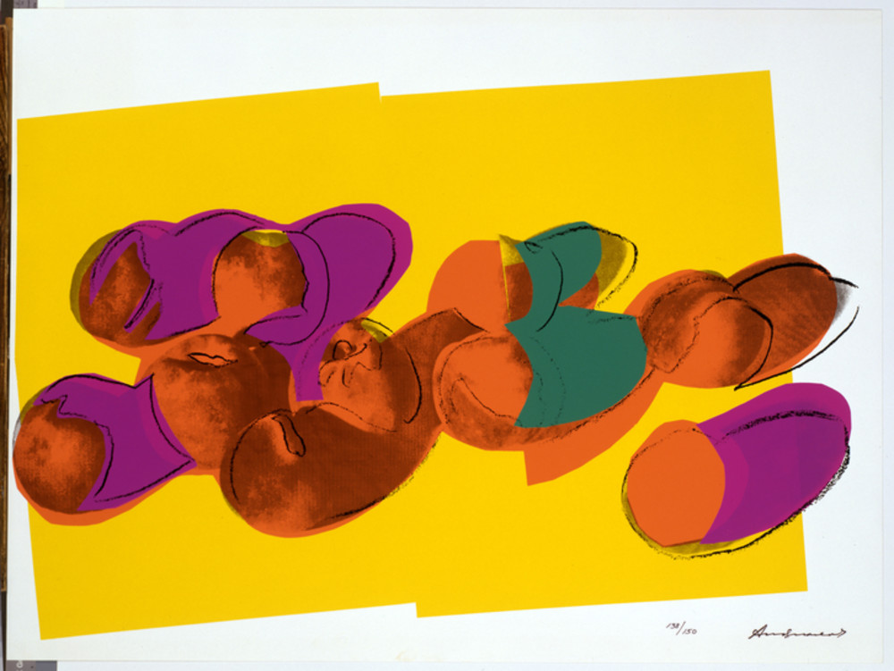

Overview
This lesson introduces basic concepts and terminology relating to color theory using Andy Warhol’s screen print imagery as examples. Students will learn the basics of Warhol’s unique underpainting and printing process through a demonstration video.

Grade Levels
- Middle school
- High school

Subjects
- Arts
- Art history
- Social studies and history

Objectives
- Students identify, describe, and discuss key aspects of Warhol’s silkscreen printing process.
- Students develop a working knowledge of the color wheel and its terminology.
- Students use color theory concepts and terminology to discuss Warhol’s use of color combinations.
- Students examine how the printing process allowed Warhol to create endless color combinations and compositions.

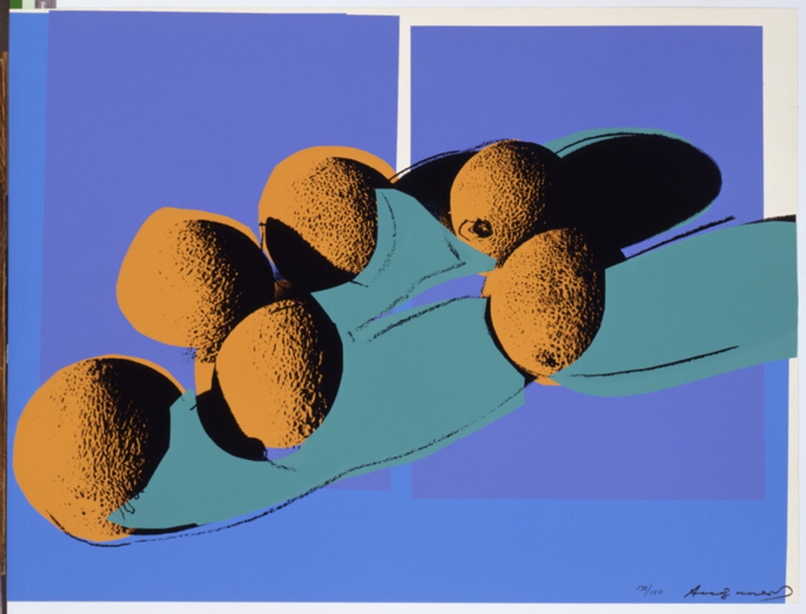

Andy Warhol, Space Fruit: Still Lifes (Cantaloupes I), 1979
The Andy Warhol Museum, Pittsburgh; Founding Collection, Contribution Dia Center for the Arts
2002.4.19.4

About the Art
Throughout his career, Warhol worked with assistants and printers to create numerous print portfolios. In 1977, he met printer Rupert Jasen Smith who worked with him to create the series Space Fruit. These prints demonstrate Warhol’s experimentation with a centuries-old genre in painting—the still life. Still lifes by their very nature are choreographed compositions focusing on shape, color, space, and oftentimes symbolism. Warhol was interested in using shadows as a compositional element. He first placed one or more pieces of fruit on a white background, lit the arrangement from an angled position so that shadows were cast onto the white paper, and then photographed these compositions. He also used collage and drawing to create the source imagery for the additional screens used in each print. This artwork is an example of a multilayer silkscreen print since each color represents a different silkscreened layer. This printing process allowed Warhol endless color combinations within each composition.

Points of View
“When I look at things, I always see the space they occupy. I always want the space to reappear, to make a comeback, because it’s lost space when there’s something in it.”
Andy Warhol, The Philosophy of Andy Warhol (From A to B and Back Again), 1975

“When I have to think about it, I know the picture is wrong. And sizing is a form of thinking and coloring is too. My instinct about painting says, 'If you don’t think about it, it's right.’ As soon as you have to decide and choose, it's wrong. And the more you decide about, the more wrong it gets. Some people, they paint abstract, so they sit there thinking about it because their thinking makes them feel they're doing something. But my thinking never makes me feel I'm doing anything.”
Andy Warhol, The Philosophy of Andy Warhol (From A to B and Back Again), 1975

Vocabulary
- Photographic silkscreen printing: This printing process uses a light sensitive emulsion applied directly to the silkscreen in order to expose a film positive of the image, using a proper light source.
- Multilayer silkscreen printing: The use of multiple photographic silkscreens or cut stencils used with open silkscreens to create a multilayered silkscreen print.
- Film positive: A clear film used for exposing an image onto a silkscreen. The most common types of media used for film positives are inkjet film and vellum paper.
- Color wheel: A circle with different colored sections used to show the relationship between colors and the essential elements of mixing color.
- Color scheme: The combination of colors on the color wheel implemented by artists, designers, and illustrators.
- Color theory: The science and art of color; how we perceive color, how we mix color, and the visual effects of specific color combinations. See the Color Terminology Handout.

Discussion Questions
- Look carefully at the print Space Fruit: Still Lifes (Cantaloupes I). How did Warhol use photography, collage, drawing, and silkscreening in this print?
- Analyze all of the prints together in the Space Fruit series using the following prompts:
- What color combinations does Warhol use? Are the colors realistic? Are they appealing? Why or why not?
- How is the fruit arranged? How does Warhol use shadows in the compositions?

Materials
- Powerpoint: Silkscreen Printing: Introduction & Color Theory
- Digital projector
- Color wheels
- Pencils
- Color Terminology handout
- Cards of Warhol’s Space Fruit series handout
- Warhol’s Space Fruit student worksheet handout

Procedure
- Introduce the unit by showing students the first section of the Powerpoint Silkscreen Printing: Introduction & Color Theory. Review the video of Warhol’s silkscreen printing technique.
- Introduce the concept of the color wheel to students and why artists use it. Review color theory with students, asking what they know about color and shape. For more information on the color wheel and color theory, visit Color Matters.
Break students into groups of two to four and give each group a color wheel and a color terminology handout. A word bank of color terminology could also be written on the board.
- Briefly discuss the terminology.
- Give each group two Space Fruit cards and a Student Worksheet handout. Instruct students to work together to answer the questions on the sheet.

Wrap-up
When all groups are finished, ask students to decide:
- What three colors would they use to make a triad still-life print?
- What four colors would they use to make a tetrad still-life print?

Assessments
- Aesthetics 2
- Communication 3
- Creative process 6

