Gathering and Manipulating Source Images

© The Andy Warhol Museum, one of the four Carnegie Museums of Pittsburgh. All rights reserved.
You may view and download the materials posted in this site for personal, informational, educational and non-commercial use only. The contents of this site may not be reproduced in any form beyond its original intent without the permission of The Andy Warhol Museum. except where noted, ownership of all material is The Andy Warhol Museum, Pittsburgh; Founding Collection, Contribution The Andy Warhol Foundation for the Visual Arts, Inc.

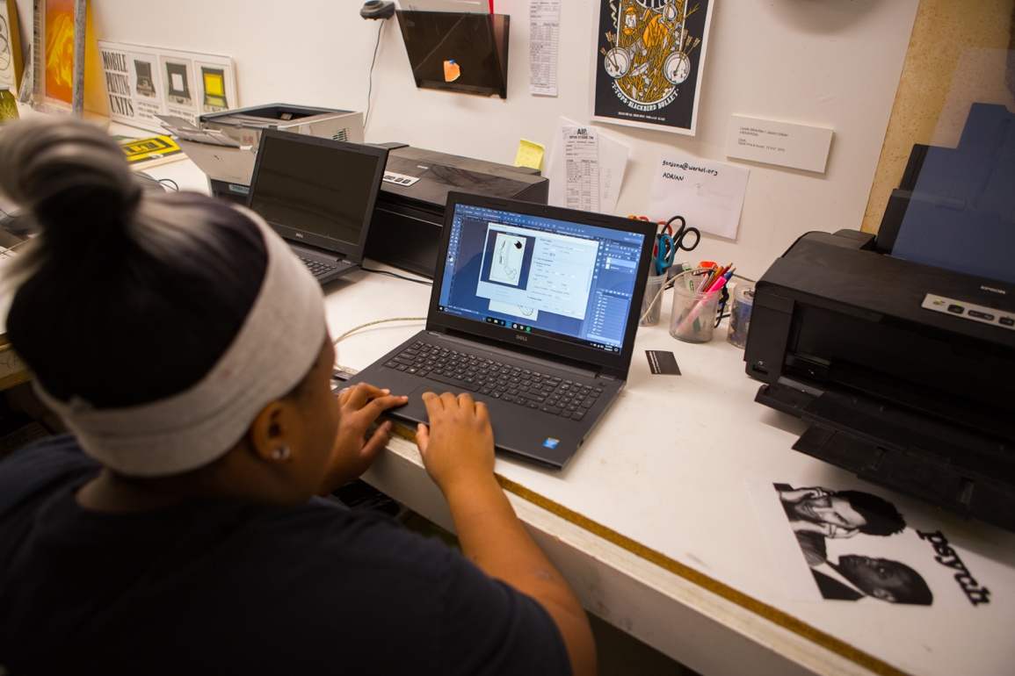

Overview
Students use Andy Warhol’s processes of gathering images for source material using appropriation, photography, and still life arrangements. Students will digitally manipulate their images using Adobe Photoshop in order to create a film positive to expose onto their silkscreens.

Grade Levels
- Middle school
- High school

Subjects
- Arts
- Art history
- Social studies and history

Objectives
- Students discuss Warhol’s photographic process and use of lighting, cropping, editing and contrasting to manipulate images as source material for his art.
- Students use digital cameras or phones to take photos for source imagery for their silkscreens.
- Students demonstrate working knowledge of Adobe Photoshop to digitally manipulate images.

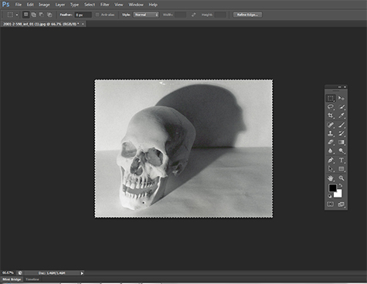

Digital image of a skull opened for editing in Adobe Photoshop.

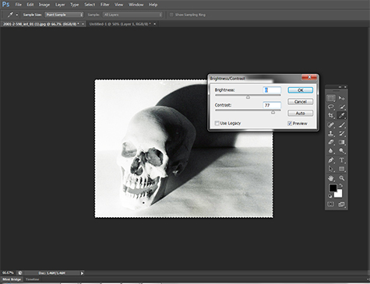

Adjusting the brightness and contrast of an image in Adobe Photoshop.

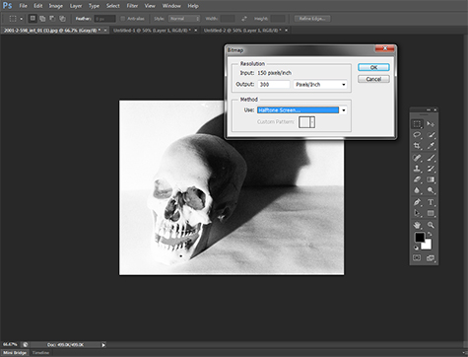

Bitmapping the digital image in Adobe Photoshop.

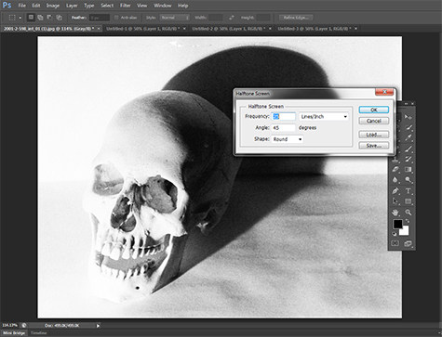

Adjusting the half tone on the image in Adobe Photoshop.

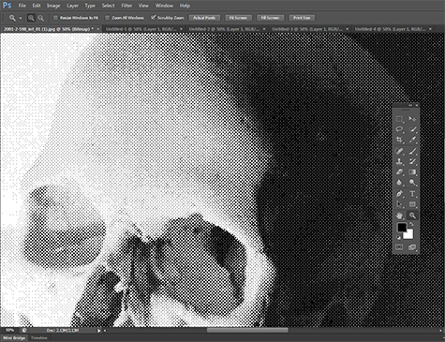

A close up of an image that has been bitmapped in Adobe Photoshop.

Vocabulary
- Adobe Photoshop: Image editing software that allows users to manipulate, crop, resize, bitmap, and adjust color on digital photos.
- Cropping: The process of removing portions of a photo to edit out information, create focus, or strengthen the composition.
- Contrast: The degree of difference between the white and black tones of a photograph, or other image. High contrast images have bright highlights and dark shadows.
- Levels: Refer to the brightness, contrast and tonal range of an image.
- Bitmap: Bitmapping turns a grayscale image into a series of dots representing different values.

Discussion Questions
- How did Warhol use lighting, cropping, editing, and contrasting to manipulate his source images for photographic silkscreen printing?
- Warhol’s source images were usually tightly cropped and highly contrasted before sending them off to the printer to be exposed on a screen. Why did Warhol do this? What aesthetic was he trying to achieve?

Materials
- Powerpoint: Gathering and Manipulating Source Images
- Digital cameras or phones
- Computers with Adobe Photoshop
- Transparency or clear film for film positives. (Select clear film suited for your type of printer.)
- Adobe Photoshop Tutorial Handout
- Inkjet printer or laser printer and photocopier

Procedure
- Review the Gathering and Manipulating Source Images section of the Powerpoint as a class. Discuss Warhol’s photographic process and use of lighting, cropping, editing, and contrasting to manipulate images.
- Students take photographs using digital cameras or phones, either inside or outside the school building. Possible Warhol-related subject matter: still-life arrangements of popular objects, abstract patterns found in nature, portraits, or architectural elements.
- Upload the images onto the computer and open them in Adobe Photoshop. Distribute tutorial handouts. Explain to students that they will use the tutorial to crop their images and transform them into high contrast bitmaps.
- Students follow tutorial instructions independently (or work with a partner) to create a bitmap of their manipulated image and save their work.
- Assist students in printing their images onto clear film using an inkjet printer, or print images onto paper and then copy onto transparency film to create their film positive. Be sure to select the clear film suited for your type of printer or copier.

Wrap-up
When all groups are finished, hang up the film positives and discuss as a class:
- Are all of the images properly bitmapped? Why or why not? (Ex: if the dot looks too small it most-likely will not burn properly to the screen.)
- Compare the bitmapped image with the original image. Is it adequately cropped and high contrast?

Assessments
- Communication 4
- Creative process 3
- Creative process 5
- Critical thinking 1

