Exposing Photographic Silkscreens

© The Andy Warhol Museum, one of the four Carnegie Museums of Pittsburgh. All rights reserved.
You may view and download the materials posted in this site for personal, informational, educational and non-commercial use only. The contents of this site may not be reproduced in any form beyond its original intent without the permission of The Andy Warhol Museum. except where noted, ownership of all material is The Andy Warhol Museum, Pittsburgh; Founding Collection, Contribution The Andy Warhol Foundation for the Visual Arts, Inc.

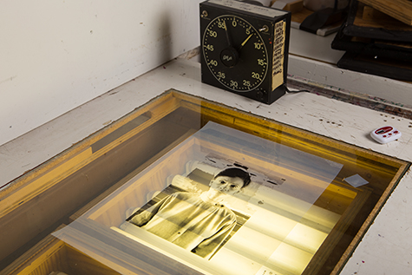

Overview
This lesson walks students through the process of coating silkscreens with light sensitive emulsion, drying coated screens, and exposing screens using their ﬁlm positives.

Grade Levels
- Middle school
- High school

Subjects
- Arts
- Art history
- Social studies and history

Objectives
- Students will learn how a source image is exposed on a silkscreen.
- Students will apply the proper steps of coating, drying and exposing their images onto their silkscreen.

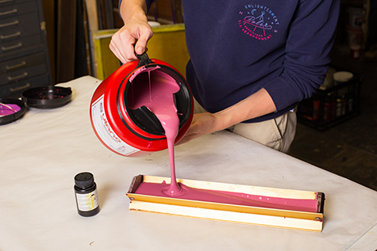

A student pours photo emulsion into a scoop coater.

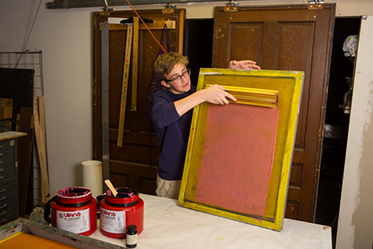

A student pulls a scoop coater across the screen to coat it.

A student places the coated silkscreen underneath a wooden cabinet.

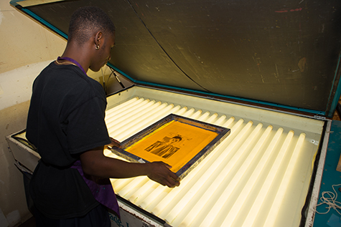

A student exposing a film positive onto a coated silkscreen on a light table.

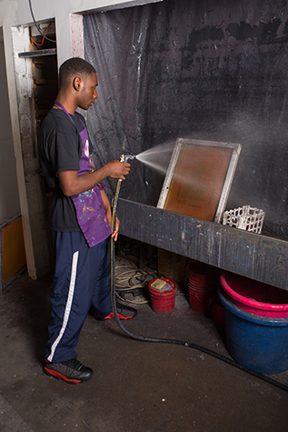

A student washes the emulsion out of the exposed silkscreen.

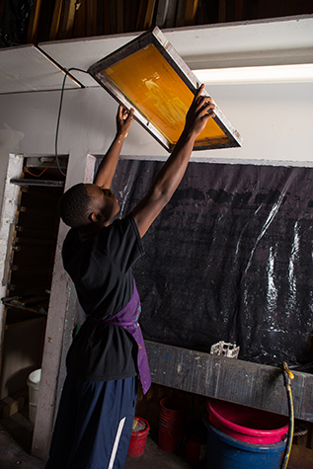

A student checks a silkscreen to see if it is properly cleaned.

Vocabulary
- Photo emulsion: A light sensitive chemical that is applied to a screen and used to expose an image onto the screen.
- Scoop coater: A metal trough used to apply a smooth, even coat of emulsion to an open silkscreen before exposing the image onto the screen.

Discussion Questions
Review the Preparing and Exposing Photographic Silkscreens Powerpoint then ask students:
- How is an image transferred onto a silkscreen?
- What does it mean to “expose” an image onto a screen?

Materials
- Powerpoint: Preparing and Exposing Photographic Silkscreens
- Screen printing emulsion for water-based inks
- One open silkscreen for every 5 students
- One silkscreen per student for the photographic layer (or two students per screen if screens are limited)
- Students’ film positive transparencies
- Dishwashing liquid for cleaning ink out of screens
- Scoop coater
- Light-tight box or dark room
- Exposing unit
- Comet cleanser for degreasing the screens if they are brand new

Procedure
- Review the Powerpoint: Preparing and Exposing Photographic Silkscreens as a class.
- If your screens are new, clean them ﬁrst with Comet to degrease the screen.
- Read and follow all of the instructions that come with the emulsion. Sensitize the emulsion, stir, and let sit for 60 minutes to allow time for the air bubbles to rise to the surface.
- In a darkened room or in a room with a yellow safe light, coat silkscreens with the emulsion and scoop coater. Follow the directions included with the emulsion.
- Store the coated silkscreens in a dark room or light-tight box until they are dry. Screens may be stacked on top of each other using blocks in between to save space. Screens should dry with the ﬂat side down.
- Once the screens are dry they may be put in black plastic garbage bags until you are ready to expose them.
- Expose the silkscreen with the students’ film positives. A screen exposure chart should be included with your emulsion. If not, you will need to test exposure times. A good time to start with is 5 minutes.
- Immediately following exposure, wash out the screens with water and a sponge, or a spray nozzle if you have one in your classroom. You will see some of the emulsion begin to leave the screen in the areas that were protected by the image printed on the film positive. Follow the wash-out instructions included with the emulsion. Dry the screens completely before the students print their ﬁrst layers.

Wrap-up
When all groups are finished exposing and drying their screens, complete the following:
- Have students use masking tape to tape off the areas around the edges of the screen where there is no emulsion.
- Have students pull a proof of their silkscreen to ensure that the image was exposed properly.

Assessments
- Communication 3
- Communication 4
- Creative Process 2

