Underpainting and Photographic Silkscreen Printing

© The Andy Warhol Museum, one of the four Carnegie Museums of Pittsburgh. All rights reserved.
You may view and download the materials posted in this site for personal, informational, educational and non-commercial use only. The contents of this site may not be reproduced in any form beyond its original intent without the permission of The Andy Warhol Museum. except where noted, ownership of all material is The Andy Warhol Museum, Pittsburgh; Founding Collection, Contribution The Andy Warhol Foundation for the Visual Arts, Inc.

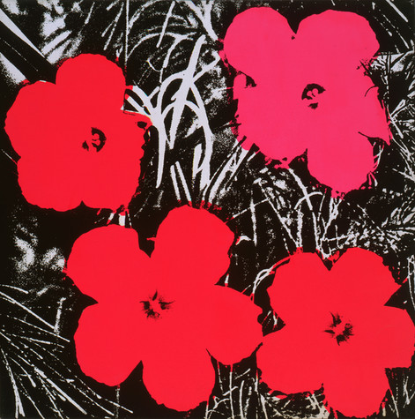

Overview
This lesson walks students through Warhol’s underpainting and photographic silkscreen printing process using their own source material and silkscreens.

Grade Levels
- Middle school
- High school

Subjects
- Arts
- Art history
- Social studies and history

Objectives
- Students will discuss the advantages and disadvantages of using a mechanized process like silkscreening to produce works of art.
- Students will demonstrate the proper steps of the photographic silkscreen printing process.
- Students will apply Warhol’s process of tracing and underpainting as a base layer for their final silkscreen print.

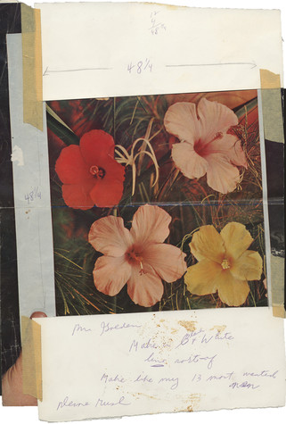

Andy Warhol, 1964
The Andy Warhol Museum, Pittsburgh; Founding Collection, Contribution The Andy Warhol Foundation for the Visual Arts, Inc.
T372

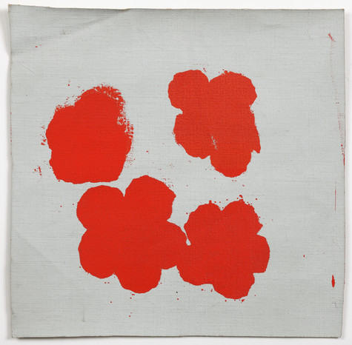

Andy Warhol, Flowers (unfinished), 1965
The Andy Warhol Museum, Pittsburgh; Founding Collection, Contribution The Andy Warhol Foundation for the Visual Arts, Inc.
T765

Andy Warhol, Flowers, 1964-65
The Andy Warhol Museum, Pittsburgh; Founding Collection, Contribution The Andy Warhol Foundation for the Visual Arts, Inc. © The Andy Warhol Foundation for the Visual Arts, Inc.
1998.1.28

About the Art
Andy Warhol turned to his most notable style—photographic silkscreen printing-- in 1962. This commercial process allowed him to easily reproduce the images that he appropriated from popular culture. Warhol’s Flowers series is a portfolio of ten screenprints and hundreds of paintings based off of photographs taken by Patricia Caulfield, which were featured in the June 1964 issue of Modern Photography magazine. After selecting the image, Warhol sent it to a commercial silkscreen maker with a note as to the desired dimensions of the screen and the number of colors to be printed. After the image was exposed and the screen was prepared for printing, it was returned to The Factory, Warhol’s New York City studio. The photographic silkscreen printing process created a precise and deﬁned image and allowed Warhol and his assistants to mass-produce a large number of prints with relative ease. While the flowers originate from realistic photographs, Warhol altered his versions of the flowers, by flattening, cropping, and increasing the contrast of the image, then painting them using vivid colors. Caulfield saw the initial prints and took legal action against Warhol. Warhol offered her a couple of prints in hopes of settling the dispute, but she declined the offer. They settled and in 1964 Warhol went on to exhibit his Flowers at the prominent Leo Castelli Gallery. While Warhol didn’t invent the photographic silkscreen process, he developed his own technique by combining hand-painted backgrounds with photographic silkscreen printed images to create unique works of art.

Points of View
“I tried doing them by hand, but I find it easier to use a screen. This way, I don’t have to work on my objects at all. One of my assistants or anyone else, for that matter, can reproduce the design as well as I could.”
Andy Warhol, Andy Warhol, 1969

“The reason I’m painting this way is that I want to be a machine.”
Andy Warhol, Art News, 1962

Vocabulary
- Tracing: A simple outline of the image from the film positive that serves as the guideline for the underpainting.
- Underpainting: A process of tracing simple outlines of the photographic image onto the canvas and painting in blocks of color prior to adding a final silkscreen layer.
- Registration: The process of lining up the image on the screen to the underpainting and/or color separations for a multilayer print.

Discussion Questions
- Warhol developed the process of underpainting before adding the final photographic silkscreen print. What were the advantages of underpainting as opposed to making a multilayer print with multiple silkscreens?
- Discuss this quote by Warhol as a class: “The reason I’m painting this way is that I want to be a machine.”
- Ask students what they think Warhol meant by this. What are the advantages and disadvantages of painting “like a machine”?
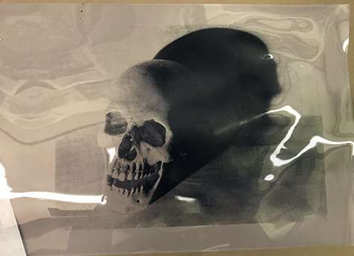

Film positive of source image.

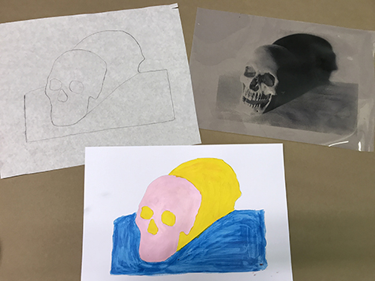

Film positive, tracing and underpainting of source image.

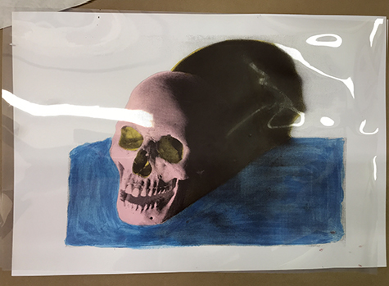

Checking color and composition by overlaying the film positive on top of the underpainting.

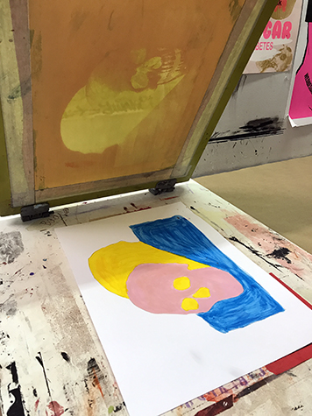

Registering the underpainting to the silkscreen.

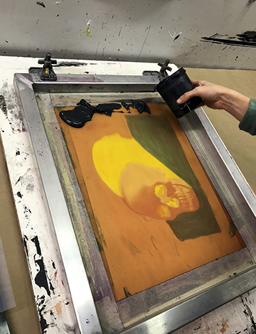

Applying ink to the silkscreen before printing.

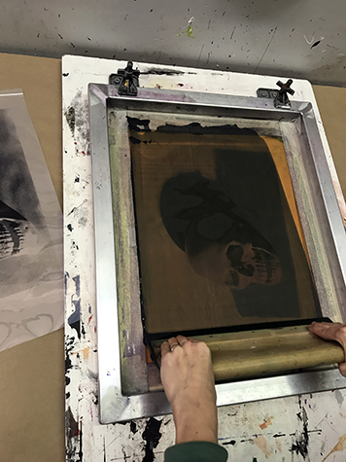

Using a squeegee to pull the ink across the image on the silkscreen.

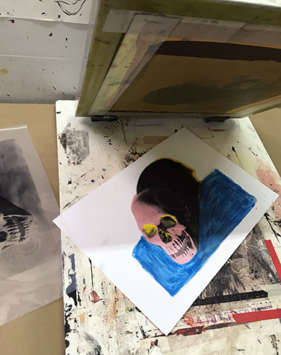

Final photographic layer printed in black on top of the underpainting.

Materials
- Powerpoint: Underpainting and Printing
- Paper (note: this lesson is designed around an 8 ½" x 11" print. The directions do however apply to any size screen and project.)
- Silkscreen exposed in Lesson 3
- Squeegee
- Film positive
- Tracing paper
- Graphite paper
- Pencils
- Acrylic paint
- Water-based screen printing ink
- Brushes
- Ink spatula
- Plastic scrapers

Procedure
- Review the process video of Warhol’s silkscreen printing technique and the Underpainting and Printing section of the Powerpoint as a class.
- Tracing: Make a tracing of the image from the film positive. This will serve as the guideline for the under painting. Trace only the general shapes such as contours of hair, shoulders, eyes, nose, lips, etc.
- Registering and transferring: Use your tracing to register or place the image onto the paper you will be printing on. The size of your paper depends on how much space you want as a border around your image. As an example, if you wanted to have a two inch border all the way around an 8.5" x 11" print, your paper size would be 12.5" x 15". Center the tracing onto the paper then lightly tape it down to hold it in place. Slip a sheet of graphite paper underneath the tracing paper. Retrace the image to transfer it to the paper. Once this is complete you can begin the underpainting.
- Underpainting: Paint the areas on the paper you have traced. As you begin to underpaint keep the film positive handy so you have an idea about which areas will be printed and which will not. The areas that are black on the film positive will print with the color ink chosen. Knowing this might help you decide which areas to paint. Try not to leave any lumps of paint on your surface: if the painted surface is smooth it is easier to print. Once the paint is dry, you are ready to print.
- Registration: There are a number of ways to set up your screen when doing multiple prints. A very efficient way is to have the screen hinged to your work surface. This eliminates the need to have people holding the screen in place while printing. If you don’t have a hinged screen you can register your silkscreen and your paper together onto your printing surface using masking tape to mark the position (this will work if all papers are the same size and image is in the same place).
- First you need to mark where your paper will be placed on the table. Use masking tape to mark the corners. Now each paper will be placed in the same spot on the table.
- Second, register/line up your film positive onto the under-painted image. Lightly tape the film positive to the paper to hold it in place.
- Third, register/line up your screen to the film positive. Lay the silkscreen (squeegee side up) on top of your paper. Look through the open areas on the silkscreen and use the film positive underneath to line up the image. Mark the spots where the corners of the silkscreen are on your printing surface with masking tape. Once you have marked your work surface, each time you print you will know where both paper and screen go.
- Printing: The person who is printing will use the squeegee to push the ink through the screen. The squeegee should be held against the screen surface at an 80-90 degree angle as you make a pass. When the squeegee reaches the bottom of the image, scoop the excess ink up with the squeegee and return to the top of the image for a second pass if needed. Always press down on the squeegee firmly and move in a smooth continuous motion. If you do not have your screen secured with hinge clamps, have another person hold your screen down securely while printing.
- Removing the screen from your print: If the screen is on a hinge clamp lift up the screen and prop it up. Remove the print and place another piece of paper down to begin again. Once you begin to print you need to work quickly because the ink can dry in the screen in a short period.
If you don’t have hinge clamps, place the squeegee to one side of the screen and lift the screen off the print like you are opening a book. Take out the print and place another paper down in the registration marks and begin again.
- Cleaning Screen: The ink on the screen will begin to dry and can ruin future prints if not cleaned promptly. To wash the screen, remove any excess ink with a rubber scraper then spray with water. You can wash with a soft sponge and mild soap. Do not use any rough abrasive cleaners or scrub sponges on the screen. Let the screen dry before printing again.

Extension: For the underpainted layer, students could create a collage using torn or cut paper instead of paint. The finished product will have the look of Andy Warhol’s Mick Jagger portraits.

Wrap-up
After the final silkscreen prints are dry, hang them up and conduct a class critique. One technique to try is the “Sandwich Critique” which consists of bread (compliment), meat (constructive criticism), and more bread (another compliment). This technique ensures a positive start and end to the critique while allowing suggestions for improvement. Here are a few questions that could help guide the critique:
- Is the underpainting successful?
  - Color scheme: Student considered color theory when choosing their colors (ex: warm or cool colors to convey a mood, complimentary colors to create contrast and balance, analogous colors for visual appeal.etc.)
  - Paint application: Did the student leave any lumps of paint on the surface that interfered with the final print layer?
- Is the final printed layer successful?
  - Registration: Student carefully registered their print so that it lined up with the underpainting.
  - Printing: Did the student apply too much or too little ink when silkscreening? Was a proper amount of pressure used when making a pass with the squeegee?

Assessments
- Aesthetics 1
- Communication 3
- Creative process 4
- Creative process 5

