Cutting Stencils for a Multilayer Print

© The Andy Warhol Museum, one of the four Carnegie Museums of Pittsburgh. All rights reserved.
You may view and download the materials posted in this site for personal, informational, educational and non-commercial use only. The contents of this site may not be reproduced in any form beyond its original intent without the permission of The Andy Warhol Museum. except where noted, ownership of all material is The Andy Warhol Museum, Pittsburgh; Founding Collection, Contribution The Andy Warhol Foundation for the Visual Arts, Inc.

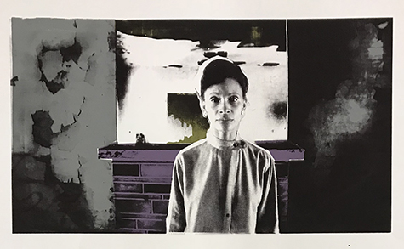

Overview
Students learn the process for cutting stencils in order to create different color combinations and compositions for their photographic silkscreen print series.

Grade Levels
- Middle school
- High school

Subjects
- Arts
- Art history
- Social studies and history

Objectives
- Students plan a four step process to print layers of color using multiple silkscreens.
- Students demonstrate an understanding of color theory in their design choices.
- Students separate their print into three different color layers then cut stencils for each of those layers.

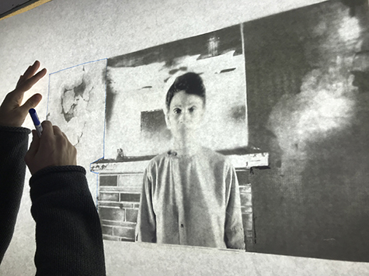

Student using a film positive to trace outlines for their first stencil.

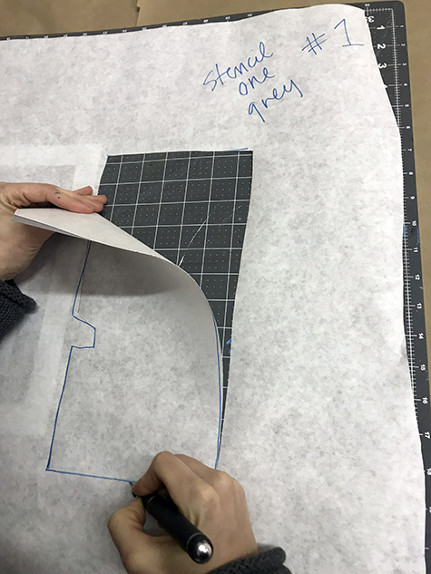

Student using an X-acto knife to cut out their stencil.

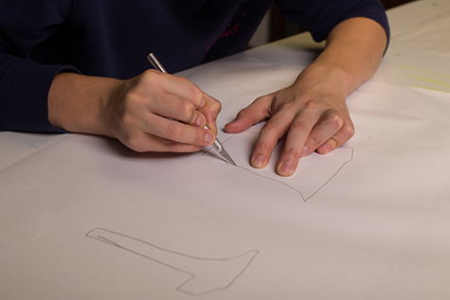

Student using an X-acto knife to cut out shapes for their second stencil.

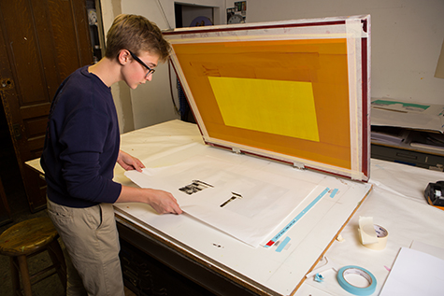

Student checking the alignment of their stencil underneath silkscreen.

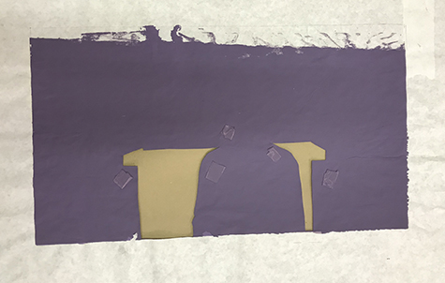

A used paper stencil that has been painted over in purple ink.

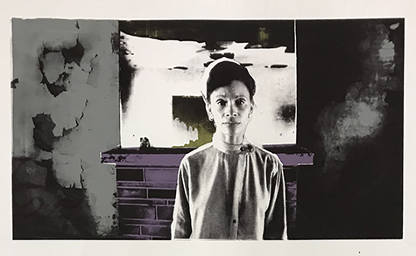

A finished multilayer silkscreen print made using stencils.

Materials
- Powerpoint: Cutting Stencils for Multilayer Prints
- Students will need their film positives from previous lesson
- Bond paper or white craft paper – (for a one-time use stencil) the size of the inside dimensions of the silkscreen
- Duralar – (for a reusable stencil) the size of the inside dimensions of the silkscreen
- Cutting tool – Xacto knife
- Pencil or marker
- Light table

Procedure
- Review the Cutting Stencils for Multilayer Prints section of the Powerpoint as a class.
- Each student needs three pieces of paper or Duralar cut to the size of the inside dimensions of their silkscreen. Students will be making three stencils, one for each of the three layers of color in their print. The 4th and final layer of color will be the photographic image that students exposed on their screen in lesson three.
- Using their film positives, have students place one piece of paper or Duralar over their film positive on a light table .
- The ﬁrst stencil is Layer 1– students should decide the color they are going to print first and then trace only the shape(s) associated with that color. Students should mark their stencils with the layer number and color, for example “Layer 1– gray”.
- Carefully cut out the shape(s) using a cutting tool.
- Continuing to use their film positives, students will trace the shape(s) for Layer 2 and Layer 3 in the center of another piece of paper. Cut out these shapes, as well.

Note: If your students are printing more than one color combination, have them cut extra paper stencils for each layer because the stencils are discarded after printing each layer or cut stencils from Duralar, since those may be used multiple times.

Wrap-up
After students have finished cutting out their three stencils they can prepare for printing in the next lesson by mixing their three ink colors:
- Mix ink in re-sealable containers.
- Label ink with student’s name and layer number.

Assessments
- Aesthetics 1
- Creative process 4
- Creative Process 5

