Silkscreen Printing with Stencils

© The Andy Warhol Museum, one of the four Carnegie Museums of Pittsburgh. All rights reserved.
You may view and download the materials posted in this site for personal, informational, educational and non-commercial use only. The contents of this site may not be reproduced in any form beyond its original intent without the permission of The Andy Warhol Museum. except where noted, ownership of all material is The Andy Warhol Museum, Pittsburgh; Founding Collection, Contribution The Andy Warhol Foundation for the Visual Arts, Inc.

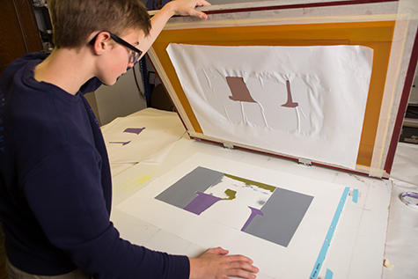

Overview
This lesson explains the process for printing the stencils and photographic layer of the multilayer print to create a series of prints.

Grade Levels
- Middle school
- High school

Subjects
- Arts
- Art history
- Social studies and history

Objectives
- Students practice mixing colors to create varying color combinations.
- Students apply stencil and photographic silkscreen processes to create a series of prints.
- Students critique their print series with their peers focusing on color and composition.

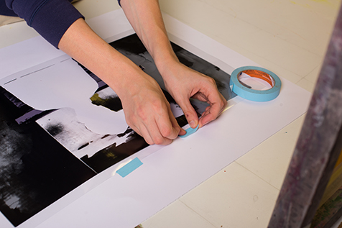

A student using tape to line up and register a stencil.

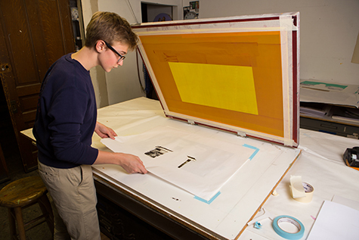

A student checking the alignment of their stencil underneath a silkscreen.

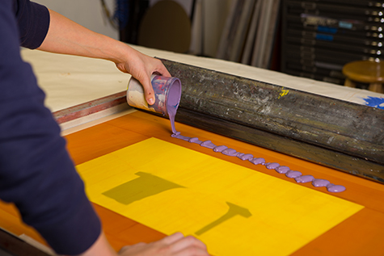

A student pours ink onto the silkscreen.

A student lifting silkscreen after printing with stencil.

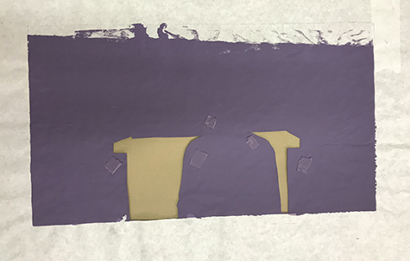

A used paper stencil that has been printed over in purple ink.

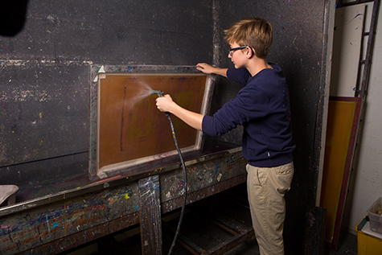

A student washing out a silkscreen after printing.

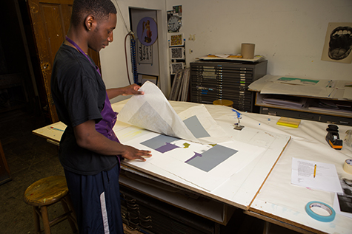

A student putting an additional stencil layer to his print.

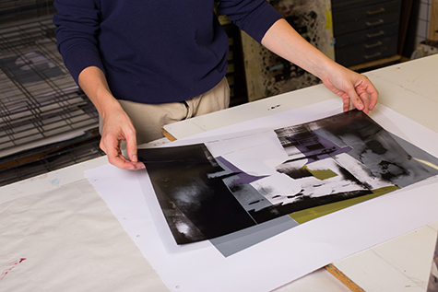

A student checking his film positive over his multiple layers.

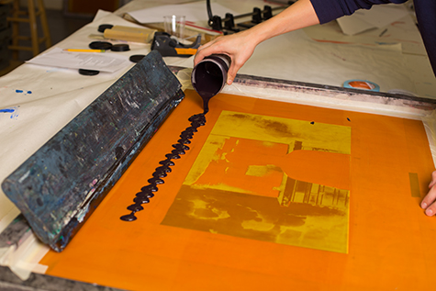

A student printing his final photographic silkscreen layer in black ink.

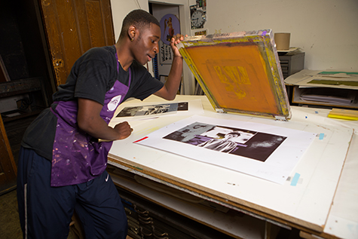

A student checking his final printed layer.

Vocabulary
- Hinge clamps: A clamping system for screen printing in which the screen is held in place by clamps and hinges.
- Registration: The process of lining up the image on the screen to the underpainting and/or color separations for a multilayer print.
- Tape brackets: L-shaped registration marks usually made with tape, used for aligning a screen image to the underpainting or source art.

Materials
- Powerpoint: Silkscreen Printing with Stencils
- Two-inch masking tape
- ¾” blue painter’s tape
- Ten pieces of final printing paper for each student. An economical paper for silkscreen is two-ply Bristol Board sold in pads of twenty sheets. For an even better deal, go to your nearest office supply store and use 11” x 17” reams of paper that are similar in thickness to the two-ply Bristol board
- Silkscreens: the exposed screen prepared in lesson 3 and 4. Plus an open screen (one that has no emulsion on it)
- Squeegees
- Hinge clamps

Procedure
- Review the Powerpoint Silkscreen Printing with Stencils as a class.
- Mixing Ink: students should mix all three colors of ink prior to printing:
• Mix ink in re-sealable containers.
• Label ink with student’s name and layer number.
Printing:
- Use masking tape to tape off the areas of the screen where there is no emulsion, tape both the front and back of the screen, making sure not to tape over the image.
- Place your open silkscreen in the hinge clamps, securely tightening the clamps.
- Line up the film positive to one piece of the printing paper then secure it with pieces of blue painter’s tape.
- Place your paper with the film positive under your screen and register the open screen to the edges of your film positive. Use the blue painter’s tape to mark the edges of your paper on the table you are printing on. This will show you where to put the paper for each print.
- Now place your stencil over your film positive to register your stencil. Carefully remove the small pieces of blue painter’s tape holding the film positive in place on the paper. Take care to not move the stencil from its position.
- Carefully close the screen over the stencil paper and print the ﬁrst color using enough ink for adequate coverage.
- The stencil will stick to the back of the silkscreen because the ink acts as an adhesive. Starting from a top corner, slowly peel the stencil away from the screen.
- For large areas of color you may need to make two passes (or more) with the squeegee.
- Continue this process, placing each piece of paper inside the tape corners until all ten pieces of paper are printed.
- Remove the stencil from the silkscreen and discard.
- Clean the open silkscreen and squeegee thoroughly. The two-inch tape you placed around the edges of the silkscreen in step 11 should remain until you are ﬁnished printing your entire print.
- Making sure the silkscreen is completely dry, place your taped silkscreen into the hinge clamps and securely tighten the clamps.
- When layer 1 of your print is dry, register your next stencil (layer 2) to the film positive. Once it is in the correct place, use two small pieces of painter’s tape to secure it to the print. Remove the film positive.
- Repeat Steps 5-12.
- When layer 2 of your print is dry, register your next stencil (layer 3) to the film positive. Once it is in the correct place, use two small pieces of painter’s tape to secure it to the print. Remove the film positive.
- Repeat Steps 5-12.
- To print layer 4, the final photographic image, register your film positive to your print using small pieces of painter’s tape to secure it to the print.
- Tape the edges of the screen with the two-inch tape on both sides (as in step 1). Securely tighten your silkscreen with the photographic image exposed on it in the hinge clamps.
- Register your print to the screen and place tape marks on the corners of three edges of your paper. Remove the film positive.
- Print your final layer.
- Clean your screen. Be sure that no ink is left in the open holes of the screen. Use the soft side of a sponge to help ease the ink out if necessary.

Wrap-up
After the final silkscreen prints are dry, hang them up and conduct a class critique. Try ranking the student work as a class according to various categories. This technique reinforces specific criteria and objectives learned in this unit while encouraging suggestions for improvement. Here are a few categories that could help guide the critique:
- Most thoughtful color scheme: Student considered color theory when choosing their colors (ex: warm or cool colors to convey a mood, complimentary colors to create contrast and balance, analogous colors for visual appeal.etc.).
- Layer slayer: Student successfully arranged and layered their shapes and colors for overall visual appeal (light to dark/dark to light, color opacity, color vibration, etc.).
- Best overall composition: Student considered color, shape, and layering that was well thought out and visually appealing.
- Master level printer: Student carefully registered their print so that it lined up with the underpainting. Appropriate amount of ink was used; image isn’t too dark or too light. Proper amount of pressure was used when making a pass with the squeegee.

Assessments
- Communication 3
- Creative process 4
- Creative process 5
- Critical thinking 1

