Intuitive Response Prompts
© The Andy Warhol Museum, one of the four Carnegie Museums of Pittsburgh. All rights reserved.
You may view and download the materials posted in this site for personal, informational, educational and non-commercial use only. The contents of this site may not be reproduced in any form beyond its original intent without the permission of The Andy Warhol Museum. except where noted, ownership of all material is The Andy Warhol Museum, Pittsburgh; Founding Collection, Contribution The Andy Warhol Foundation for the Visual Arts, Inc.

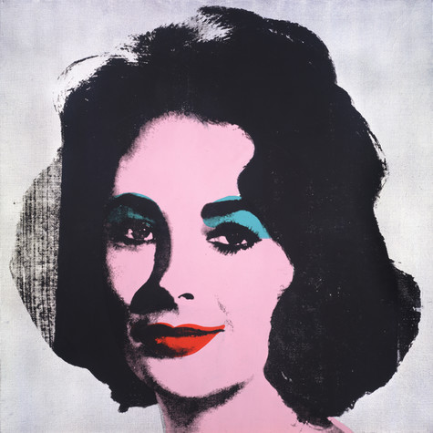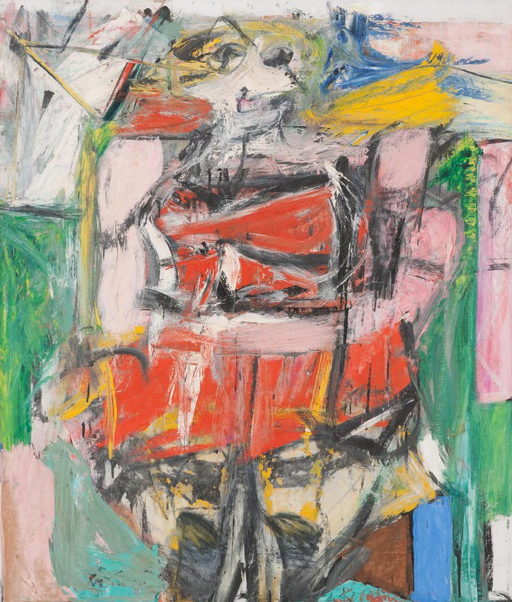
Willem de Kooning, Woman VI, 1953
Oil on canvas, 68 x 58 in.
Carnegie Museum of Art, Pittsburgh Gift of G. David Thompson © 2002 The Willem de Kooning Foundation / Artists Rights Society (ARS), New York

Andy Warhol, Silver Liz [Ferus Type], 1963
The Andy Warhol Museum, Pittsburgh; Founding Collection, Contribution The Andy Warhol Foundation for the Visual Arts, Inc., © The Andy Warhol Foundation for the Visual Arts, Inc.1998.1.55
List ﬁve adjectives that come to mind as you look at each painting:

1. | 1.
2. | 2.
3. | 3.
4. | 4.
5. | 5.

What can you tell about the woman in each of the paintings? What do you think she does for a living? Is she famous? What is she thinking? How is she feeling?

If you were to put these images on an album cover, what type of music or musical group would you assign to each one? Explain your answer based on what you see in the painting.

__________________________________ __________________________________

