Art Tastes and Biases
© The Andy Warhol Museum, one of the four Carnegie Museums of Pittsburgh. All rights reserved.
You may view and download the materials posted in this site for personal, informational, educational and non-commercial use only. The contents of this site may not be reproduced in any form beyond its original intent without the permission of The Andy Warhol Museum. except where noted, ownership of all material is The Andy Warhol Museum, Pittsburgh; Founding Collection, Contribution The Andy Warhol Foundation for the Visual Arts, Inc.
Fill in the web with writing describing your feelings, thoughts and associations with Andy Warhol’s Brillo Soap Pads Box ,1964.
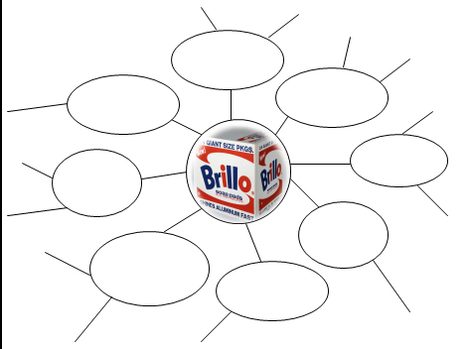

Art Tastes and Biases
© The Andy Warhol Museum, one of the four Carnegie Museums of Pittsburgh. All rights reserved.
You may view and download the materials posted in this site for personal, informational, educational and non-commercial use only. The contents of this site may not be reproduced in any form beyond its original intent without the permission of The Andy Warhol Museum. except where noted, ownership of all material is The Andy Warhol Museum, Pittsburgh; Founding Collection, Contribution The Andy Warhol Foundation for the Visual Arts, Inc.
Choose another artwork. Fill in the web with writing describing your feelings, thoughts and associations with this piece.
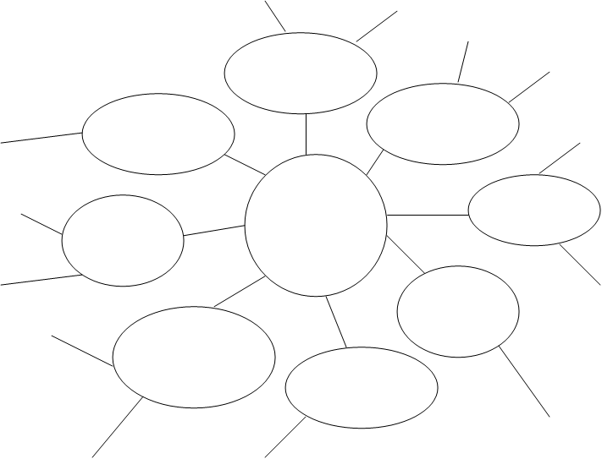
artwork of your choice

Art Tastes and Biases
© The Andy Warhol Museum, one of the four Carnegie Museums of Pittsburgh. All rights reserved.
You may view and download the materials posted in this site for personal, informational, educational and non-commercial use only. The contents of this site may not be reproduced in any form beyond its original intent without the permission of The Andy Warhol Museum. except where noted, ownership of all material is The Andy Warhol Museum, Pittsburgh; Founding Collection, Contribution The Andy Warhol Foundation for the Visual Arts, Inc.

Look at both webs. Identify your artistic tastes and biases by separating statements from the webs to the lists below.

Tastes | Biases

