Critiques by Professionals
© The Andy Warhol Museum, one of the four Carnegie Museums of Pittsburgh. All rights reserved.
You may view and download the materials posted in this site for personal, informational, educational and non-commercial use only. The contents of this site may not be reproduced in any form beyond its original intent without the permission of The Andy Warhol Museum. except where noted, ownership of all material is The Andy Warhol Museum, Pittsburgh; Founding Collection, Contribution The Andy Warhol Foundation for the Visual Arts, Inc.
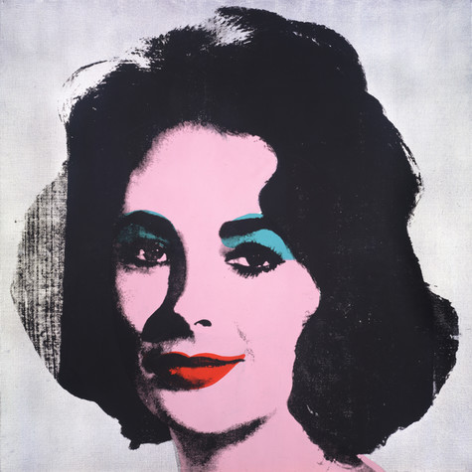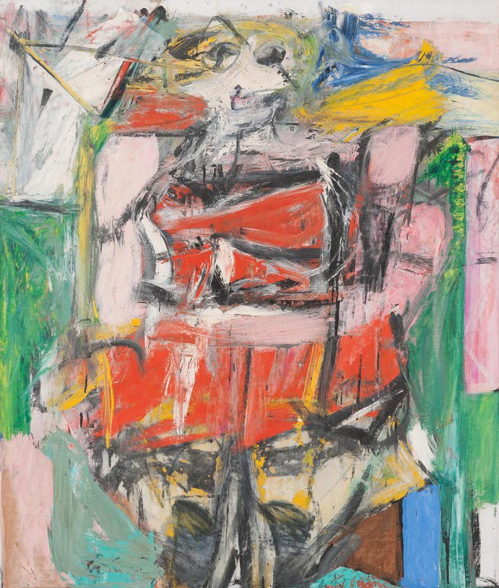
Willem de Kooning, Woman VI, 1953
Oil on canvas, 68 x 58 in.
Carnegie Museum of Art, Pittsburgh Gift of G. David Thompson © 2002 The Willem de Kooning Foundation / Artists Rights Society (ARS), New York

Andy Warhol, Silver Liz [Ferus Type], 1963
The Andy Warhol Museum, Pittsburgh; Founding Collection, Contribution The Andy Warhol Foundation for the Visual Arts, Inc., © The Andy Warhol Foundation for the Visual Arts, Inc.1998.1.55

Warhol’s Silver Liz  Critic and art historian Peter Gidal writes about Warhol portraits, claiming that the artist covers the faces with garish colors and then machine prints over these again and again to create an exaggerated mask, which he compares to a clown in make-up:  [Referring to the studies of Marilyn, Liz, Jackie, and Elvis] “A conﬂict takes place between one’s reaction to the person underneath and the stenciled cutout covering . . . A clown paints simple color shapes around his eyes, nose, and mouth. When a clown smiles, for some unfathomable reason there is pathetic sadness in his expression. Is this caused by the ambiguous situation: where does artiﬁce end and the real begin? Is it the harsh contradiction of cold colors on warm skin? Is it that the accentuation of human characteristics is ugly, and in conjunction with a clown’s exaggerated gestures, horriﬁc?”  Peter Gidal, Andy Warhol Films & Paintings:  The Factory Years, 1971  In this passage Robert Rosenblum writes about how Warhol combines factual and ﬁctional information by bringing together photography and painting in his celebrity portraits:  “The contradictory fusion of the commonplace facts of photography and the artful ﬁctions of a painter’s retouching was one that, in Warhol’s work, became a particularly suitable formula for the recording of those wealthy and glamorous people whose faces seem perpetually illuminated by the afterimage of a ﬂash bulb, and whose physical reality might be doubted by the millions who recognize them.”  Robert Rosenblum,  Andy Warhol Portraits, 1993 | de Kooning’s Woman VI  Art Critic E. A. Carmean, Jr. looks at de Kooning’s Woman as a reﬂection of the artist’s attitudes towards women:  “As to the painting’s content, we have a clue in the title “Woman,” but that is only a starting point. De Kooning’s women through this series are predatory monsters . . .The artist himself said that he always began with an image of a young, beautiful woman, only to see it transformed on canvas, as he worked, into a hideous nightmare creature. We have a sense of de Kooning struggling against the women in his paintings, struggling to carve them up and subdue them, while at the same time the painted women become more and more menacing, in danger of destroying the artist. The content of [de Kooning’s Woman series] then, is not simply a woman, but de Kooning’s conscious and unconscious feelings about women.”  Rita Gilbert and William McCarter,  Living with Art, 1988  Clement Greenberg, an inﬂuential critic of the ’50s and ’60s, championed de Kooning and his Woman paintings. In response to the Woman series, Greenberg wrote that the artist had a huge ego, an aspiration or grand dream possibly larger than any other artist. According to Greenberg, de Kooning was bringing together the old (ﬁgurative painting) and the new (Abstract Expressionism) to create a great new style of painting that was entirely original:  “No more than Picasso can de Kooning tear himself away from the ﬁgure and that modeling of it for which his sense of contour and chiaroscuro so well equip him. And perhaps [there is] even more Luciferian pride behind de Kooning’s ambition than there is behind Picasso’s were he to realize all his aims, all other ambitious painting would have to stop for a generation since he would have set both its forward and its backward limits.”  Clement Greenberg, Art and Culture, 1961

Comprehension Questions:

- Critic E.A. Carmean uses descriptive language in his writing. Select four adjectives used in this paragraph. Explain what each adjective describes and how this relates to the painting Woman VI?

- Describe how Peter Gidal sees Warhol’s painting Silver Liz as clown-like.

- Clement Greenberg thinks de Kooning is a great artist. Explain why he thinks this.

- According to Robert Rosenblum, what techniques make Warhol’s process great for capturing elements of celebrity?

Analysis Questions:

- Compare the critics’ analogies of de Kooning’s Woman IV as monster to Warhol’s Silver Liz as clown. Do these critics like what the artists are doing? Explain your answer.

- Which critic’s analysis do you agree with, and why? If you do not agree with any of them, pick one critic and explain why you disagree with his or her statement. What do you think are the critics’ personal tastes and biases?

