Formal Methods and Artists’ Ideas
© The Andy Warhol Museum, one of the four Carnegie Museums of Pittsburgh. All rights reserved.
You may view and download the materials posted in this site for personal, informational, educational and non-commercial use only. The contents of this site may not be reproduced in any form beyond its original intent without the permission of The Andy Warhol Museum. except where noted, ownership of all material is The Andy Warhol Museum, Pittsburgh; Founding Collection, Contribution The Andy Warhol Foundation for the Visual Arts, Inc.
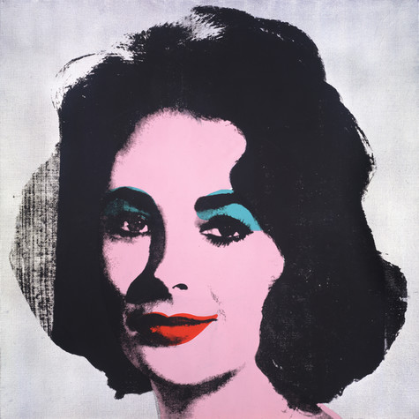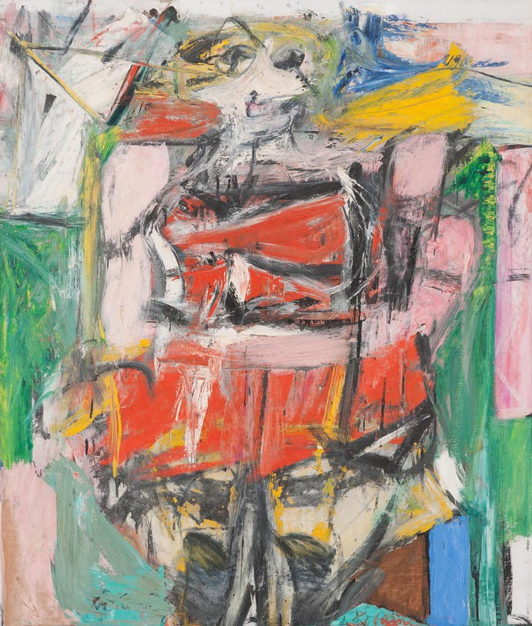
Willem de Kooning, Woman VI, 1953
Oil on canvas, 68 x 58 in.
Carnegie Museum of Art, Pittsburgh Gift of G. David Thompson © 2002 The Willem de Kooning Foundation / Artists Rights Society (ARS), New York

Andy Warhol, Silver Liz [Ferus Type], 1963
The Andy Warhol Museum, Pittsburgh; Founding Collection, Contribution The Andy Warhol Foundation for the Visual Arts, Inc., © The Andy Warhol Foundation for the Visual Arts, Inc.1998.1.55

Warhol’s Silver Liz  Andy Warhol began using photographic silkscreen printing in 1962 and continued using this technique throughout his career. This approach allowed him to make artworks that looked machine-made, just like the advertisements and product labels that were his subjects. Silkscreening also enabled him to “mass produce” or repeat large numbers of paintings using the same photographic source image. Each portrait was first “under-painted”. He did this by tracing simple outlines of the photographic image onto the canvas and then painting in blocks of color. Some portraits were painted in slick, hard-edge styles, whereas others had solid fields of color or more gestural brushwork. Once this initial painted layer was dry, Warhol printed the photographic silkscreen image on top.  To create a silkscreen, Warhol sent the source image out to a commercial darkroom. They enlarged the image and transferred it onto the silkscreen. The silkscreen was then returned to Warhol’s studio where he laid the under-painted canvas on the ﬂoor and lined up the silkscreen with the canvas. Printing ink was applied to the screen using a rubber squeegee over the screen’s surface, the rubber blade helped push an even layer of ink through the open holes in the screen. | de Kooning’s Woman VI  De Kooning said “flesh was the reason oil paint was invented,” as evidenced in his signature style of painting that fused vivid color and aggressive paint handling with deconstructed images of the female form. Woman VI was one of six paintings by De Kooning centered on the female figure that he worked on from 1950 to 1953. The ﬁrst of this series took him more than a year to ﬁnish. De Kooning created hundreds of preliminary sketches and studies of women in addition to his final paintings. He combined both traditional and non-traditional drawing and painting techniques in his work. For example, sometimes he cut out pictures of women’s mouths from magazines and collaged these onto his canvases. Other times he experimented with the wide-ranging methods of applying paint to canvas, exploring the physical possibilities of the medium. Although his Woman paintings may appear rapidly and intuitively executed, De Kooning repainted the canvas repeatedly—scraping away and re-working the image until he was satisﬁed with the results.  Willem de Kooning, like many of the Abstract Expressionist artists, was inspired by the music of his time. Improvisational jazz music was hip and expressive, and many of the painters cite listening to the music as a source of inspiration for their works.

Comprehension Questions:

- List the materials each artist used to make these paintings.
- Explain the techniques each artist used in his work.
- Describe the way each artist used layering in his process.
Analysis Questions:

- Look at the images again. Are the artists’ methods and techniques visible in the paintings?
- Discuss reasons why the artists chose to use these methods and techniques.

Formal Methods and Artists’ Ideas
© The Andy Warhol Museum, one of the four Carnegie Museums of Pittsburgh. All rights reserved.
You may view and download the materials posted in this site for personal, informational, educational and non-commercial use only. The contents of this site may not be reproduced in any form beyond its original intent without the permission of The Andy Warhol Museum. except where noted, ownership of all material is The Andy Warhol Museum, Pittsburgh; Founding Collection, Contribution The Andy Warhol Foundation for the Visual Arts, Inc.
Willem de Kooning, Woman VI, 1953
Oil on canvas, 68 x 58 in.
Carnegie Museum of Art, Pittsburgh Gift of G. David Thompson © 2002 The Willem de Kooning Foundation / Artists Rights Society (ARS), New York
Andy Warhol, Silver Liz [Ferus Type], 1963
The Andy Warhol Museum, Pittsburgh; Founding Collection, Contribution The Andy Warhol Foundation for the Visual Arts, Inc., © The Andy Warhol Foundation for the Visual Arts, Inc.1998.1.55

Warhol’s Silver Liz  “The Pop artists did images that anybody walking down Broadway could recognize in a split second—comics, picnic tables, men’s trousers, celebrities, shower curtains, refrigerators, Coke bottles—all the great modern things that the Abstract Expressionists tried so hard not to notice at all.”1  “If you want to know all about Andy Warhol, just look at the surface: of my paintings and ﬁlms and me, and there I am. There’s nothing behind it.”2  1. Gretchen Berg, Andy: My True Story,” 1967  2. Andy Warhol and Pat Hackett. Popism: The Warhol ‘60s, 1980 | de Kooning’s Woman VI  “Painting isn’t just the visual thing that reaches your retina—it’s what is behind it and in it. I’m not interested in ‘abstracting’ or taking things out or reducing painting to design, form, line and color. I paint this way because I can keep putting more and more things in it—drama, anger, pain, love, a ﬁgure, a horse, my ideas about space. Through your [the viewer’s] eyes it again becomes an emotion or an idea. It doesn’t matter if it’s different from mine as long as it comes from the painting which has its own integrity and intensity.”  --Willem de Kooning interviewed in The New York Times, Jan. 21, 1951.

Comprehension Questions:

- What was important about art and art making for de Kooning?

- What was important for Warhol in art and art making?

Analysis Questions:

- List what was important to Warhol in painting his portrait then list what was important to de Kooning in painting the ﬁgure. Compare and contrast these two lists.

- Hypothesize how each artist might have painted your image.

