Historical and Cultural Context
© The Andy Warhol Museum, one of the four Carnegie Museums of Pittsburgh. All rights reserved.
You may view and download the materials posted in this site for personal, informational, educational and non-commercial use only. The contents of this site may not be reproduced in any form beyond its original intent without the permission of The Andy Warhol Museum. except where noted, ownership of all material is The Andy Warhol Museum, Pittsburgh; Founding Collection, Contribution The Andy Warhol Foundation for the Visual Arts, Inc.
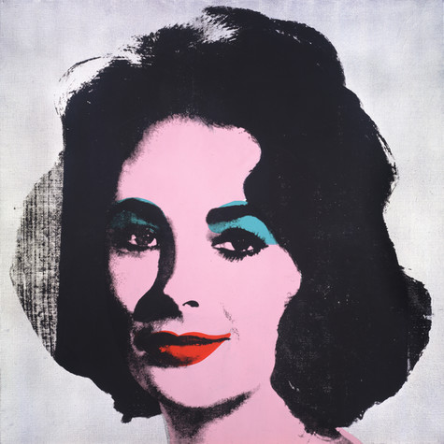
Willem de Kooning, Woman VI, 1953
Oil on canvas, 68 x 58 in.
Carnegie Museum of Art, Pittsburgh Gift of G. David Thompson © 2002 The Willem de Kooning Foundation / Artists Rights Society (ARS), New York

Andy Warhol, Silver Liz [Ferus Type], 1963
The Andy Warhol Museum, Pittsburgh; Founding Collection, Contribution The Andy Warhol Foundation for the Visual Arts, Inc., © The Andy Warhol Foundation for the Visual Arts, Inc.1998.1.55

Warhol’s Silver Liz  In the 1960s, the New York art world was starting to embrace Pop Art. Pop artists took a friendly view of technology, incorporating photography, commercial printing, and mass media methods into their artistic practice. The works they created contained images taken from billboards, advertisements, and all kinds of popular material. The public reception to this work was ﬁlled with suspicion and confusion. Many viewers felt the artists made fun of common people and their lives instead of valuing them, as the Pop artists claimed to do. It was hard for people to understand the reasons why Pop artists painted seemingly boring and cheap objects, when historically the function of art was to uphold and represent culture’s most valuable ideals.  The mid-60s shaped American values through many new forms of media. The expansion of television, newspapers, and magazines produced a mass familiarity with women in public arenas that had never existed before. Everyone loved to read about the private lives of famous women such as Elizabeth Taylor, who was always in the spotlight. Her marriages and divorces, her health problems, and high salary were all revealed in tabloid papers and even in such magazines as Business Week and U.S. News & World Report. While women made headlines for their roles in Hollywood or in the entertainment business, the undercurrents of feminism brewed. In reaction to established roles of the past, and to the 1950s in particular, women read feminist literature that advocated their equality to men in all arenas. Women faced many new lifestyle and career choices and, signiﬁcantly, for the ﬁrst time felt they could choose whether or not to have children. By the end of the ’60s, younger women spoke publicly about larger political issues like the Vietnam War, civil rights, and education. | de Kooning’s Woman VI  The 1950s was a time of contrasts. Following World War II, the fear of communism and atomic bombs was high. Mass consumer culture emerged, featuring everything from hula-hoops to TV sitcoms. At the same time, artists found a new individual freedom in experimental literature, avant-garde jazz, and abstract art. New York was the center of much of this activity, and artists such as de Kooning were celebrated as great innovators. In 1953 the impact of de Kooning’s Woman series was enormous, stirring up controversy among artists and the public alike. There were two main criticisms against his work. Some thought as de Kooning put people in his paintings, he betrayed the progress of abstract art. Others found his treatment of the female form offensive. To this group, it seemed as if de Kooning attacked the female form with paint and created monstrous images.  De Kooning’s abstract Woman series also came at a time when pop culture portrayed images of women unrealistically: from making their bodies conform to hour-glass shapes in tight-ﬁghting girdles to wearing high heels while cooking and cleaning. In the 1950s, women were rarely assumed to have a productive role in the economy. They were, however, taken seriously as consumers. Ads of the time urged them to aspire to the role of a competent wife, thrilled to keep a smooth-running household using all the latest gadgets, while remaining a glamour girl, always sexy and perfectly made up. “The two big steps that women must take are to help their husband decide where they are going and use their pretty heads to help get them there,” wrote Mrs. Dale Carnegie in the April 1955, Better Homes and Gardens magazine. As Barbie dolls made their debut in 1959, many teenage girls looked to challenge these established roles.

Comprehension Questions:

- What was the public reaction/criticism to each work? Explain the reasons why the public had these opinions/reactions.
- How were women portrayed in the ‘50s and ‘60s? Were these portrayals accurate? Why or why not?
- What was happening to change women’s roles in family and society?
Analysis Questions:

- Review the public reactions to each artist. Do you see the reactions as valid? Why or why not?
- What are some controversies about artists today that seem similar to the controversies written about here? (Contemporary artists could be musicians or performers, etc.)
- Compare the portrayal of women in the media from the ’50s and ’60s to how they are portrayed today. Do you think the culture or the media inﬂuences artists? Why or why not?

