Introduction to Artworks and Styles

© The Andy Warhol Museum, one of the four Carnegie Museums of Pittsburgh. All rights reserved.

You may view and download the materials posted in this site for personal, informational, educational and non-commercial use only. The contents of this site may not be reproduced in any form beyond its original intent without the permission of The Andy Warhol Museum. except where noted, ownership of all material is The Andy Warhol Museum, Pittsburgh; Founding Collection, Contribution The Andy Warhol Foundation for the Visual Arts, Inc.

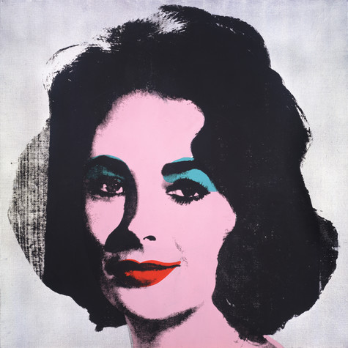 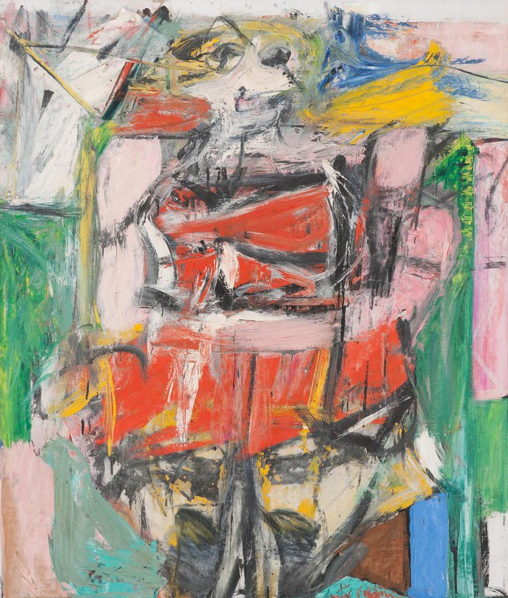

Willem de Kooning, *Woman VI*, 1953

Oil on canvas, 68 x 58 in.

Carnegie Museum of Art, Pittsburgh Gift of G. David Thompson © 2002 The Willem de Kooning Foundation / Artists Rights Society (ARS), New York

Andy Warhol*, Silver Liz* [Ferus Type], 1963

The Andy Warhol Museum, Pittsburgh; Founding Collection, Contribution The Andy Warhol Foundation for the Visual Arts, Inc., © The Andy Warhol Foundation for the Visual Arts, Inc.1998.1.55

|  |  |
| --- | --- |
| **Warhol’s *Silver Liz***  This painting of Elizabeth Taylor is one of the early celebrity portraits created by Pop artist Andy Warhol. Pop artists emerged in the late 1950s and early ’60s. In their work, they represented subjects from popular culture that had not previously been considered as high art, such as celebrities, newspapers, advertising, and food. In reaction to Abstract Expressionism, Pop artists embraced the current culture and sought to reference it directly in their images. Warhol was a fan of Taylor and produced several portraits of her during the 1960s. For this painting, Warhol chose the image of Taylor from a publicity photograph of her 1960 ﬁlm *BUtterﬁeld 8*. Warhol created this portrait when she was at the height of stardom but also ill with pneumonia. He caused a stir when he ﬁrst exhibited these paintings, both because of the appropriated subject matter and his use of commercial printing techniques. His multiple portraits of Taylor mimicked Hollywood’s system of marketing celebrities and movies in the mass media. Audiences had historically valued uniqueness and individual expression in art, and artists like Warhol were holding up common popular culture (canned soup and movie stars) as valuable and important. | **De Kooning’s *Woman VI***  *Woman VI* is one of a series of paintings Willem de Kooning created from 1950 to 1953 with female ﬁgures as subject. At the time, de Kooning was well known as an Abstract Expressionist. Abstract Expressionism was an art movement that was most prominent in the late 1940s through the 1950s. This movement created a form of non-representational art—objects, people, places, or things were not depicted as they looked in the real world. Abstract Expressionism celebrates the power and ability of formal elements, such as line, shape, color, texture, and space to express inner feelings, ideas, spirituality, and sometimes the psychology of the artist. In the *Woman* paintings, de Kooning combines a recognizable ﬁgure with abstract techniques, using aggressive, gestural brushstrokes that give his paintings vibrant energy and a rich texture. De Kooning’s departure from the strict rules of abstract art was controversial and brought the artist a great deal of attention. During this time, de Kooning looked to artists throughout history who painted the human ﬁgure in different styles, such as Rembrandt, Picasso, and Chaim Soutine. Throughout his career he pursued abstraction and figurative portrait painting at the same time, shifting back and forth between the two styles. |

**Comprehension Questions:**

1. What is the subject matter for each painting? Identify and describe.
2. Identify and deﬁne the type of art each artist was known for.
3. Explain why these works were controversial.

**Analysis Questions:**

1. Based upon your reading, compare and contrast Pop Art to Abstract Expressionism.
2. What did each art movement value, and why did they value these things in their works?