Intuitive Response
© The Andy Warhol Museum, one of the four Carnegie Museums of Pittsburgh. All rights reserved.
You may view and download the materials posted in this site for personal, informational, educational and non-commercial use only. The contents of this site may not be reproduced in any form beyond its original intent without the permission of The Andy Warhol Museum. except where noted, ownership of all material is The Andy Warhol Museum, Pittsburgh; Founding Collection, Contribution The Andy Warhol Foundation for the Visual Arts, Inc.
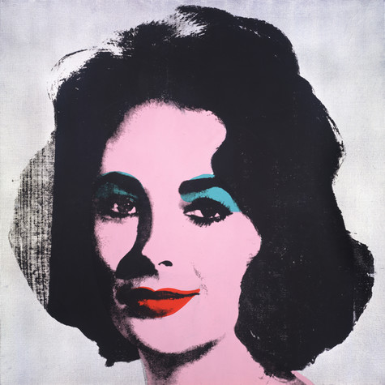

Overview
This lesson teaches students how to respond intuitively to works of art. Through a series of prompts and deep looking at artworks by Andy Warhol and Willem de Kooning, students write a variety of responses based on impression and emotion and share them with the class.

Grade Levels

Middle School

High School

Subjects

Arts

Art history

English and language arts

Social studies and history

Objectives
- Students respond intuitively to two artworks.
- Students describe and discuss personalities of subjects depicted in artworks.
- Students articulate opinions and rationale about artworks.

Materials
- Powerpoint: Critical Response (slides 1-5)
- Intuitive Prompts handout
- Large images for classroom use pdf, printed out or digitally displayed
- Pencils

Vocabulary
- Intuitive Response: a first response to music or a works of art that is intuitive, personal and often purely emotional. This response is based on personal experience, feelings, associations. and creative imagination.

Procedure
- Review the definition of intuitive response with the class and explain to students that intuitive response shapes much of what we value—our likes and dislikes. Explain to them that it is an important part of enjoying student artwork and key to formulating our critical and aesthetic responses, which we will be doing in subsequent lessons.
- Introduce the unit by showing students slides 1-5 of the PowerPoint: Critical Response.
- Print out and hang or project digital images on a wall of Andy Warhol’s Silver Liz and Willem de Kooning’s Woman VI. Explain to students that they will be using a process of point/counterpoint to compare and contrast two artworks. This critical thinking technique teaches students that it is important to consider multiple viewpoints when interpreting and responding to artwork.
- Use the Intuitive Prompts handout to generate intuitive responses to the artworks. This handout may be shortened for time constraints. Pick two or three prompts instead of all five.
- Ask students to share their writing with the class.
- Collect these responses from your students when they are finished and hand them out again later in the unit as they write their formal criticism in Lesson 5.

Wrap-up
When all students are finished presenting:
- Review the definition of intuitive response
- Ask students to brainstorm other scenarios in which they might have formulated an intuitive response (to music, movie, theater, etc.)

Assessments
- Aesthetics 1
- Aesthetics 2
- Aesthetics 3
- Communications 2
- Communications 3
- Critical thinking 1
- Critical thinking 2
- Critical thinking 4

