What is a Critic?

© The Andy Warhol Museum, one of the four Carnegie Museums of Pittsburgh. All rights reserved.
You may view and download the materials posted in this site for personal, informational, educational and non-commercial use only. The contents of this site may not be reproduced in any form beyond its original intent without the permission of The Andy Warhol Museum. except where noted, ownership of all material is The Andy Warhol Museum, Pittsburgh; Founding Collection, Contribution The Andy Warhol Foundation for the Visual Arts, Inc.

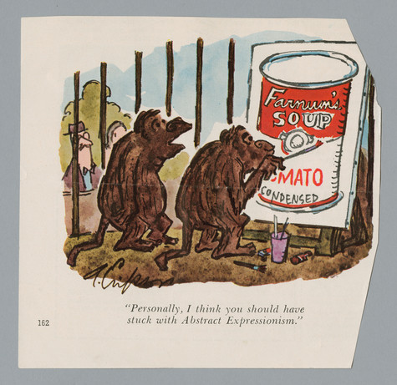

Overview
This lesson is a starting point for understanding critical response and analysis, as it introduces the concept of a critic. Students learn the difference between an informed and uninformed opinion and discuss the kinds of judgments they make in their everyday lives.

Grade Levels
- Middle school
- High school

Subjects
- Arts
- Art history
- English and language arts
- Social studies and history

Objectives
- Students will define and discuss the role of a critic
- Students will differentiate between two different types of opinions (informed and uninformed).
- Students will analyze a film, music, or fashion review by identifying the critic’s opinions, interpretations, and judgments that make up the critique.

Materials
- Powerpoint: Critical Response (slides 6-10)
- Critical opinions on music, film or fashion found in newspapers, magazines, or from the internet
- Pencils or markers

Vocabulary
- Critic: one who forms and expresses judgments of the merits, faults, value or truth of a matter. A critic gives opinions on things like movies, books, food, places to go on vacation, and art. Critics’ opinions can be found in newspapers, magazines, online product reviews etc. When a critic gives his or her opinion, he or she does not only state his or her likes and dislikes, but also explains why, by including facts and descriptions that support his or her opinion.
- Critical Response: a well thought out response that uses a combination of describing, analyzing, interpreting, judging, and evaluating to assess merit.
- Opinion: a belief or judgment held with confidence, but not necessarily based on fact or knowledge.
- Informed Opinion: a belief, judgment or way of thinking about something based on reliable information, such as informed sources or another person’s informed opinion.
- Uninformed Opinion: a belief, judgment or way of thinking about something that is not based on reliable information.

Discussion Questions
Ask students the following questions:
- What is a critic?
- Where have you heard or seen a critic’s opinion?

Procedure
- Define and discuss the role of a critic and accompanying vocabulary using the PowerPoint: Critical Response (slides 6-10).
- Discuss the difference between an informed and uninformed opinion.
- Ask students, “When are we critics?” Discuss how they make critical judgments everyday about things, such as music, fashion, and movies.
- Ask students if they have seen a critic’s opinion in a newspaper or on TV. Show examples.
- As a homework assignment, have students find critical reviews on music, film, or fashion, then circle all of the critic’s opinions, interpretations, and judgements used to form the critique.

Wrap-up
After all students are finished analyzing their reviews ask them to share their findings with the class:

- Who wrote the review and what did they critique?
- Why did you choose the review?
- Discuss what opinions, interpretations, and judgements you circled and why.
- Did the examples you found contain comparisons? How can a comparison help you create an informed opinion?

Assessments
- Communication 1
- Communication 3
- Critical thinking 1
- Critical thinking 2
- Critical thinking 3

