Tastes and Biases

© The Andy Warhol Museum, one of the four Carnegie Museums of Pittsburgh. All rights reserved.
You may view and download the materials posted in this site for personal, informational, educational and non-commercial use only. The contents of this site may not be reproduced in any form beyond its original intent without the permission of The Andy Warhol Museum. except where noted, ownership of all material is The Andy Warhol Museum, Pittsburgh; Founding Collection, Contribution The Andy Warhol Foundation for the Visual Arts, Inc.

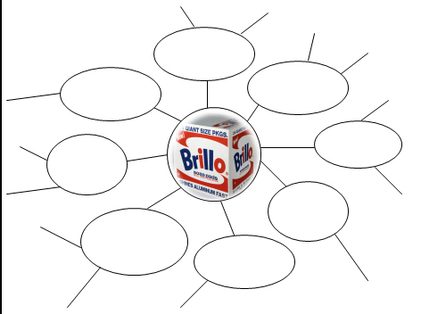

Overview
In this lesson, students explore the difference between tastes and biases. After setting ground rules for discussion and using a warm-up word association list, students will use their newly honed skills to observe and comment on art and music..

Grade Levels
- Middle school
- High school

Subjects
- Arts
- Art history
- English and language arts
- Social studies and history

Objectives
● Students will create brainstorming webs
● Students will categorize tastes and biases
● Students will discuss and define personal tastes and biases

Materials
- Powerpoint: Critical Response (slides 11-15)
- Ground Rules for Taste and Bias Discussion handout
- Musical Tastes and Biases handout
- Art Tastes and Biases handout
- Visual images, printed out or digitally displayed: Warhol’s Brillo Boxes and art/music of students’ choice

Vocabulary
- Taste: a personal preference or liking.
- Bias: a preference or an inclination that inhibits impartial judgment.
- Implicit bias: the attitudes or stereotypes that affect our understanding, actions, and decisions in an unconscious manner.

Discussion Questions
- Define and discuss tastes and biases, and implicit bias using the Powerpoint: Critical Response (slides 11-15).

- Establish ground rules to build a safe environment for discussion. Use the Ground Rules for Taste and Bias Discussion handout.

Procedure

Warm-up Word Association:
- Create a list of words and phrases ahead of class time. Please keep students’ interests in mind as you create your list. We suggest using words from different categories such as:

      - Foods: broccoli, ice cream, pizza, vegan

      - Hairstyles: ponytails, dreadlocks, braids

      - Accessories: Coach purse, diamond ring, iPhone, messenger bag

      - Cars: SUV, hybrid, sports car

      - Clothing choices: wearing all black, wearing all white, cowboy hat, miniskirt, overalls

- Explain to students they should write a list of the first things that come to mind (intuitive response) as they hear each word. Call out the list of words you created quickly.

- Students share their responses and discuss the reasons why they made their associations.

- Students determine whether their associations are personal tastes or biases.

Brainstorming Webs:
- Use the Musical Tastes and Biases handout to identify, list, and clarify students’ thoughts. In this step, students identify what they like and dislike, how they judge music to be good and bad, and why they have certain opinions. Students should choose two musicians or bands—one that they like and one that they dislike—and then make a brainstorming web for each. Instruct them to write out all of the things they know about the music—their likes, dislikes, and assumptions.

- Students present their webs and explain their answers. Encourage them to explain ideas more fully when their answers are unclear.

- Students examine their webs and pick out which statements are tastes and which are biases, creating two lists on page three of the Music Tastes and Biases handout.

- Use the Art Tastes and Biases handout to repeat the brainstorming web activity from above for two visual artworks. Use Andy Warhol’s Brillo Boxes and another visual piece of your choice.

- Students present their visual art webs and discuss individual ideas.

- Students use the webs to create individual lists of art tastes and biases on the third page of the handout. It may be useful for them to keep this list and refer to it throughout the rest of the unit.

Wrap-up

Discussion:
- What are some similarities and differences between personal tastes and biases? When was it difficult to distinguish between the two? When was it easy?

- How might tastes and biases affect a critic’s response?

Assessments
- Aesthetics 1
- Aesthetics 2
- Communication 2
- Communication 3
- Critical thinking 1
- Critical thinking 2
- Critical thinking 3
- Critical thinking 4

