Writing a Critical Response

© The Andy Warhol Museum, one of the four Carnegie Museums of Pittsburgh. All rights reserved.
You may view and download the materials posted in this site for personal, informational, educational and non-commercial use only. The contents of this site may not be reproduced in any form beyond its original intent without the permission of The Andy Warhol Museum. except where noted, ownership of all material is The Andy Warhol Museum, Pittsburgh; Founding Collection, Contribution The Andy Warhol Foundation for the Visual Arts, Inc.

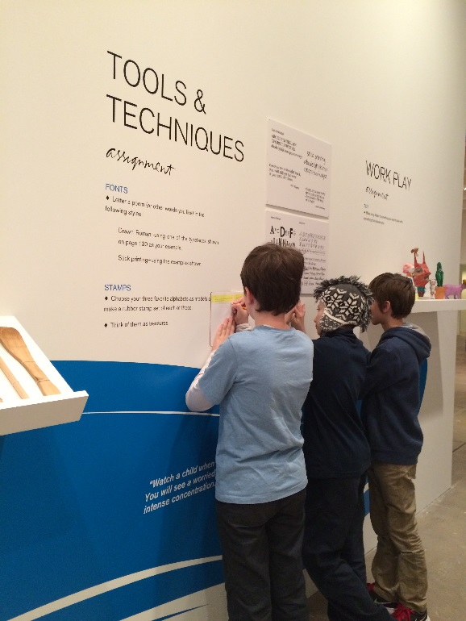

Overview
Students analyze their ideas from lessons two, three, and four, and combine their writings in order to establish and articulate their own informed critical point of view relating to a piece of art.

Grade Levels
- Middle school
- High school

Subjects
- Arts
- Art history
- English and language arts
- Social studies and history

Objectives
- Students will compare and contrast using intuitive response and critical response as a means of evaluating an artwork
- Students will combine research and analysis in order to construct an informed opinion on a work of art
- Students will explain their personal points of view and discuss the strengths and weakness of their arguments

Materials
- Students’ writings from the previous lessons
- Paper
- Pencils

Discussion Questions

Explain to students that the final step in writing a critique is to combine all of their research and analysis into one cohesive essay. To get started, discuss the steps for building a critique using the Powerpoint: Critical Response (slides 17-22).
- Research: artwork, style, historical and cultural context, formal methods, and artist’s ideas and published critiques.
- Organize your ideas. Spend time observing the artwork. Then:
  - Describe
  - Analyze
  - Interpret
  - Judge/Evaluate
- Ask students: Why is it important to consider both our intuitive response as well as our research when writing a critique?

Procedure
- Look at the paintings again and list adjectives that come to mind.
- Review your intuitive responses from Lesson 1. Combine the adjectives from both lists.
- Choose one of the paintings—Warhol’s Liz or de Kooning’s Woman VI—then combine the ideas from your intuitive responses and from your Research and Analysis in Lesson 4 to write a critique or “point of view”. Address the following:
  - What is your critical judgment (positive or negative) about the work? Support your judgment with informed reasoning.
  - How do you think the artist portrayed women?
  - How do the formal elements and the artist’s technique support the meaning or your understanding of the work?
  - In what ways did the artist reflect the values of their time?
  - In what ways are this painting and the ideas it communicates relevant or irrelevant to viewers today?
- Use the Critical Response Assignment handout to check that you have addressed the necessary criteria.

Wrap-up
Review the students’ writing samples as a class.
Ask the following discussion questions:
- What are the strengths and weakness of their arguments?
- Review the research components as a class (artwork and style, historical and cultural context, methods and ideas, published critiques)
  - What do you notice about the critiques of the two different styles?
  - Did some information or research inform the critiques of one style more than the other?
- What points did you find more convincing?

Extension
Have your students write a critique of an artwork of their choice, conducting their own research, citing sources, and synthesizing ideas.

Assessments
- Aesthetics 1
- Aesthetics 2
- Aesthetics 3
- Communication 1
- Communication 2
- Communication 3
- Critical thinking 1
- Critical thinking 2
- Critical thinking 3
- Critical thinking 4
- Historical context 1
- Historical context 2
- Historical context 3
- Historical context 4

