Apple Pirog Recipe
Collection of Irina Peris

Ingredients:
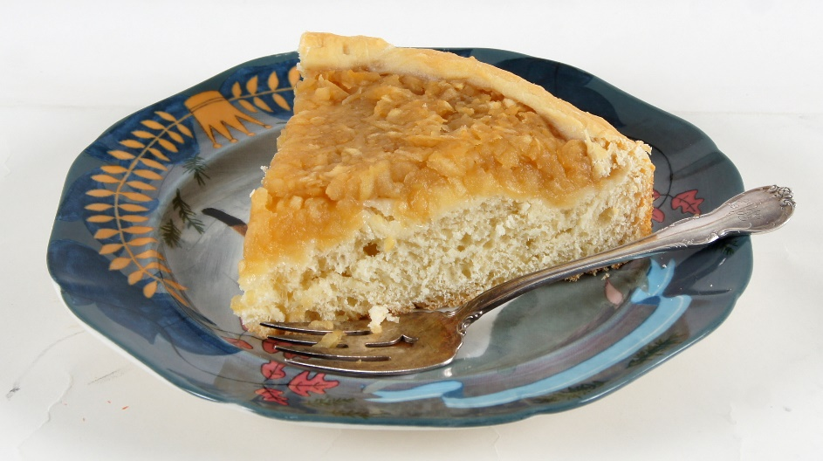
1 packet of yeast
1 cup of warm water
2 cups of warm milk
2 eggs
3 Tbsp. of sugar
1 tsp. of salt
40 grams of butter
3 to 5 cups of white flour
1 Tbsp. of vegetable oil (light, like canola oil)

In a large bowl, mix 1 cup of flour, 1 cup of warm water, 1 packet of yeast, and 1 Tbsp. of sugar. Put the mixture into a warm spot for 30-40 min.

In a separate bowl, mix the 2 cups warm milk with the melted butter, eggs, and remaining sugar and salt.

Add the second mixture to the first and add 2 cups of flour to it. Mix well. Put into a warm place.

In approximately one hour, the dough will have doubled in size. Add enough flour so that when you mix it, the dough would come off your hands easily without sticking to them. Mix in 1 Tbsp. of vegetable oil, then replace the mixture into warm spot, so that the dough will rise again.

After that, you can form your pie, putting slightly cooked apples in the middle, or stewed cabbage, or cooked ground meat with potatoes.

Bake at 350 degrees for 30-40 min.

Enjoy!

