The Art of Making Paska
by Mary Ellen Dudick

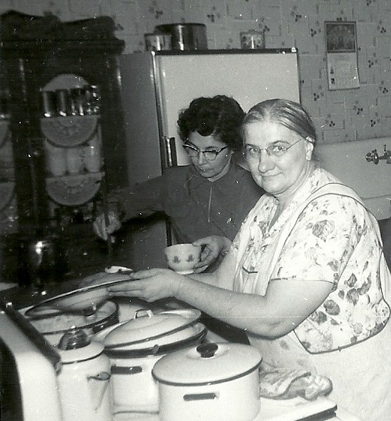
Mary Ellen’s “Mother’s Paska”
(Rapid Rise Method)

In a large bowl, mix:
10 cups flour
2 cups sugar
1 tsp. salt
3 envelopes rapid rise yeast

In a heat-proof container, heat to 125 degrees:
3 cups milk
½ cup butter (I heat this in the microwave on high for about 3 ½ minutes)
¼ cup Crisco
Mother and Aunt Anna preparing a Sunday Dinner, mid 1950’s

¼ cup oil

In a separate bowl, lightly beat 4 eggs (room temp.) and 1 ½ Tbsp. vanilla with a fork
Stir hot mixture into the dry mixture
Add the eggs and vanilla

Knead in up to 4 more cups of flour, until dough is smooth and no longer sticky.
(I rarely need more than 3 additional cups of flour)

Cover with a towel and let rise in a warm place for 1 hour.

Punch down the dough and let it rise for ½ hour.

Divide into loaves to fit your pans. (I get 6 small round loaves about 7” in diameter.)
Place Paska into greased pans and let rise again for about ½ hour.

I hold back some dough for rolling out to make crosses for the tops of the loaves. I attach the crosses with a little bit of water on my finger tip.

Brush with an egg wash (one egg beaten with a little water) before baking at 325 degrees for 45 to 50 minutes. Bread should be nicely browned and sound hollow when tapped on the bottom.

Remove loaves from pans to cool on wire rack. Brush with butter. Enjoy!

The History of My Paska Recipe

Growing up in a Rusyn/Slovak household, of course we had the tradition of baking Paska for our Easter meal. I believe my mother, Mary Gnora Tirpak, experimented with several recipes for Paska before she settled on her sister-in-law, Anna Tirpak Varhola’s recipe. The Paska baked by my maternal Grandmother, Mary Velky Gnora, was kind of dry, even if it was baked a day or so before Easter. My Aunt Anna’s Paska was always moist, dense, and delicious!

In the 1960’s Aunt Anna was in her fifty’s and had been widowed in the mid 1930’s after being married for only a few months. She worked for Corning Glass in Charleroi and “kept house” for her father and several single siblings. She was a great cook and baker. I would guess that her Paska recipe was one that her mother, Parascevia Dudjak Tirpak (She died in 1941) had made.

My mother, who was also a great baker, got the recipe and began to make it for Easter. Originally, she used fresh yeast and traditional methods for preparing and baking the Paska. She began to use dry yeast and experimented on the “shortening” in the original recipe. She noted her results and settled on the recipe that I eventually began to use. I can remember being in her kitchen writing down each step of the process. She used a metal “miska” on her stove to heat the liquid ingredients until she felt it was warm enough (too hot can “kill the yeast”).

Shortly after I was married in January of 1968, I began to bake my own Paska. I did have some uneven results; sometimes the bread was raw in the middle. After my mother died in 1975, I took her Paska pans and had better results. She used 3 small enamel and 3 small aluminum pans. Different materials bake differently, so I had to put the enamel pans on the top rack (enamel browns more than aluminum). Those Paska pans are a treasure. The aluminum ones have a price, 35 cents stamped on the bottom. When Rapid Rise dry yeast came on the market, I changed the recipe to the guidelines for that product and have great results. In recent years, I discovered through a friend that 7” diameter aluminum pet dishes yield a beautiful product.

Through the years, I have given out a multitude of Paskas to friends and family. I have taught many of my friends how to bake this wonderful bread. Baking a family recipe can be a very spiritual experience. I always think that I am keeping my Mother’s memory “alive” by making and sharing this family recipe.

