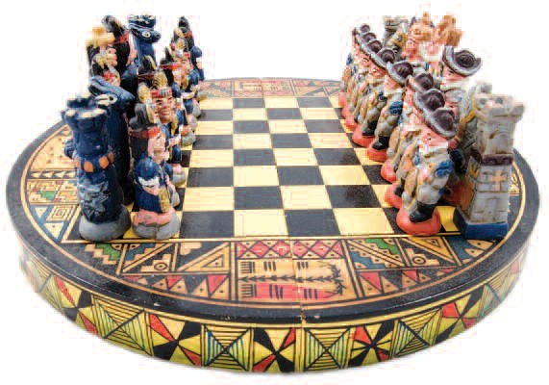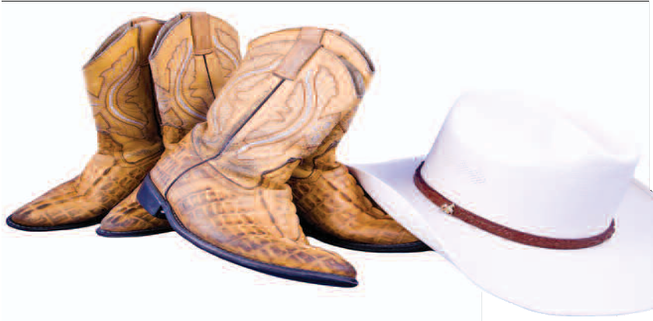

THE THINGS THEY CARRIED
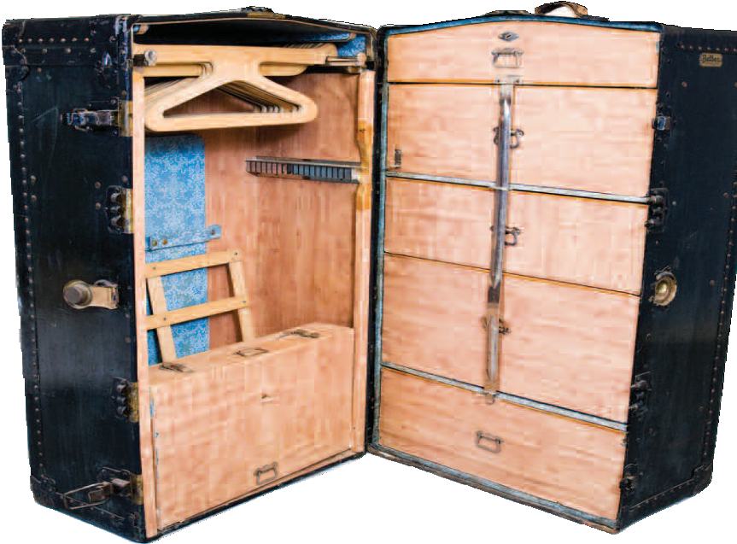
The Warhol partners with the Heinz History Center and local community groups to document immigrants’ journeys—and contributions—to western Pennsylvania, one object at a time. BY REID R. FRAZIER

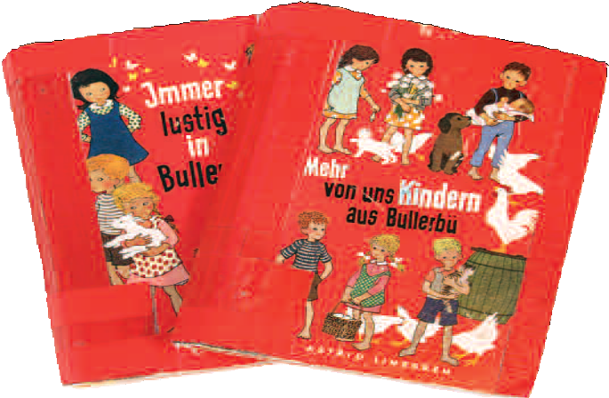

At right, Moshe Baran wearing his tefillin, a garment of the Jewish faith, and a photograph of Baran’s mother and twin sisters. Only one of the girls survived the Holocaust. Above, hundreds of personal objects belonging to regional immigrants were photographed by The Warhol for inclusion in each group’s Time Capsule. The steamship trunk, for example, was used by three generations of the Cavaliere family in their travels between Italy and the United States.

OBJECT PHOTOS: MARIA BERNAZZOLI AND MATT FREEMAN
20 CARNEGIE • WINTER 2010

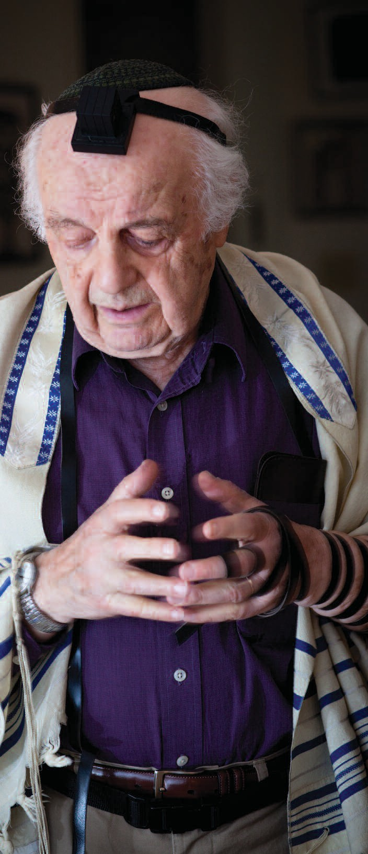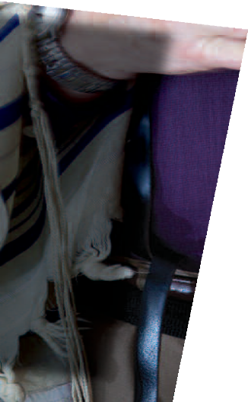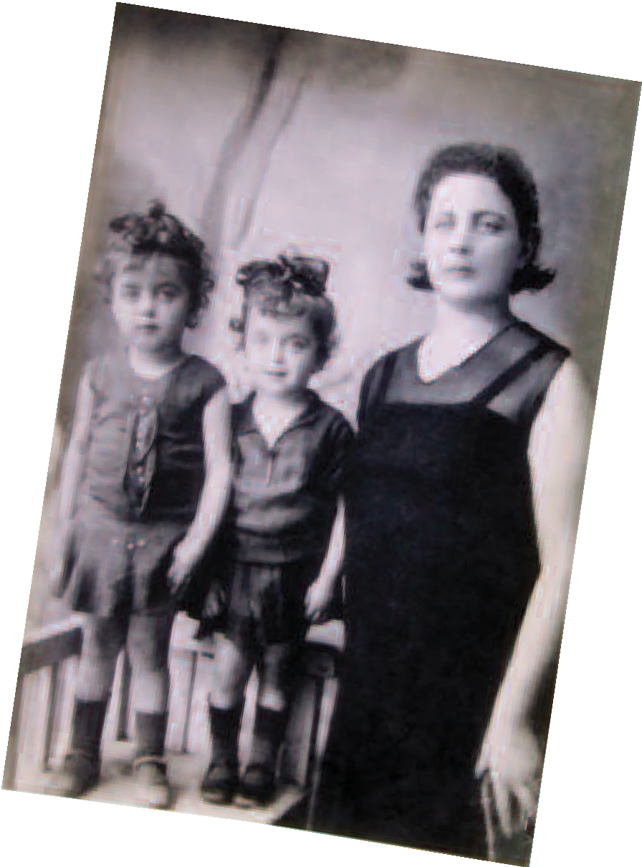
n Moshe Baran’s coffee table rests a stack of framed photographs. They’re col- orful images of a trip he took a few years
PHOTOS: RENEE ROSENSTEEL
O
ago with two of his grandsons. The young men are seen smiling on the streets of Eastern European villages. Baran made the journey to retrace his route out of the village of Horodok, in what was then Poland, to America.
During his visit, he found a man who was a boy during World War II. The man recalled a day in 1943, when the village’s 900 Jews, including Baran’s father and sister, his uncles and cousins, were marched through the square. The Jews were “selected” to either be sent to a Nazi work camp or summarily shot.
Baran, now 89, would have been in that line, most likely, if he hadn’t escaped a work camp the fall before. He hid out in the swamps and forests near his hometown, joining the local resistance. Then in his early 20s, he helped save his brother, sister, and mother, but could not save his father and other sister. His surviving family members lived with other escaped Jews in the woods and swamps, in the same camps depicted in the 2008 movie Defiance. They were among only a few Jews from the town to survive.
Nowadays, Baran wakes up early and makes the short uphill hike from his Squirrel Hill apartment to Beth Shalom synagogue, where he prays every morning at 7:30 a.m. He brings with him a blue box containing a “tefillin,” a pair of black wooden plaques connected by a long ribbon. While praying, he places one of the plaques on his head, and the other on his arm (close to the heart), and wraps the ribbon around his wrist seven times, according to Jewish tradition.
“There were thousands, tens of thousands, hun- dreds of thousands, who would have been doing this had they been alive, but they were
deprived of doing it by the Holocaust,” says Baran. “I feel that I do it for them. If I survived, I didn’t survive just for my own sake.”
Baran is making another offer- ing, of sorts, to a unique project that will preserve his journey to western Pennsylvania, and those of many like him. His tefillin and a half-dozen other items from his life are being photographed and documented by educators at The Andy Warhol Museum as part of an ongoing Community Time Capsule project, now three
years in the making.

(continued)

CARNEGIE • WINTER 2010 21
PHOTO: JOSHUA FRANZOS

“She used to paint them when she watched the Steelers, or anytime, really.”

- MARIA SILVESTRI, OF
HER LATE GRANDMOTHER

Above, Maria Silvestri, curator of the National Carpatho-Rusyn Society’s collections, talks with Maritza Mosquera about pysanky, Eastern European eggs decorated with wax, ink, and dye. A much younger Silvestri and her late grandmother, Helen Timo, at work on the eggs. Below, food is a common theme in the Time Capsules, including a recipe for a German tort.

Each Time Capsule is being filled, virtually, with photographs of objects that tell the stories of a different local immigrant or ethnic community, including Jewish-Americans. Eventually, with additional funding, the images will be uploaded to a website and used as a resource for cross-disciplinary learning at local schools,
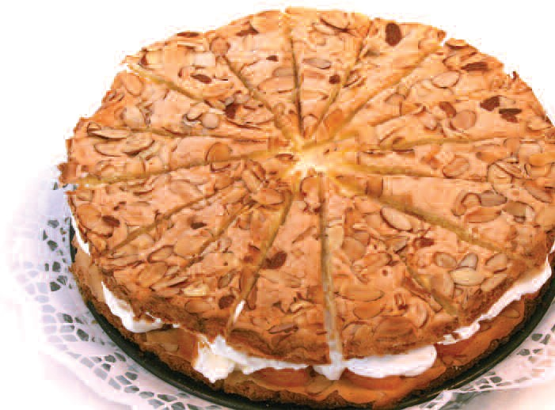
much like Warhol: Resources & Lessons, an online curricu- lum that uses Andy Warhol’s life, art, and practice to teach not just art lessons but lessons across the humanities.
Local communities involved in the project include Greek Orthodox, German, Carpatho-Rusyn, Latin- American, Mexican, and Italian. Time Capsules for the African-American and Somali refugee communities are in the planning stages.

Rummaging through the cupboards
The Community Time Capsules project is inspired by Warhol’s own Time Capsules—612 cardboard boxes the Pop artist obsessively filled each day for more than a decade, with just about everything that came across his desk.

Warhol was a tireless collector, and, as a result, his Time Capsules form a remarkable record of his life and times. They contain everything from the seemingly trivial—phone bills, newspapers, passing fads such as Pet Rocks, and a slice of crusty wedding cake—to clues of the artist’s lesser-known interests, such as opera, as well as priceless works of art, including dozens of Warhol’s drawings and photographs, and a few small paintings. There’s even a bag full of used painter’s palettes which were a gift to Warhol from Salvador Dali.
Matt Wrbican, The Warhol’s archivist and caretaker of the Time Capsules, sees the filled-to-the-brim boxes as another way that Warhol documented the ephemeral world around him, much as he did with his photographs and audiotapes. “His Time Capsules were a much more personal archive, and record the myriad of ways that

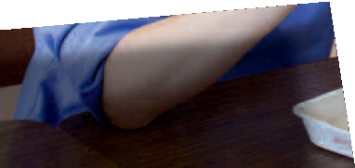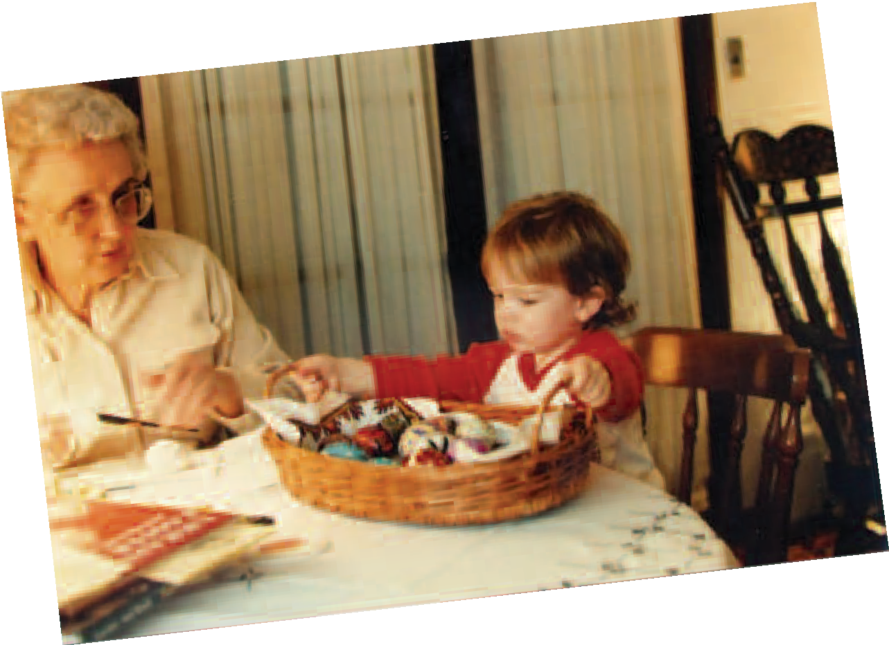

22 CARNEGIE • WINTER 2010

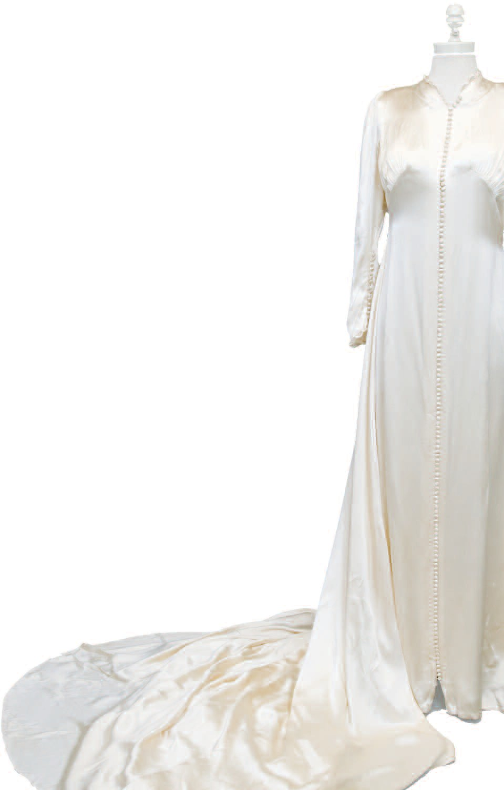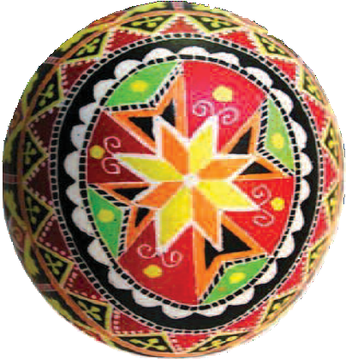the larger culture was changing,” Wrbican says. “They’re a serial work of art that straddles the line between art and archive.”
Abby Franzen-Sheehan, The Warhol’s associate cura- tor of education for interpretation and resources, saw in Warhol’s Time Capsules a way to use objects to explore the complex issue of immigration.
“Our idea was to use the model to edify kids about dif- ferent cultures,” says Franzen-Sheehan. Because personal objects pique the fascination of young people, she explains, they hold a unique ability to draw kids’ atten- tion. “I don’t know anybody wh doesn’t like to rummage through someone else’s cupboards. We all have an inquiring mind.”
To assist with the project, Franzen- Sheehan looked to artist and former Warhol educator Maritza Mosquera. This past summer and fall, Mosquera worked with photographer Matt Freeman, and together they logged hundreds of miles around western Pennsylvania visiting homes, synagogues, churches, and community centers in search of per- sonal objects, and the stories behind them, that provide a window into local immigrant culture.

Keeping traditions alive
On a clear September morning, Mosquera
met with Maria Silvestri, curator of the National Carpatho-Rusyn Society’s cultural collections, which
are housed in the group’s community center in the former Cathedral of St. John the Divine in Munhall. Pittsburgh has one of the nation’s highest concentrations of Carpatho- Rusyns, or simply Rusyns, as they call themselves, with a total regional population of 60,000. There are roughly
1.5 million Rusyns in the world today, Slavic people whose homeland lies in a crescent-shaped swath of mountainous terrain in what is now the Ukraine, Poland, and Slovakia. Warhol, who grew up in Four Mile Run, a Pittsburgh neighborhood at the foot of Oakland that’s heavily popu- lated by Rusyns, is the group’s most famous member.
In the milky light of the converted cathedral, Silvestri opens an egg carton containing a dozen hollowed eggs painted fuschia, lapis lazuli, periwinkle, and lime green. Even more eye-popping are the hand-painted shapes: flowers and wheat stalks, crowns and snowflakes. They’re called pysanky, the Eastern European eggs decorated with melted wax, ink, and dye using a stylus, or a pointed metal tip. These particular masterpieces were painted by Silvestri’s late grandmother, Helen Timo, who instructed many in the Pittsburgh community on how to paint the festive eggs. “She used to paint them when she watched the Steelers, or anytime, really,” Silvestri says.

Evelyn Brusco Vescio was married in this satin gown, which was made by her sister, Ida. Twenty years later, Evelyn was shown a picture by another immigrant woman from Italy living in Pittsburgh. She excitedly exclaimed, “You are wearing my wedding dress!” The woman had received the gown from another bride in their shared village. It had been passed from bride to bride for years.
Warhol was intimately familiar with pysanky, as his mother Julia Warhola decorated them in their home. Silvestri, 25, believes that Warhol’s Time Capsules were a reflection of his own Rusyn heritage. “I think it was a very Rusyn thing to do. Rusyns are pack-rattish. You never know when you’re going to need something,” she says with a laugh.
Silvestri shares other traditional items, like a tablecloth used for the traditional Christmas Eve dinner, which is observed on January 6. “You always set an empty seat
for your ancestors,” Silvestri explains. “You put straw on the floor and a string or chain around the table to
keep everybody together. Christmas Eve is believed to be a time when the spirits of
the ancestors are out.”
At Mosquera’s urging, Silvestri reveals mementos of her own explorations into Rusyn culture.
Among these is a photo of a family trip Silvestri took in 1999, when she was 13, to visit relatives in the Ukraine. At the time, many rural Rusyns still harvested crops by hand and drew water from wells. Her
cousins had to take a 24-hour train ride over the Carpathian Mountains just to meet with
Silvestri’s family. She was struck by the parallel lives she and her cousins
inhabited—hers in the modern world, theirs from a seemingly different era.
“They were exactly my age,” she notes, “and I’d think, if one of my great-grandparents had gotten side-tracked, I would not have this life that I have now, growing up in suburban Pittsburgh. I was thinking, that could be me.”

Lest we forget
Many of the Time Capsules have a similarly personal feel, mingling individual history with broader cultural themes. Mosquera, who was born in Ecuador and came to the United States in 1969, has dealt with immigration themes in her own artwork.
“As immigrants, we sometimes feel like we need to speak for our people,” says Mosquera.

(continued)

CARNEGIE • WINTER 2010 23

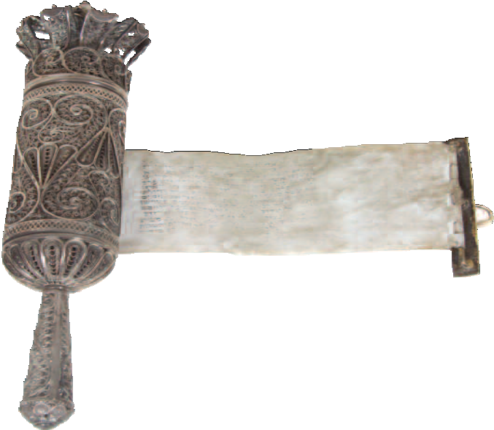“What people keep with them when they go to a new country tells us what’s important to them. These objects are how they keep their ethnic or religious identity alive.”
- ABBY FRANZEN-SHEEHAN, WARHOL’S ASSOCIATE CURATOR OF EDUCATION FOR INTERPRETATION AND RESOURCES

“We may look for an object that would be about all Ecuadorians, or about all Rusyns or Germans or Africans. I wanted people to just be themselves for this project, and let the objects tell the stories.”
The objects, as it often turns out, also flesh out larger historical themes at a more granular level. The Italian Time Capsule includes a coal miner’s helmet from the early 20th century, with a visible dent in it. “The helmet saved a coal miner’s life,” says Franzen-Sheehan. She envi- sions using the helmet and other objects as a tool to teach middle and high school students about the labor movement and the rise of labor laws in the United States. “Students
who look at this can be learning about larger issues of identity, history, immigration law,
through these personal stories.” Created by scouring the Italian-
American collection of the Senator John Heinz Pittsburgh Regional
History Center, with the help of their curatorial staff, the Italian

Time Capsule also includes everyday items such as a bar- ber’s scissors, a knife grinder, a wedding gown, a religious processional statue, and a cornerstone from the Beneficial Society of Northern Italy building in East Liberty.
For many of the newer immigrant groups involved in the project, their keepsakes show how immigrants re-con- stitute their home cultures. Food is a common theme: a German chocolate cake recipe, a recipe for Matzoh ball soup, and a spice packet from Mexico. There are also lots of games and books—soccer jerseys, puzzles, and movies. All are slices of home, small enough to tuck into a suitcase. Some saved items show immigrants adapting to life in a new country, like a photograph of a Mexican family’s trip to New York, posing with a human Statue of Liberty who spoke Spanish.
Ultimately, Franzen-Sheehan hopes the project will illustrate how people assimilate and change, as well as honor their past when they settle in a new place.
“An object is just an object, but you can imbue it with a sacredness,” she says. “What people keep with them when they go to a new country tells us what’s important to them. These objects are how they keep their ethnic or reli- gious identity alive.”
Baran, for example, volunteered his objects for the Time Capsule to teach future generations about the Holocaust, and about where his people came from. He doesn’t want that history erased. But his artifacts also

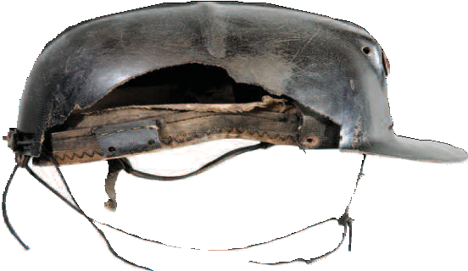

As part of the Jewish Community Time Capsule, items from Beth Shalom synagogue in Squirrel Hill were photographed. Pictured here is Rabbi Michael Werbow. Above, Richard Furgiuele, a second gen- eration Italian-American, wore this helmet in the 1940s while working
for the Redlands Coal Company in rural Indiana County. It saved his life.

24 CARNEGIE • WINTER 2010

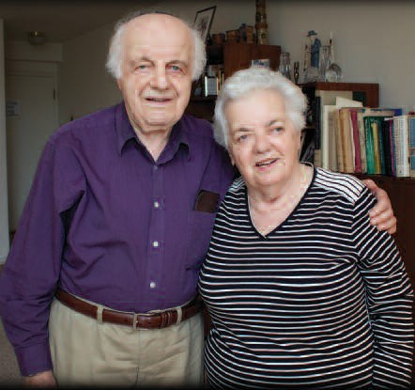
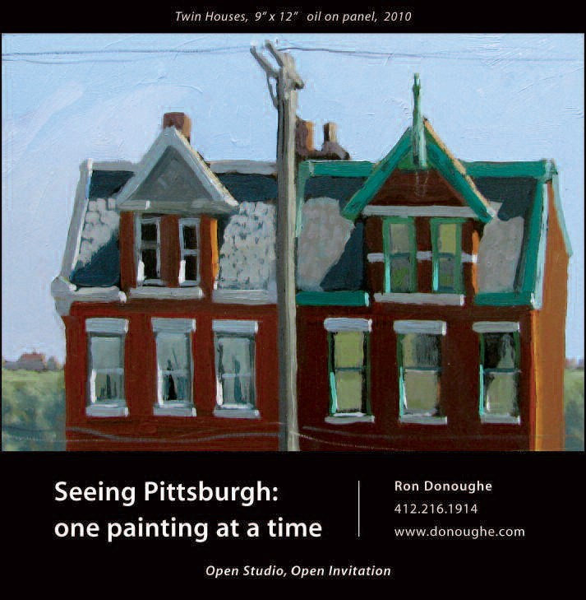Moshe Baran with his sister, Mina Rosenberg, who he helped save during the Holocaust.

reveal a lesson learned through the crucible of his own survival.
One of the items Baran shared is a
white binder filled with letters, photographs, and mementos his family created shortly before the death of his wife, Malka, in 2007. The pair met at a displaced persons’ camp in Austria in 1946. She was from Poland, and her entire family was destroyed by the Nazis. They came to America and settled in Queens, where she made a
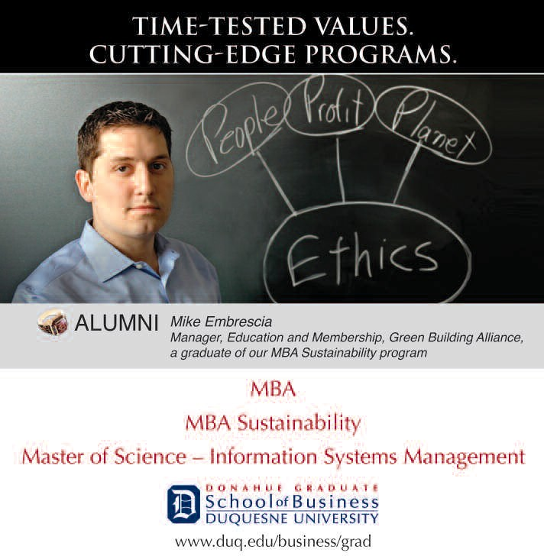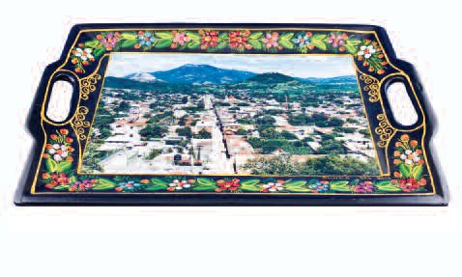career as a schoolteacher. In the 1990s, the couple moved to Pittsburgh to be near their daughter.
“My wife had a mantra,” Baran says. “Never use the word hate. It was hate that caused what happened to my people. I could have come easily to the conclusion that there is no God, because where was he when I needed him? My short answer to this is, if the people who did what they did to us would believe in the God I believe in, they wouldn’t have done it.”
As it turns out, the painful lessons of
the past are really the most important things Baran carried with him from the village
of Horodok. •

This photo tray of Olinala in the state of Guerrero, Mexico, hangs in Saul Franco’s family store in Beechview. Franco says he never felt “alien” in Pittsburgh because the hills are a nice reminder of the mountains in Olinala.
CARNEGIE • WINTER 2010 25

