- Cut out 3 parts.

- Decorate can (A).

- Cut piece B in half.

- Fold 2 pieces (B) on dashed lines.

- Create two 3d rectangles
out of pieces (B) then tape or glue them together.

- Fold a piece of 8.5 x 11 cardstock in half, then tape or glue the rectangles in the center.
Tape or glue the circle (C) on top of your rectangles.

- Add glue to the flat sides of your rectangles. Wrap the label around the rectangles, then tape or glue the label together to create a tube.

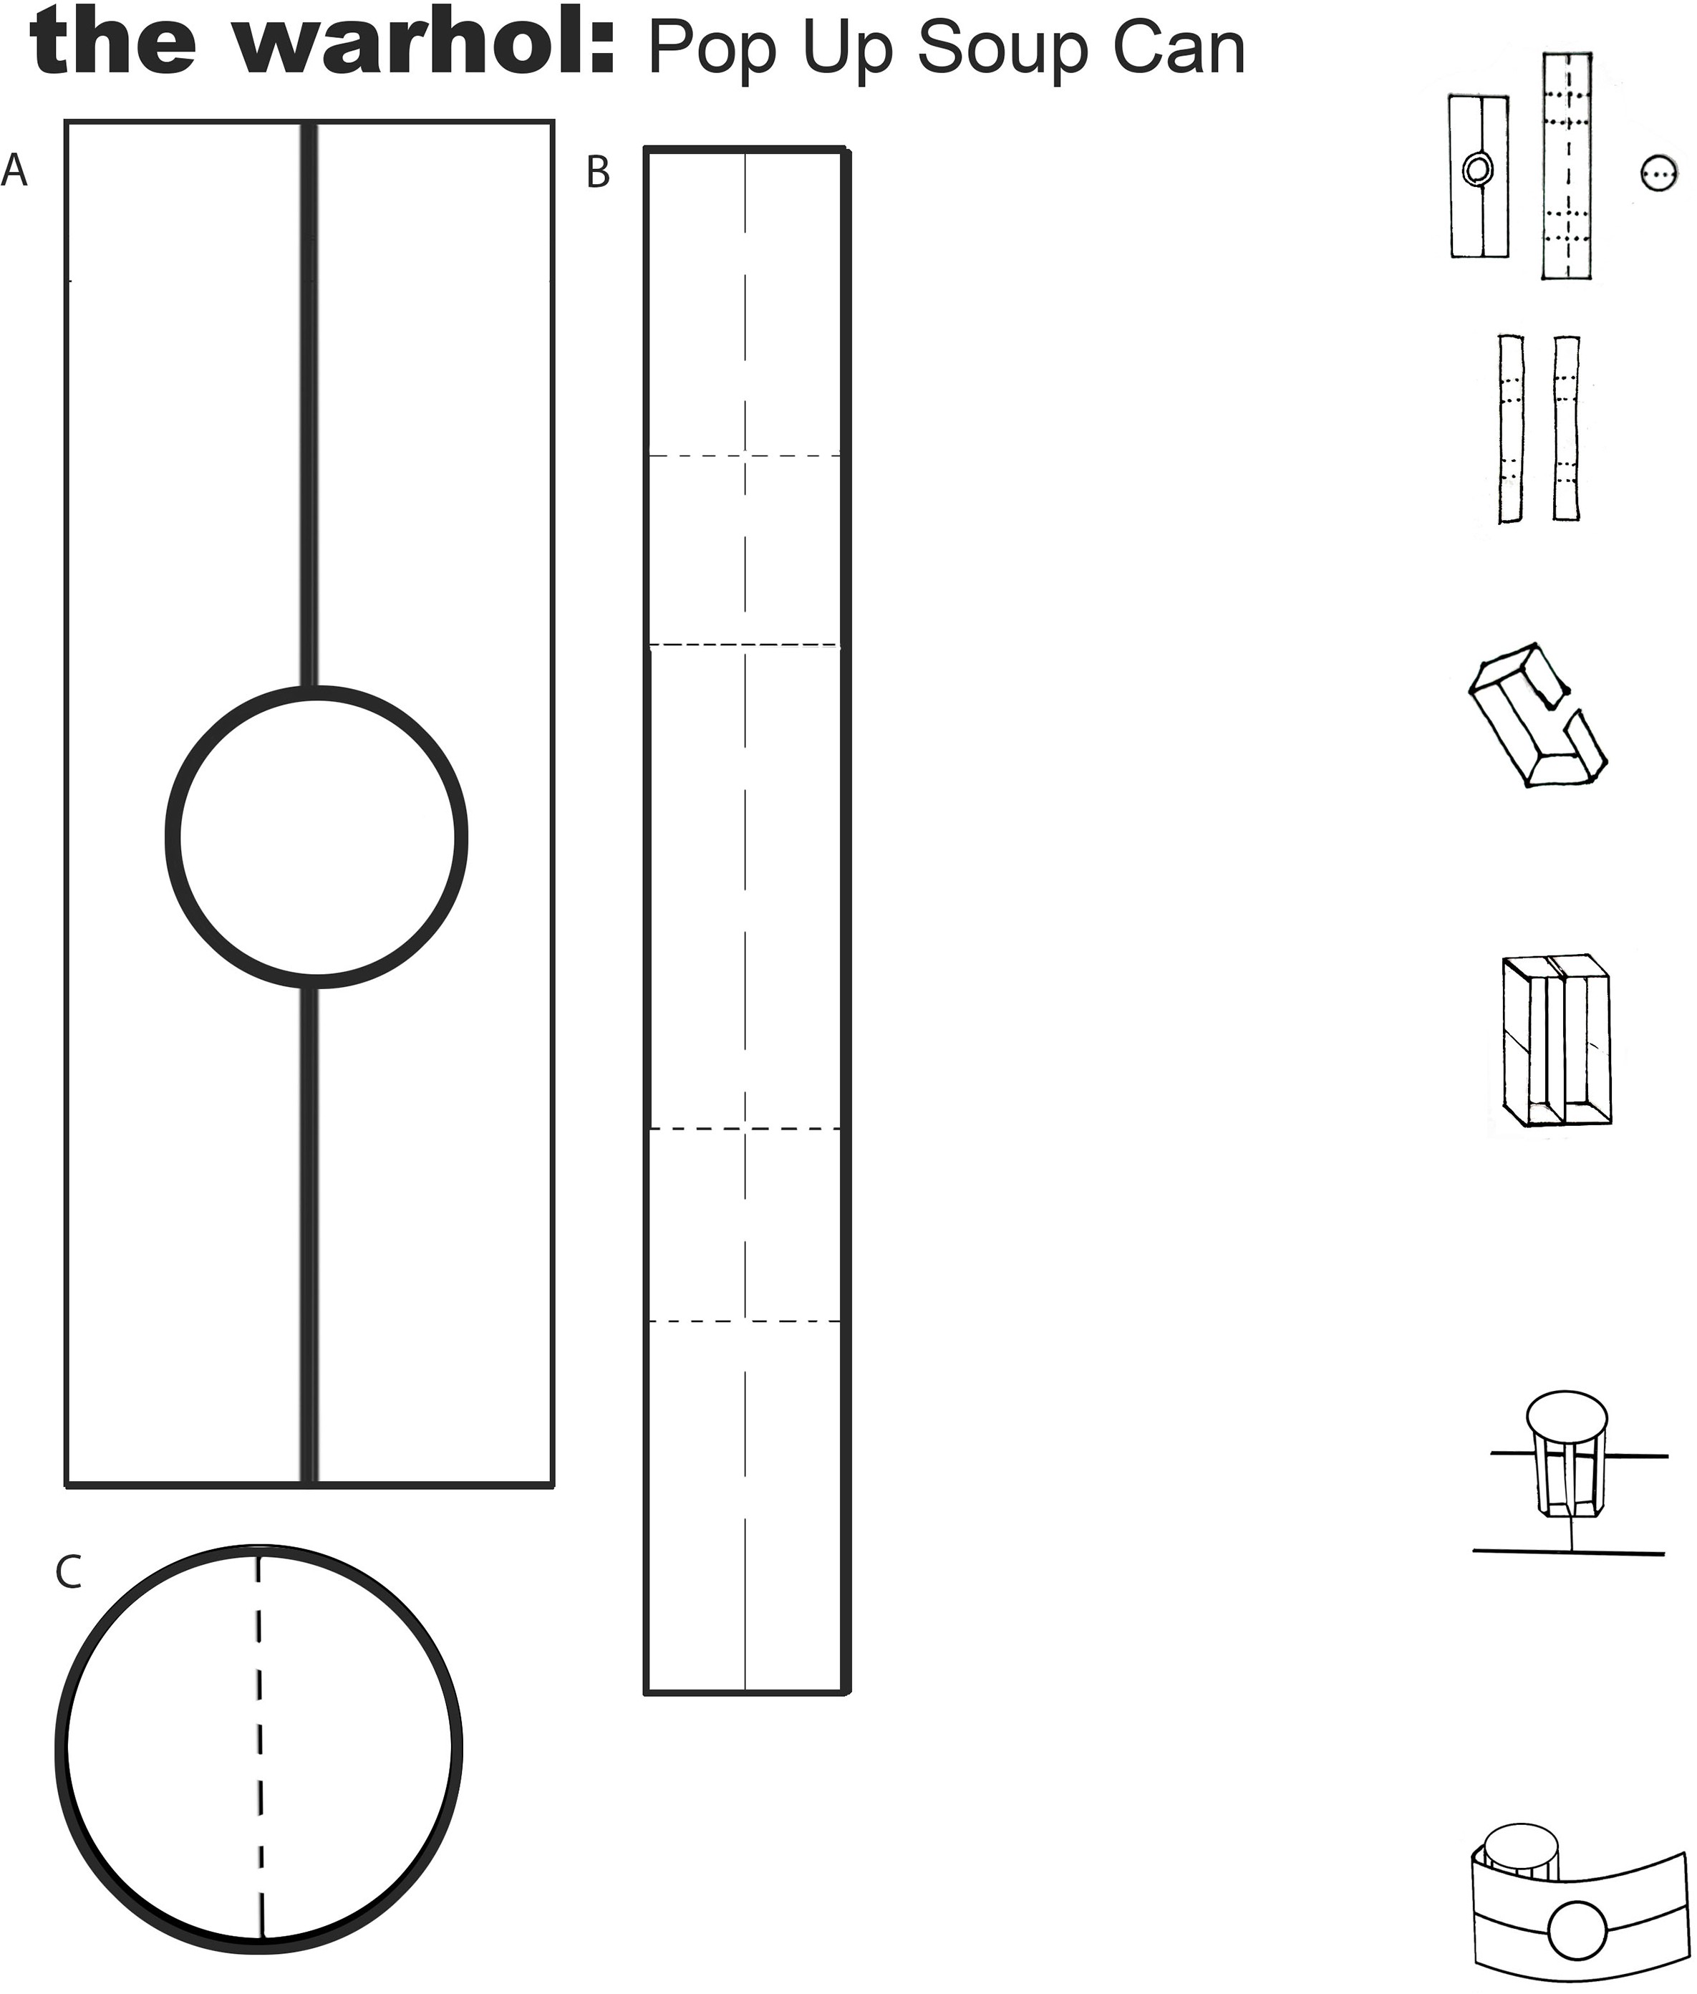
A 6.25 in x 2.25 in
B 1 in x 7.25 in
C 1.75 in circle diameter

- Fold your card and pop up can in half a few times to create creases along the sides and top of your can.

