the warhol: Gen-Z Time Capsule Participatory Art Project

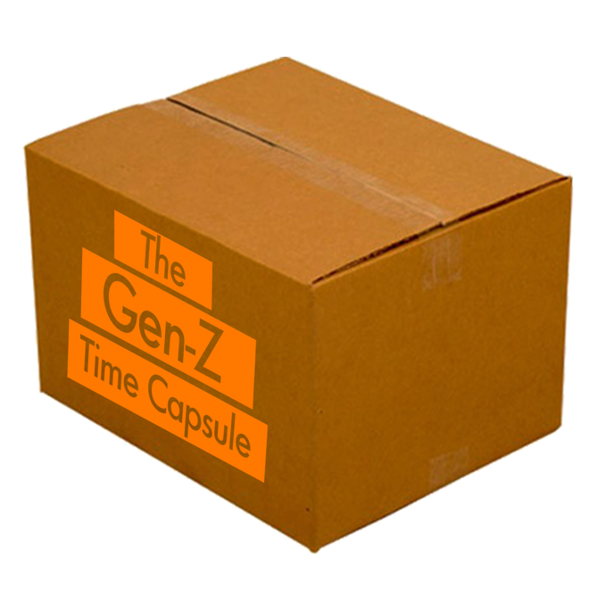
Inspired by Andy Warhol’s 610 Time Capsules, The Gen-Z Time Capsule project will electronically collect photos and videos of objects, activities, places, and people that best represent and are most important to Generation Z—those young people born between 1997-2012.

The goal of The Gen-Z Time Capsule is to create the ultimate portrait of this unique and dynamic generation, who is at the forefront of popular culture and already impacting and influencing the world in groundbreaking ways. Submissions will then be selected to be exhibited online at warhol.org.

The Gen-Z Time Capsule project is a collaboration between the Learning and Public Engagement department at The Andy Warhol Museum and Harvard-trained educator, artist, author, and Gen-Z advocate John Schlimm.

Online Submissions are now open for The Gen-Z Time Capsule project!

For more information, or to invite The Gen-Z Time Capsule project co-creator John Schlimm and The Warhol’s Associate Director of Learning Nicole Dezelon to speak with your class or group, please email AWMeducation@warhol.org.

Discussion Questions

Designed for Gen-Zers and anyone who works with them, the following discussion questions are meant to be a launching point to further explore who Generation Z is and how Gen-Zers everywhere can contribute to The Gen-Z Time Capsule project.

1. How do you view your generation?

2. What do you think sets Generation Z apart from other generations? Why?

3. Describe how you and other members of Generation Z are already impacting and influencing the following areas: Art, Music, Politics & Current Events, Faith & Spirituality, Mental Health, Fashion, Sports & Gaming, Innovation & Technology, Food, and Social Media.

4. What objects, activities, places, and people are most important to you? How do those things relate to your generation?

5. Inspired by your answers to the question above, what three things would you like to photograph and submit to The Gen-Z Time Capsule Project?

