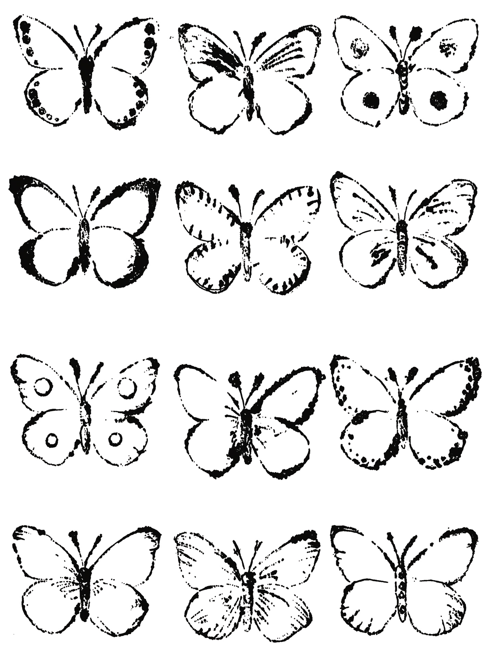

© The Andy Warhol Museum, one of the four Carnegie Museums of Pittsburgh. All rights reserved.

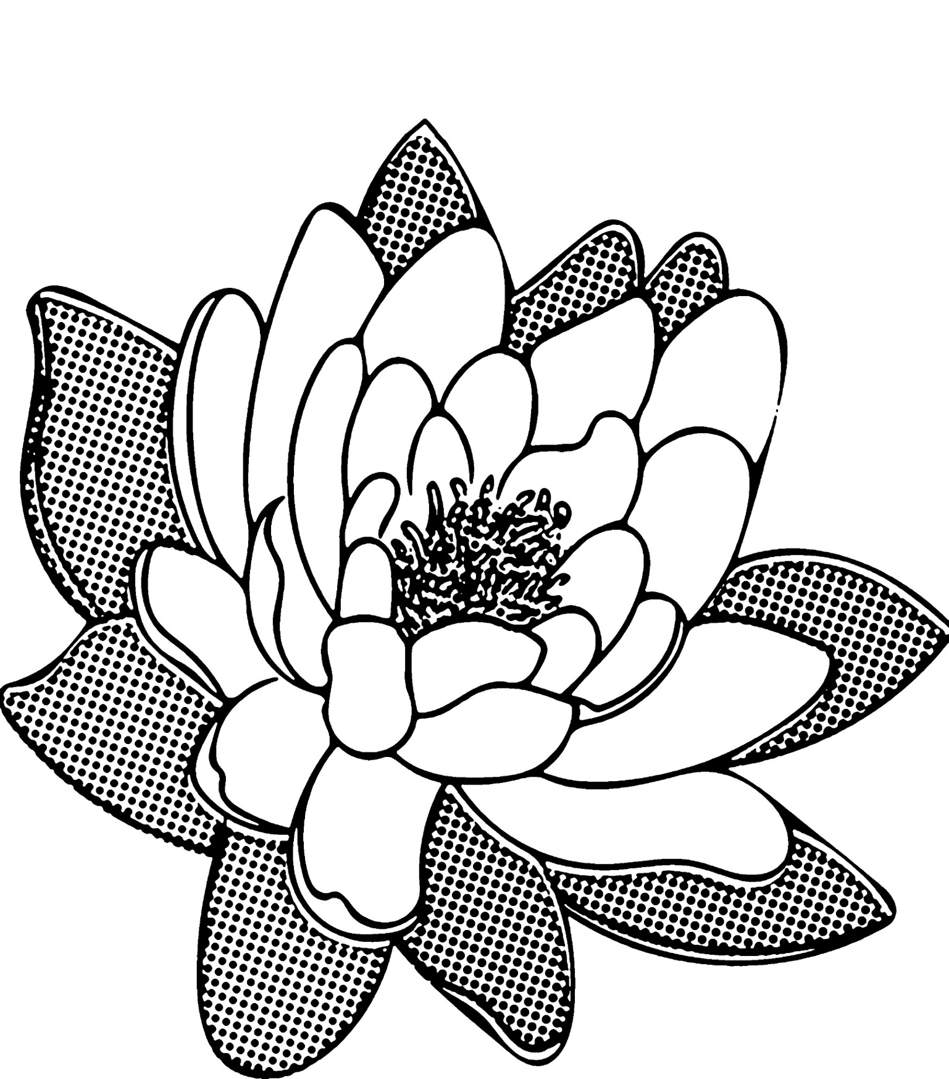

© The Andy Warhol Museum, one of the four Carnegie Museums of Pittsburgh. All rights reserved.

© The Andy Warhol Museum, one of the four Carnegie Museums of Pittsburgh. All rights reserved.

© The Andy Warhol Museum, one of the four Carnegie Museums of Pittsburgh. All rights reserved.

